**ELEC5564M FPGA Design for System on Chip**

**Assignment 2:** **Interactive LCDbased FPGA Demonstrator**

**Group Mini-Project**

Group 19

Zhu Zhu-201388759

Junnan Liu-201715540

Longfei Zou-2201777135

Yifeng Chen-201769378

01/05/2024

### Abstract

For this project, our team is preparing to create a game on the DE1-SoC development board: Airplane War. Players need to control the direction keys. What they have to do in the game is to fly the plane, avoid enemy bullets, and use bullets to shoot down as many enemy planes as possible to get more scores.

### Yifeng Chen 201769378

#### Project Introduction

What I am responsible for is developing the module that controls the movement of the aircraft and the module that displays the game score.

#### Design introduction

Since this design needs to be completed on the DE1-SoC development board, I decided to use the four buttons on the development board to control the game. The four keys (key0, key1, key2, key3) control the movement of the aircraft respectively. While considering that the four buttons can be correctly recognized and output, debounce processing must also be added to increase accuracy.

As for the display of scores, I will use 6 seven-segment digital tubes on the development board to display the player's game scores.In order to realize the function of calling the button, I wrote the v file of switch. The code is in the appendix.

#### Test Bench and Verification

##### 1.Switch

For the test bench of the switch module, I wrote the v file of switch_tb, which is designed to simulate the switch module and test its ability to handle button presses and releases.

I defined the inputs (clk, rst, key_in) and outputs (key_state, ready) for the switch module and connected the inputs and outputs of the switch module (referred to as uut for "unit under test") to the corresponding signals in the test bench. The clock runs for 5000 cycles.

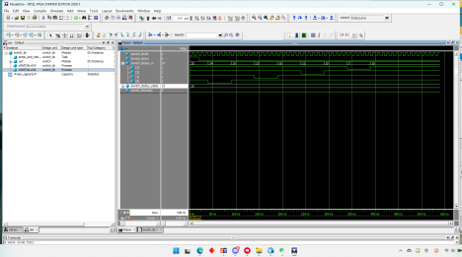

The simulated waveform is shown in above. We can see from the image: the clock signal is a standard square wave with a period of 10 ns. At the beginning, the reset signal is set high for 20 nanoseconds to ensure that the system starts from a known state. It is then set low to allow the system to operate normally. The key input is pressed and released sequentially starting from key0 to key3.

The simulated waveform shows that the module was successfully tested on the test bench.

##### 2.Segment7Device

In Seg7Decode_tb, data is a 4-bit binary input, varying from 0 to 5, with each value lasting 10 nanoseconds. hex_pattern2 is a 7-bit binary output indicating whether each segment of the seven-segment display is lit.

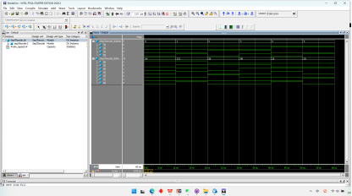

As shown in the in above, according to the change of data, the digital tube can correctly display its correct numbers.

#### Hardware Testing

##### 1.Switch

After doing the test bench and simulating no problems, I decided to do actual testing on the development board to make sure there were no problems with my module. So I wrote the v file of test_switch, and after compiling and configuring the pins, I imported the program to the development board.

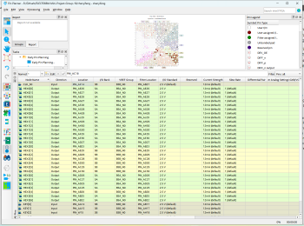

It receives input from the onboard 50 MHz clock, reset button and four user buttons, and outputs them to four seven-segment digital tubes.

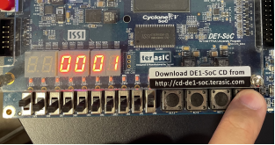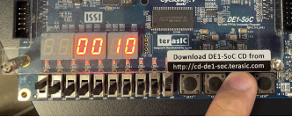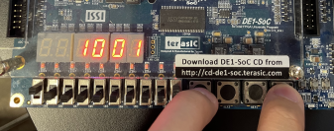

As shown in above, after my finger presses the button, the corresponding digital tube will change to 1, while the corresponding digital tube of the button that is not pressed will be 0. Pressing two buttons at the same time will also display the corresponding digital tube at the same time, which shows that the switch module has been successfully verified and can be called by the upper main module at any time.

##### 2.Segment7Device

For the digital tube, I verified it with my teammates who wrote the LCD display and the main logic module.

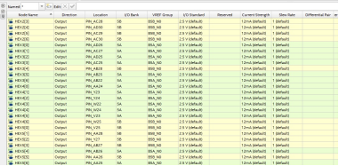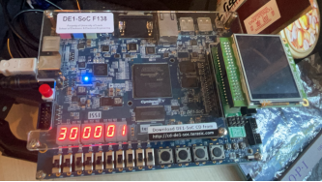

As shown in above, our score is 300001 points, and the digital tube clearly displays it, which means that the module is very successful.

#### Conclusion

Throughout the development process, from the initial design phase to the rigorous testing phase, I effectively utilized available hardware resources to achieve responsive, reliable game controls and a clear score display using a seven-segment digital tube.

### Longfei Zou 201777135

#### Introduction:

I constructed LCD_Display module, LCD_top module and all IP Cores. During this time, I also found and correct some mistakes which are really helpful to improve my skill. Even though this work is challenging, I tried my best and spent lots of time to do it.

#### My Work:

#### Finding suitable images for game production

I found some images and used Photoshop to make the background transparent. These images include background, cover, fighter planes and bullets.



#### Create COE document

At first, I searched online that seems we may use COE document to create IP Core. Therefore, I downloaded Visual Studio and use programme to transfer bmp to coe document. Here are my results.

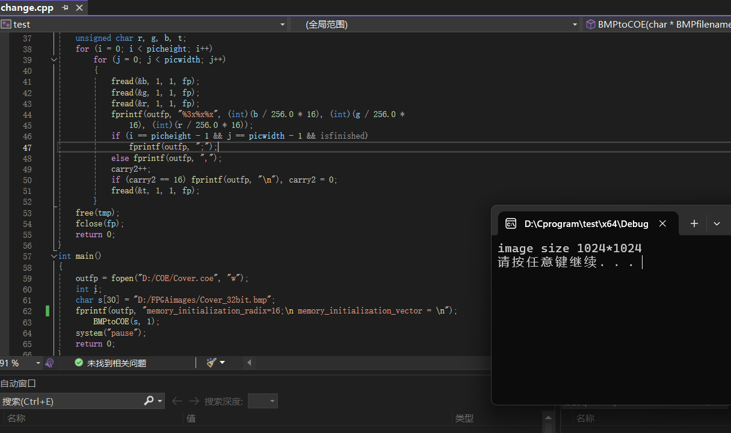

#### descript

#### Found mistake and use mif document to generate IP Core

Then, I tried to create IP Core and found I made mistake! We need mif document which is a formatted text file that specifies initial content to preload into memory elements within an FPGA in Quartus. COE (Coefficient File) serves a similar purpose but is used with Xilinx FPGA devices! And there are two ways to create the mif document. First one is that creates in Quartus. But we need to fill data by ourselves. Another way is using MATLAB to generate mif. Here we can choose ROM and RAM to create IP core. Actually, ROM is primarily designed for read operations and RAM typically offers faster data access speeds compared to ROM. This speed is important for performance as RAM needs to quickly handle active applications and system processes. Therefore, I chose RAM to create IP core for fighter plane, cover and bullets.

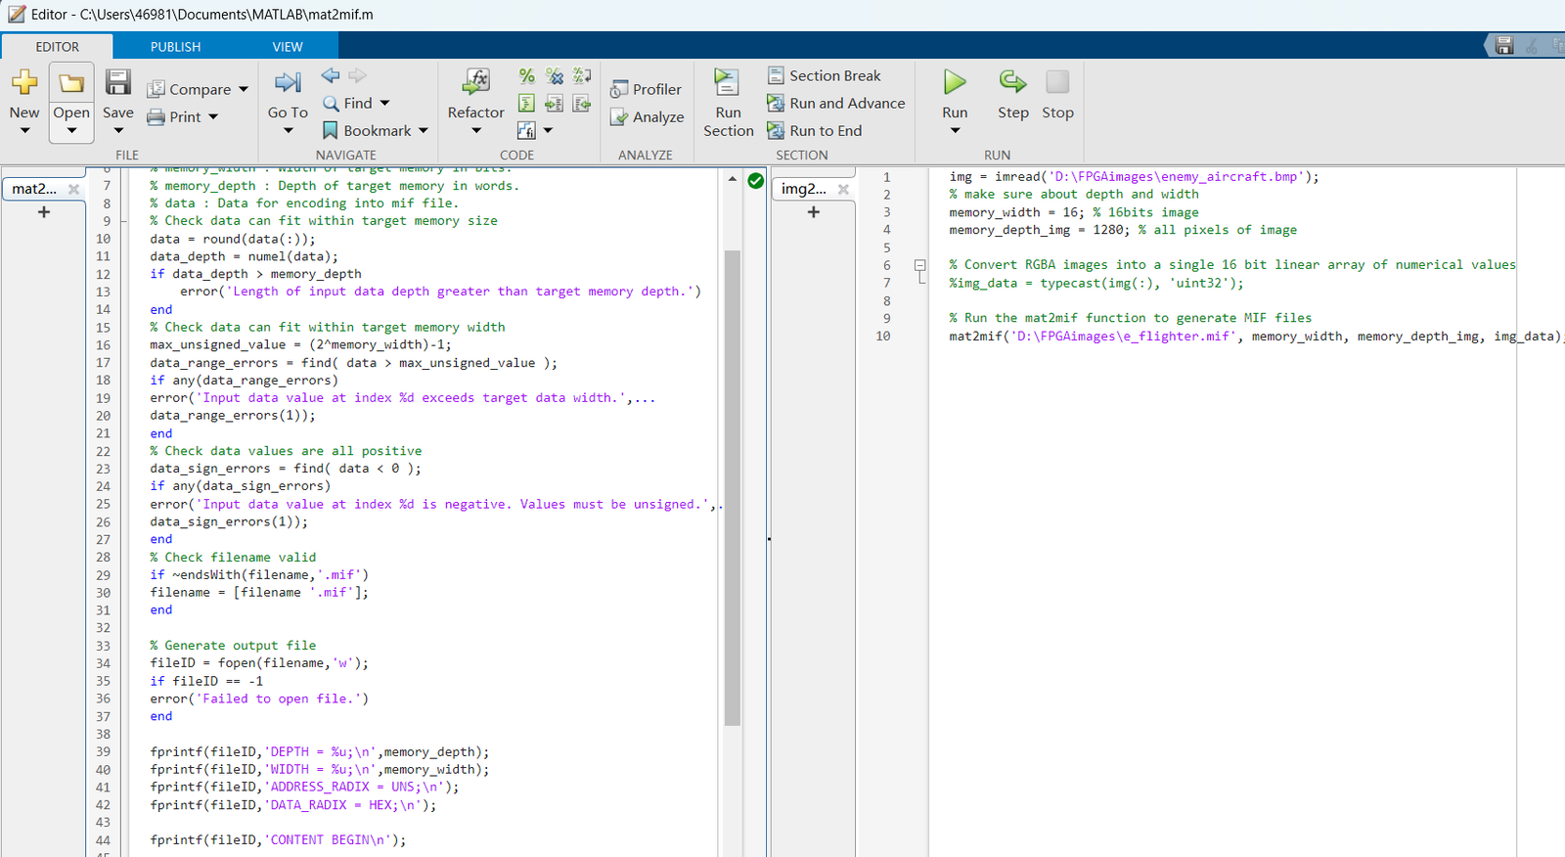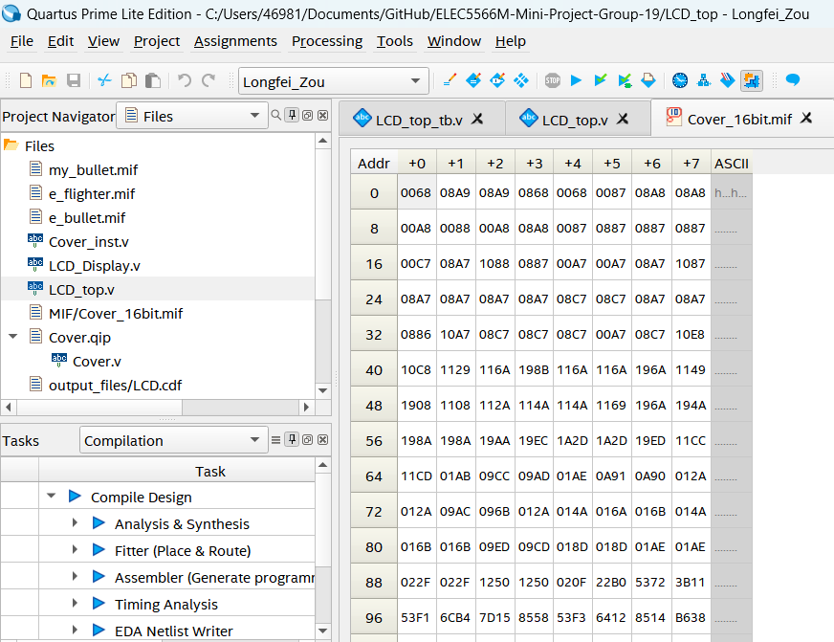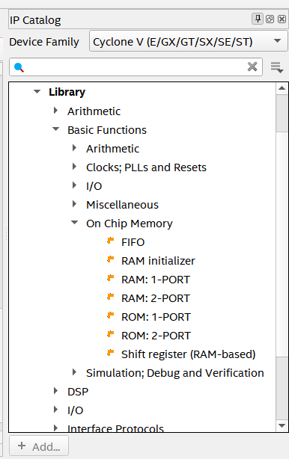

#### Problem about pixelData

I only got the ram address and the image can't display on the LCD. I thought something wrong in my coding. Finally, the reason is that I didn't use initialisation data lookup table! And images also have problems. Because Photoshop can't generate RGB565 image. It can only generate 24bits image and I chose other software to get correct one. Then, I need to combine background with fighter planes and bullets. However, I still haven't figure out how to achieve that. Because not only we need to consider logical, and bitwise operations, but also to set different priority for every elements.

#### descript

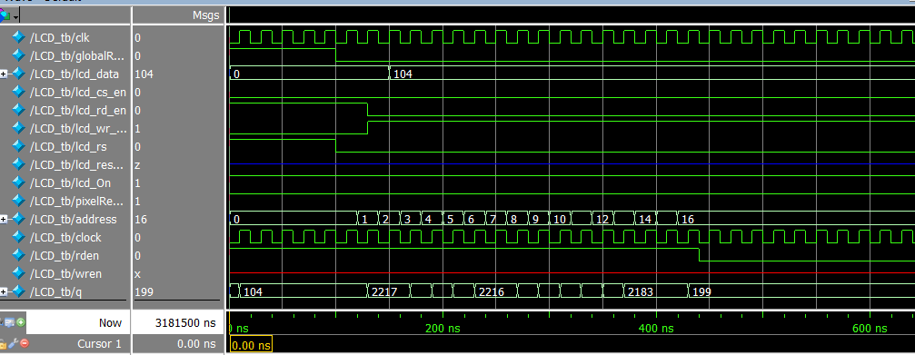

#### Pin planner and try to display

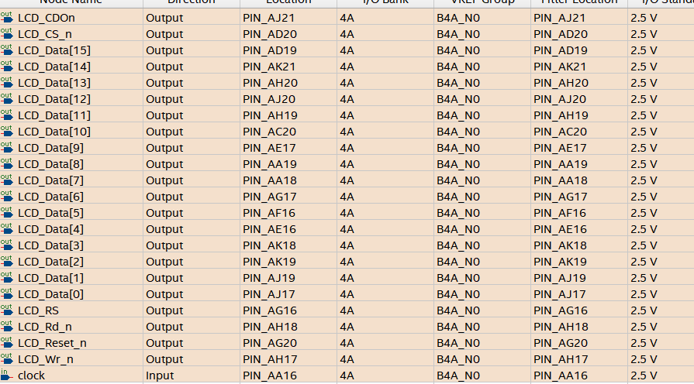

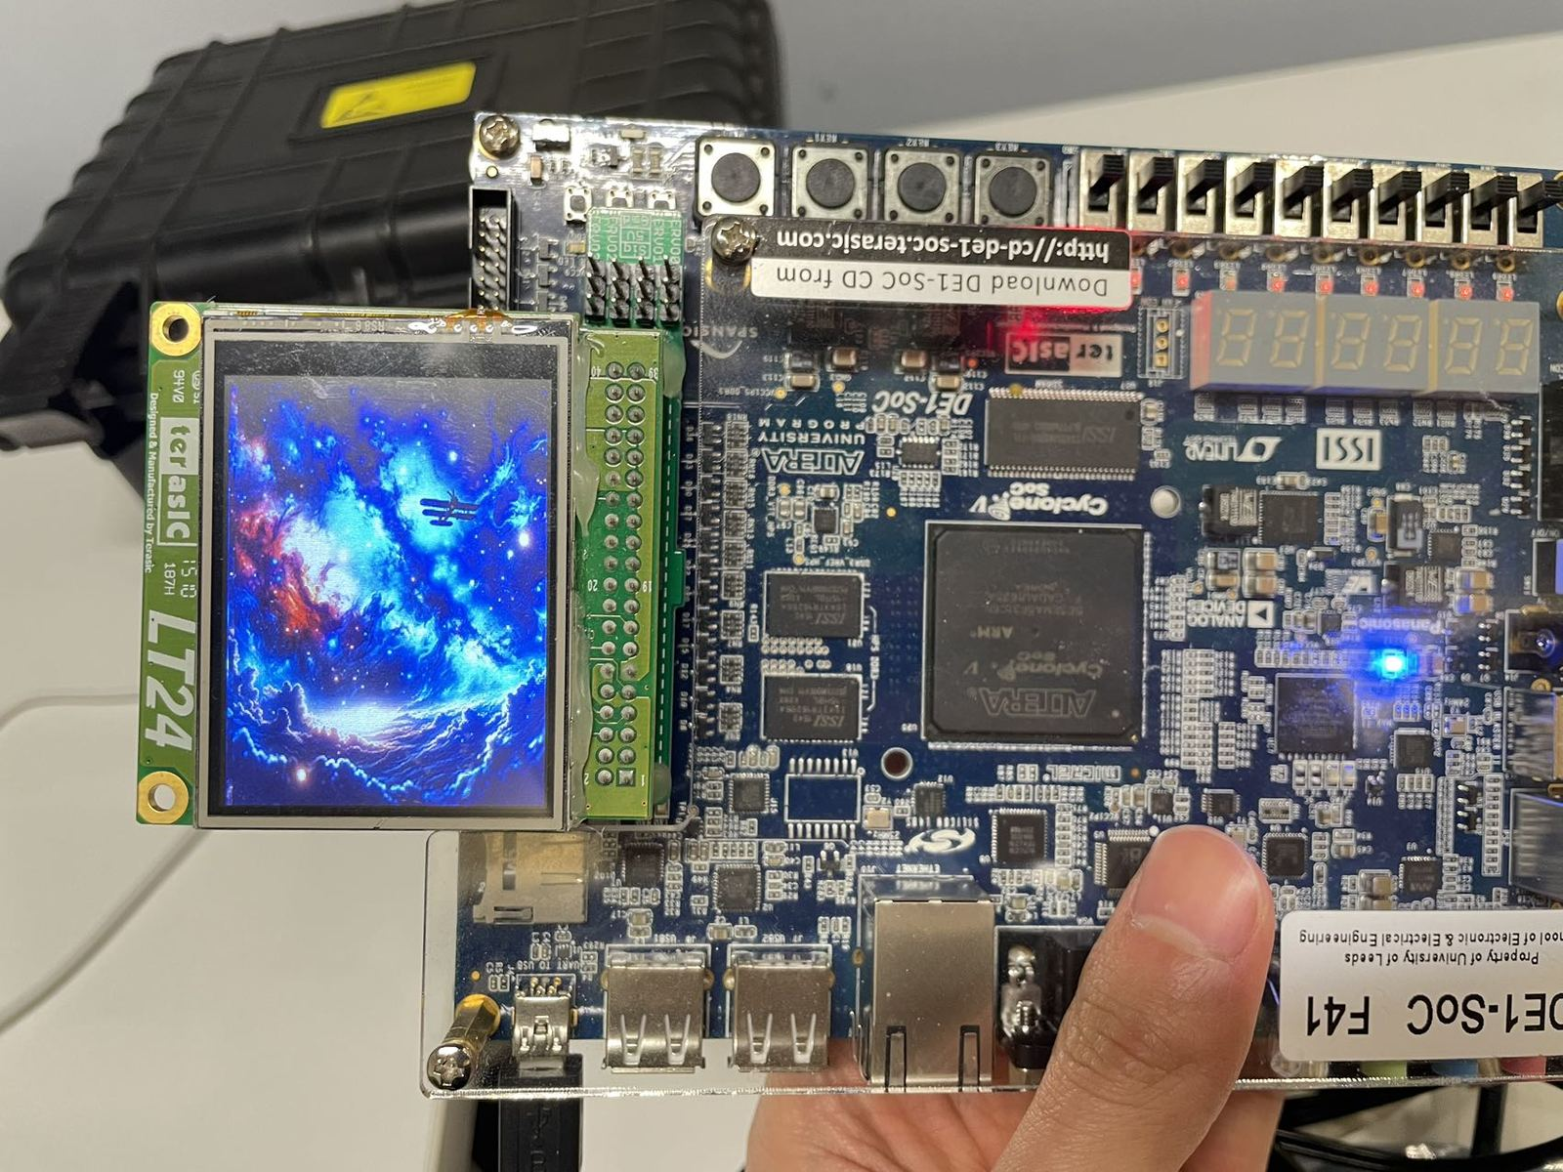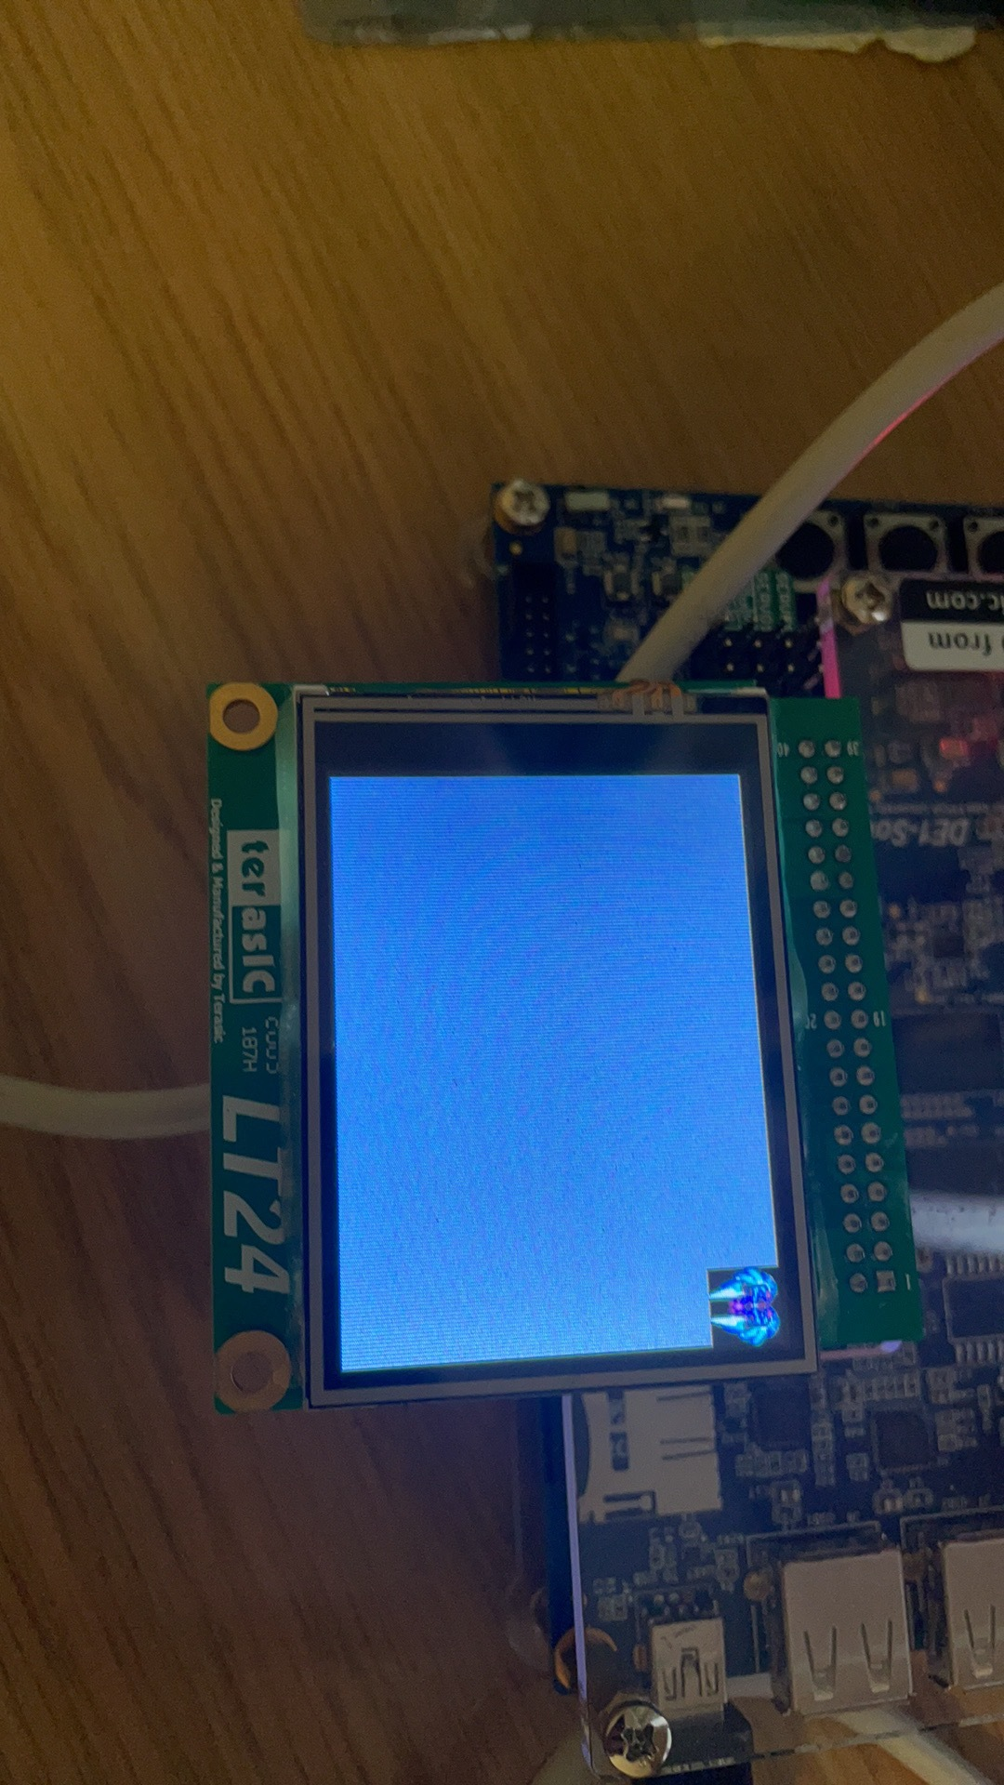

#### My Code Logic

My code is an FPGA-based system designed to control an LCD display for rendering graphics for a video game. It primarily involves managing graphics assets like a player's aircraft, enemy fighters, and bullets, handling their movement, and displaying them on the LCD.

**LCD_top Module:** It manages inputs and outputs for interfacing with the LCD and various instances of graphical objects. It receives various x and y coordinates for different game objects (player and enemy fighter planes, bullets) and outputs control signals to the LCD.

//// Reference: This code is from our FPGA class ////

**LCD_Display Module:** Multiple instances of this sub-module are used for different objects on the screen (fighters, bullets). Each instance is configured with different width and height parameters according to the object it represents. It can handle the lower-level control of the LCD, such as initializing the display, setting up pixel data for graphics, and executing commands for updating the display.

**IP core: (Cover, my_flighter, e_flighter, my_bullet, e_bullet)**

Using the Cover module as an example, it is a Verilog hardware description designed to interface with a block of RAM within an FPGA, specifically using Altera's (now Intel's) altsyncram component to implement a single-port RAM. This module first responds to the clock signal, using an N-bit counter to traverse all pixel addresses in an image, then retrieves the pixel data from the corresponding addresses in the RAM, and subsequently transmits this pixel data to the display module, thereby completing the LCD display.

address (17 bits): The memory address input where data is to be read.

clock: The clock signal that synchronizes the RAM's operations.

q (16 bits): The output where the data from the specified memory address is read.

sub_wire0: This wire is used as an intermediate connection that links the output data (q_a) from the altsyncram component to the output q of the module.

**Module controled by address**

After that, by changing the input address, the display position of the pixels can be altered, necessitating the addition of extra input ports. By using buttons to change the address, the position of the pixels can be adjusted according to this address. Specifically, this involves adding extra input addresses on top of the existing foundation, thereby enabling button control.

### Junnan Liu 201715540

#### Abstract & Introduction

I worked on the audio portion and the audio integration involved creating scripts in MATLAB to generate mif files from WAV, writing audio drivers, designing state machines and doing test bench testing. I implemented the specific audio playback function by implementing the I2C driver, transmitting I2S to the DAC, using the ROM IP core to read the mif audio file, creating the 12.5MHz clock through the PLL core, and combining it with the Avalon interface.

#### Design Methodology & Analysis

This project is a plane combat game implemented in Verilog on Quartus based on DE1-SoC and LT24 LCD. The main architecture and idea are shown in the figure 1 Aeroplane Wars xmind.

For the overall framework of this project, we have divided it into a rough state machine, as shown in the figure 2 Aeroplane Wars structure picture.

##### Audio Module

**Understanding audio decoder knowledge**: According to the information provided in the DE1-SoC User Manual by Minerva, we know that the DE1-SoC board provides high-quality 24-bit audio through the Wolfson WM8731 audio codec (codec/decoder). This chip supports microphone input, line input, and line output ports, with adjustable sampling rates ranging from 8 kHz to 96 kHz. The connection of the audio circuit to the FPGA is depicted in the figure 4 The interface of the WM8731.

**Creating audio mif file**:①Download and Determine the memory_width of the WAV file: Set to 32-bit, with a sampling rate of 48000.②Determine the data of the WAV file:Extract data array using the audioread function from the WAV file. As the data requirement is unsigned, process the data array as follows:data = uint16(data * ((2^16 - 1) / max(data - min_value)));③Determine the memory_depth of the WAV file: A multiple of 2, slightly larger than numel(data). ④Pass the above parameters to the mat2mif code to generate the mif file.(as shown in figure 5 Use Audacity to process mif files)

**Create ROM ip core to read mif data(test_rom.v):** Using the IP core function of Quartus, we can implement ROM data access without writing additional SD card driver code. When creating the IP core, because the data depth of our music is 65536, and WM8731 recommends the number of audio data bits is 16. Based on the above data, we can create the required IP core, and use the NBitcounter module to traverse the addresses in the ROM to read the audio data.

**Implementation of IIC driver(Audio/iic_driver.v):** The WM8731 device can be configured through a control interface that supports both a 2-wire and 3-wire serial bus protocol. The DE1 board's construction supports the 2-wire I2C (integrated circuit) serial bus protocol. The knowledge architecture of IIC is summarized in the figure 8 IIC mind Mapping . And the DE1 board can use the IIC interface to configure codec devices. The bus architecture mainly includes two devices: the FPGA chip of the master device and the WM8731 chip of the slave device:When configuring the internal registers of the WM8731, a 7-bit register ID is needed to store the register address and a 9-bit register data value. These two fields combined make up 2 bytes. Although there is only one slave device, the WM8731, as the slave address with the direction bit set to 0 (indicating the master device only writes), is always required.Based on the above requirements, create an FSM automaton related to IIC. The data state transmits 8-bit data, the ack state receives 2-byte data.The state machine is shown in the figure 9 IIC FSM. In practical situations, we need to transmit 1 bit of data during each transmission process. To ensure smooth data transmission, we need three states: data1, data2, and data3. The data2 state is responsible for executing data read/write operations, while data1 and data3 states stabilize the data. Details are as shown in the figure 10 IIC communication process.**.**

Furthermore, since the general IIC transfer rate is 100K per second, meaning each bit of data occupies 10 microseconds, while the DE1-SOC clock is 50MHz, approximately 0.02 microseconds per cycle. To ensure each state has enough time, we need to count clock cycles and allocate time for each state appropriately. Based on figure 7 ROM IP core testbench, we understand that different states consume time in three categories:

- 1. Half clock cycle occupation (5 microseconds): start, turn, stop, data2, or ack2 state.

- 2. Quarter clock cycle occupation (2.5 microseconds): scl_begin, data1, data3, ack1, ack3, and scl_end states.

- 3. Other: idle state.

During signal transmission, transient interference and unstable signal situations often occur. To address this, buffer units are needed for clock signal output and data signal output to ensure signal stability. The specific implementation of the state machine is shown in the figure 11 IIC state machine.

**Configure the registers of WM8731(Audio/codec_top.v)**: There is a need to configure the registers of the WM8731, requiring prior understanding of WM8731 knowledge, summarized as shown in the figure 13 WM8731 mind Mapping (path: Audio/docx/WM8731.png). The architecture of the WM8731 is illustrated in the figure 14 WM8731 internal component logic, we can understand that the circuit path consists of an amplifier circuit (on the right), two ADCs, digital filters, and a digital audio interface. As per the requirements, only configuring the registers of WM8731 and transmitting DAC data is necessary to extract and play music files stored in the ROM, following the dashed line path shown in the diagram. The relevant signal explanations as the shown in the table 1.

After understanding the above principles, we write the codec_top.v file for configuration. Based on the configuration manual's image (as shown in figure 15 WM8731 register definition ), the configurations as shown in the table 2. And the transmission process can be replaced with the following state machine (figure 16 State machine of WM8731 configuration register). After the settings are completed, the address + value + direction (24 bits) is sent through I2C.

**Use IIS protocol to transmit data to WM8731(Audio/iis_test.v)**: Once the I2C has configured the values for the WM8731 registers, audio data from the mif file stored in ROM needs to be transmitted to the WM8731 after its configuration. This requires the use of the IIS protocol.To convert the digital signals from ROM into analog signals for playing music, an IIS needs to be written to implement the related functions. Specifically, at a 48K sampling rate, with a master clock of 1843200, the bit clock division number can be calculated using the formula mentioned - approximately 5. Since the audio data is 16 bits, a 32-bit division is needed to create a new clock AUD_BCLK. Subsequently, following the left-justified mode as shown in the image, the IIS transmission is implemented.

-

#### Testbench Verification

##### Audio/CounterNBit_tb.v

Initially, we need to implement a CounterNBit module to traverse and read data from the ROM IP core, essentially using a for loop to iterate over output values. Subsequently, we wrote a testbench for verification:

The verification results are shown in the figure 6 NBitCounter module testbench, indicating that our countValue increments on each rising clock edge, demonstrating that the module operates correctly.

##### Audio/rom_tb.v

Next, we need to use the ROM IP core to read the generated mif music file. Therefore, we created a 65536-word size ROM with 32 bytes based on the mif size, and then tested it using the CounterNBit module:

The test results are shown in the figure 7 ROM IP core testbench. Upon completion of reset, countValue begins counting, and the value of q changes accordingly. By comparing with the mif file, it is confirmed that the data matches, indicating the normal operation of this IP core.

##### Audio/iic_tb.v

After completing the IIC code writing, a testbench file can be created to test whether the IIC driver operates correctly:In the testbench, the CounterNBit module is called to incrementally count the address, allowing reading of data stored in the ROMip core and then sending the retrieved data using IIC.

As observed in thefigure 12 IIC transmission process, when sda is pulled low, scl is high, indicating the 2 state, which is the start state. When scl begins to pull low, it enters the scl-begin state. After a quarter cycle, it enters the 4 (data1) state, preparing for data transmission.

The state_reg transitions from 2-3-4-5-6 represent the sequence from start->scl-begin->data1->data2->data3 before cyclically repeating 6-4-5 states, which is data3-data1-data2 continually transmitting data. This simple verification confirms that the IIC data transmission is correct. Further validation can be assisted by subsequent testbench analysis.

##### Audio/audio_tb.v

After the settings are completed, the address + value + direction (24 bits) is sent through I2C. To verify its effectiveness, a testbench is written to check if the data is sent correctly:

Based on the figure 17 codec_top.v testbench, after comparison:

R0: 24'b 00110100(Device_Address) 0000000(LIN_ADDR) 0(LHPBOTH) 0(LHPMUTE) 00 10111(LHPVOL) = 3407895, verification successful.

##### Audio/i2c_tb.v

Once the I2C has configured the values for the WM8731 registers, audio data from the mif file stored in ROM needs to be transmitted to the WM8731 after its configuration. This requires the use of the IIS protocol.

To convert the digital signals from ROM into analog signals for playing music, an IIS needs to be written to implement the related functions. Specifically, at a 48K sampling rate, with a master clock of 1843200, the bit clock division number can be calculated using the formula mentioned - approximately 5.

Since the audio data is 32 bits, a 32-bit division is needed to create a new clock AUD_BCLK. Subsequently, following the left-justified mode as shown in the image, the IIS transmission is implemented.

##### Audio/iis_test_tb.v

Since the audio data is 16 bits, a 32-bit division is needed to create a new clock AUD_BCLK. Subsequently, following the left-justified mode as shown in the figure 18 IIS left aligned mode, the IIS transmission is implemented. By comparing the figure 18 IIS left aligned mode, we found that there is a slight discrepancy in the simulation of the figure 19 iis_test.v testbench, which is the lack of alignment of the falling edge of the clock at the beginning, which needs to be modified.

##### Audio/avalon_audio_tb.v

First, we need to implement the usage of the IIS protocol for data transmission after configuration. As shown in the figure 20 avalon_audio.v testbench, after the I2C transmission is completed, the count starts counting, and data begins to be read, at which point i2c_scl remains high, indicating that the i2c process has ended.

#### Hardware Testing

**Pin Configuration:** According to the pin descriptions of the AUDIO section in the "DE1-SoC_User_Manual," we have written the relevant scl file to allocate pins. The pin allocation is as shown in the figure 21 Pin configuration: Only the dac-related pins are configured, and the ADC is not configured because we only use the functionality of the DAC.

**Achievements display:** Since the audio module demonstration can only listen to the sound, we chose to take a video for verification.****

#### Conclusions

This project allowed me to gain substantial knowledge as I engaged in the complete process of developing a game on an FPGA board, utilizing the I2C and IIS protocols. We thoroughly validated our design through testbench verification and hardware testing, ensuring its correctness and performance. The project enhanced our expertise in hardware descriptive language design, particularly in Verilog, and underscored the importance of planning and communication in team projects. Overall, this experience provided a comprehensive understanding of the hardware design process and we look forward to applying and augmenting these skills in future endeavors.

### Zhu Zhu 201388759

#### Introduction

I took the lead role in developing the core logic that forms the basis of our code base. My work involved designing and implementing several key gameplay elements, including the development of accurate collision detection algorithms for interactions between aircraft and enemy units, as well as between aircraft and incoming munitions. In addition, I was responsible for the implementation of the main logic code, which included the application and interconnection of multiple modules such as the display module for screen rendering, the key input module for player interaction, the seven-segment display module, and the collision detection module. The efficient collaboration of these modules ensured the smoothness and responsiveness of the game.

In terms of specific technical implementation, I completed the BCD conversion module, bullet hit determination module, aircraft crash determination module, ‘AntiJitter’ jitter correction module and the main module of the main code, as well as the test bench code of these modules. The development and testing of these modules ensured the stability and accuracy of the game at the technical level, and I was also involved in modifying the display logic of the seven-segment code and the writing of the corresponding test bench, which further improved the game's user interface and player experience. Through this work, I ensured that the game mechanics were not only actionable, but also fully compliant with the desired goals we set for a dynamic game experience.

#### Design Methodology

In this project, although I wrote many modules, I think the three most important files I wrote are hit, crash and main files, I will talk about these three in detail, the others will not be detailed due to space.

##### 1.Hit module

This module is responsible for detecting if an enemy bullet hits our aircraft. This module detects the bullet and plane by inputting their x and y coordinates, and outputs 1 if they are hit.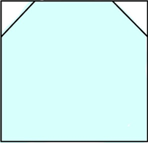

The coordinates of the aircraft are the upper left corner of the picture, and the size of our plane is 40x40. The code is compiled so that the judgement range is the blue area, and when the coordinates of the bullet are located in the blue range, then it is judged to be a hit, and the module will output a high-level signal (check), which indicates that our plane has been hit.

Implementing a collision detection algorithm that is both fast and accurate is challenging because the plane and bullet can move very fast. I have used an optimized algorithm to ensure a fast response without losing accuracy.

##### 2. Crash module

The Crash Module is responsible for detecting whether our plane has made physical contact with an enemy plane, which will result in an in-game crash event.

This module receives the coordinates of the enemy plane (e_x, e_y) and the coordinates of our plane (mi_x, mi_y). The input coordinates refer to the upper left corner of the plane. If any contact is detected into the boundary of our plane, the module will output a signal (check) indicating that a crash has occurred.

Crash detection requires calculating complex spatialrelationships, which involves checking if 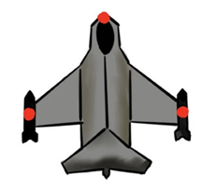any part of an enemy plane has entered our plane's boundaries. To do this, we define extra detection points such as the front, back, and wingtips of the enemy plane, as shown in the diagram.

The gaming environment requires the module to respond in real-time, particularly in scenarios with multiple enemy planes, where any delay in crash detection could significantly impact the gaming experience. We ensure swift and accurate execution of the module through algorithm optimization and hardware acceleration.

##### 3. Main module

The Main Control Module acts as the central hub for the entire airplane combat game, coordinating the activities of various sub-modules, responding to player inputs, and managing transitions between game states. This module receives inputs such as the system clock and control signals entered by the player via switches and buttons. It is responsible for outputting game state indicators, such as scores and life values displayed on the HEX display. Additionally, it controls the LCD display and LED indicators to provide feedback on game information.

At the start of the game, the Main Module initializes all game parameters, including setting the player's initial life values and scores, and prepares the game interface. Subsequently, the main module enters a continuous game loop, where it updates the game logic based on the current game state and player inputs. This includes interpreting player movement commands, processing bullet firing, and updating the states of enemies and obstacles according to game logic.

When the hit or crash modules detect an event, the Main Control Module receives a signal and updates the game state accordingly, such as adjusting the player's life values or triggering game over logic. Additionally, the main control module continuously scans player inputs and adjusts the behavior of the aircraft and other aspects of the game in real time based on these inputs.

The main module is also responsible for updating the display outputs according to the latest game state, providing visual feedback of crucial information like life values and scores. Moreover, it controls the game's progress, deciding whether the game should continue or end.

Challenges faced by the Main Control Module include how to effectively manage multiple concurrent events and ensure the real-time performance and smoothness of the game logic on an FPGA. Through well-designed state management, event handling logic, and player interaction processing, the main module not only ensures stable operation of the game system but also provides an excellent player interaction experience.

#### Implement Detail

In the process of integrating and developing the main module for our FPGA-based flight combat game, I encountered a series of challenges that tested my technical skills and understanding of complex system interactions. Here is a detailed account of the primary issues that arose during the development phase:

1.Inconsistent Submodule Interfaces: Different team members' modules had varying interface designs, necessitating adjustments for seamless integration and compatibility.

2.Complexity in Control Logic: As the game rules evolved, the control logic became more complex, requiring careful design to maintain system stability and ensure fast response times.

3.Bug Localization and Fixing: Integration testing revealed multiple logical errors and performance bottlenecks. Systematic testing and analysis were essential to effectively identify and resolve these issues.

#### Test Bench and Verification

During the development of our airplane combat game project, I created a detailed testing platform to validate the functionality of each key module and the interaction of the entire system. Through the test bench (_tb files), I conducted integration tests between modules and comprehensive system tests to ensure the proper operation of each function block and their compatibility with each other.

In my test bench, I first conducted unit tests on the hit and crash modules, which are critical parts of the game logic. By simulating various potential positions of enemy aircraft and bullets, I tested the accuracy of the hit detection and crash detection logic. These tests helped confirm that the modules could accurately reflect dynamic events in the game, such as hitting enemy aircraft and aircraft crashes.

Next, I integrated these modules into the main control module and conducted a full system test, simulating a complete game environment to observe the interaction between modules. This included testing the system response time, game logic processing, and user input response. Specifically, I ensured that the system could respond instantly to player actions and that game status updates were immediately reflected on the user interface.

When testing the main module, the simulated waveforms did not output correct results for various reasons, prompting me to make repeated modifications. As I was not very familiar with the code of other teammates but needed to detail their code for integration, I had to learn and reference their code extensively and also wrote additional test modules for integration testing, repeatedly trying until the correct results were obtained.

#### Hardware testing

During the hardware testing phase, I followed the procedures outlined in Unit 3-1, assigning specific locations to each pin before downloading the developed game code onto the FPGA development board. By operating the FPGA board in real-time, I tested various hardware interfaces and the responsiveness of the game, ensuring that all functional blocks operated correctly in a real hardware environment. This process was crucial for verifying the compatibility between the software and hardware, as well as the overall system stability. By doing so, I was able to directly observe the game's performance on the hardware, promptly identifying and resolving issues that had not appeared in the simulation environment.

#### Results and Discussion

In the final stages of our project, we carried out extensive testing of the plane game. This included both software testing on test benches and practical hardware tests. These tests confirmed that the game runs stably on the FPGA development board and offers a seamless interaction experience for players.

Verification on the test benches assured us that the hit and crash detection modules were accurately responding to dynamic events in the game, such as hits on enemy aircraft and crashes involving our plane. The precision of these modules is essential for the realism and challenge level of the game. Additionally, the tests on the main control module showed that the system responds promptly to player inputs, efficiently handling commands for movement and shooting.

During the hardware testing phase, we downloaded and executed the game code on the FPGA board, testing the game's hardware interfaces and responsiveness directly. This stage not only confirmed the software's compatibility with the hardware but also showcased the stability and efficiency of the system on actual hardware, especially under conditions with multiple enemy aircraft where the system maintained robust performance, affirming the effectiveness of our design and optimization efforts.

Overall, while some test results were less than perfect, the project was generally successful. This development and testing process not only deepened our team's understanding of complex system integration but also equipped us with valuable experiences and confidence for future projects and potential upgrades.

# Appendix

##### Table for 201715540

|  |  |
| --- | --- |
| Signal name | Function |
| rlinein, llinein | Line inputs for the right and left channels of analog signals |
| micin | Microphone input |
| rhpout, lhpout | Headphone outputs for the right and left channels |
| dacdat | Data to DAC |
| adcdat | Data from ADC |
| mclk | Master clock signal |
| bclk | Bit clock |
| daclrc | Clock signal for DAC left and right channels |
| adclrc | Clock signal for ADC left and right channels |
| sdin | Serial data input |
| sclk | Serial clock |

**Table 1 WM8731relevant signal explanations**

|  |  |  |
| --- | --- | --- |
| Signal name | Function | Value |
| LHPBOTH | Whether to load the mute value and gain of the left line into the right channel. | 0 |
| LINMUTE | Mute the left line input, choose 0 to unmute. | 0 |
| LRINVOL | Volume of the left line input amplifier, set to the default volume 10111 (0dB). | 5’b10111 |
| LHPVOL | Left headphone volume, default value is 1111001 (0dB) | 7’d126 |
| LCZEN | Enable zero crossing detection circuit to reduce popping noise. | 1 |
| LRHPBOTH | Whether to load left headphone volume and zero crossing value into the right channel simultaneously. | 0 |
| INSEL | Input selection, 1 for line input, 0 for microphone input. | 1 |
| BYPASS | Select bypass ADC input | 0 |
| DACSEL | Select DAC output. | 1 |
| SIDETONE | Select microphone input | 0 |
| MICBOOST, MUTEMIC, SIDEATT | Other microphone operations | All set to 0 |
| ADCHPD | Enable ADC high pass filter | 0 |
| DEEMP | Set DAC de-emphasis filter | 0 |
| DACMU | Mute DAC | 0 |
| HPOR | Store or clear DC offset when DAC high pass filter is disabled | 0 |
| R6 | Control power on/off for various circuits | All 0 |
| FORMAT | Specify basic format of the serial data stream | 1 |
| IWL | Specify resolution (sample bit depth) | 01 |
| LRP | Use daclrc to indicate DAC data stream channel | 0 |
| LRSWAP | Swap left and right clocks | 0 |
| MS | Master/slave mode | 0 |
| BCLKINV | Bit clock inversion | 0 |
| USB/NORMAL | Choose 0 for normal mode | 0 |
| BOSR | Basic oversampling rate | 0 |
| SR | Sampling rate control | 0000 |
| CLKDIV2 | Core clock division by 2 | 0 |
| CLKODIV2 | Clock output divided by 2 | 0 |
| ACTIVE | activate the digital audio interface. | 1 |

**Table 2 WM8731 configurations and value**

##### Figure for 201715540

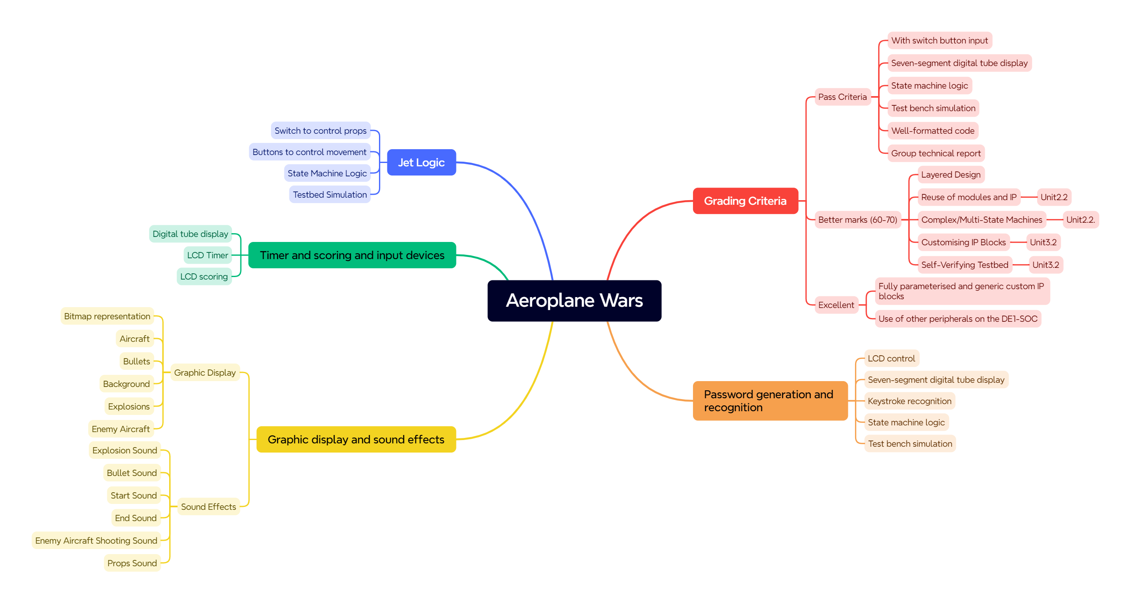

figure 1 Aeroplane Wars xmind

1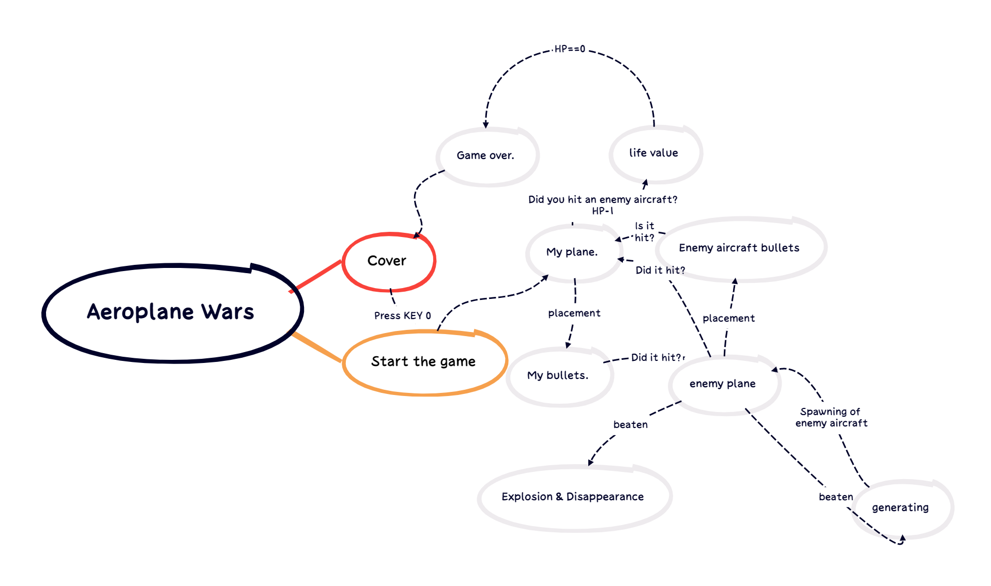

figure 2 Aeroplane Wars structure picture

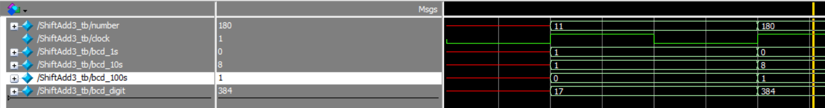

figure 3 NBitBCDcounter testbench

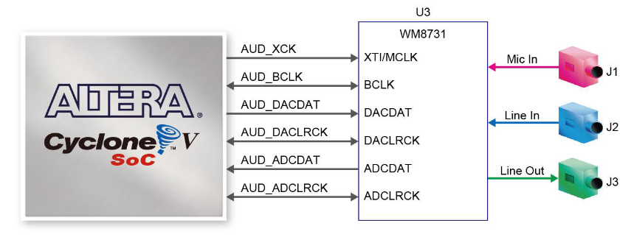

figure 4 The interface of the WM8731

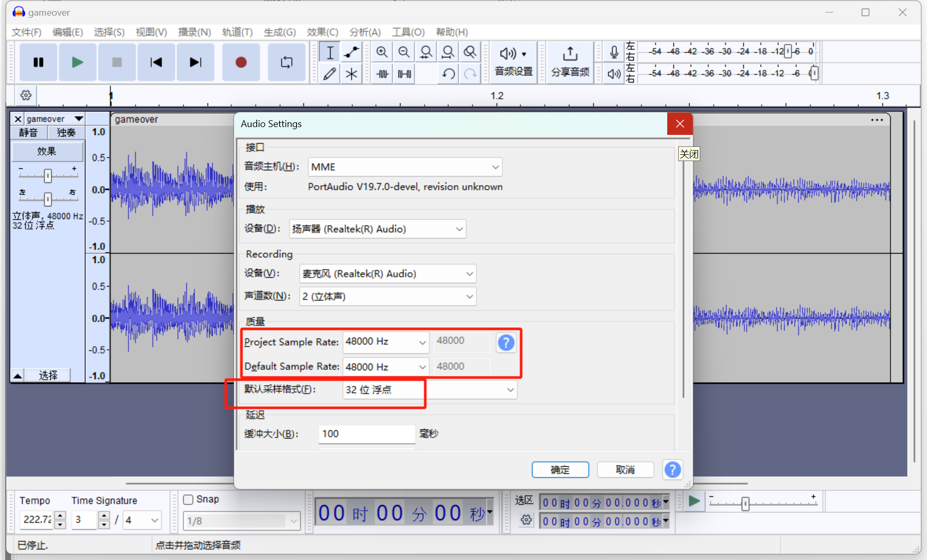

figure 5 Use Audacity to process mif files

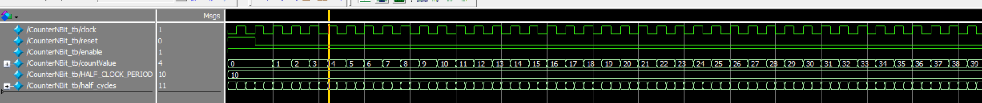

figure 6 NBitCounter module testbench

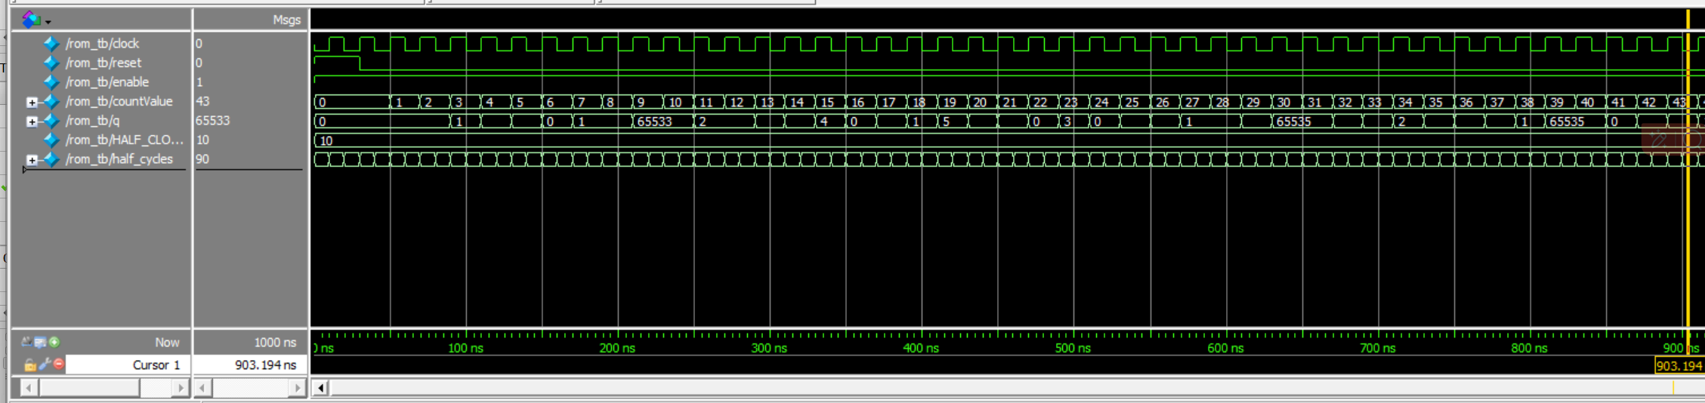

figure 7 ROM IP core testbench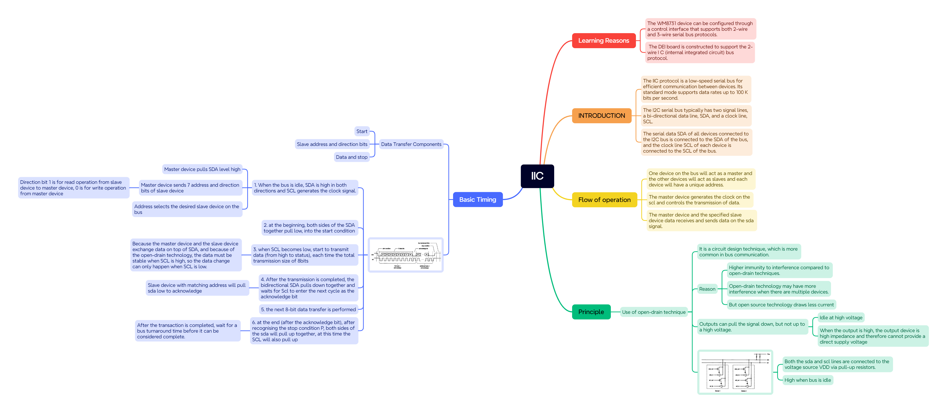

figure 8 IIC mind Mapping 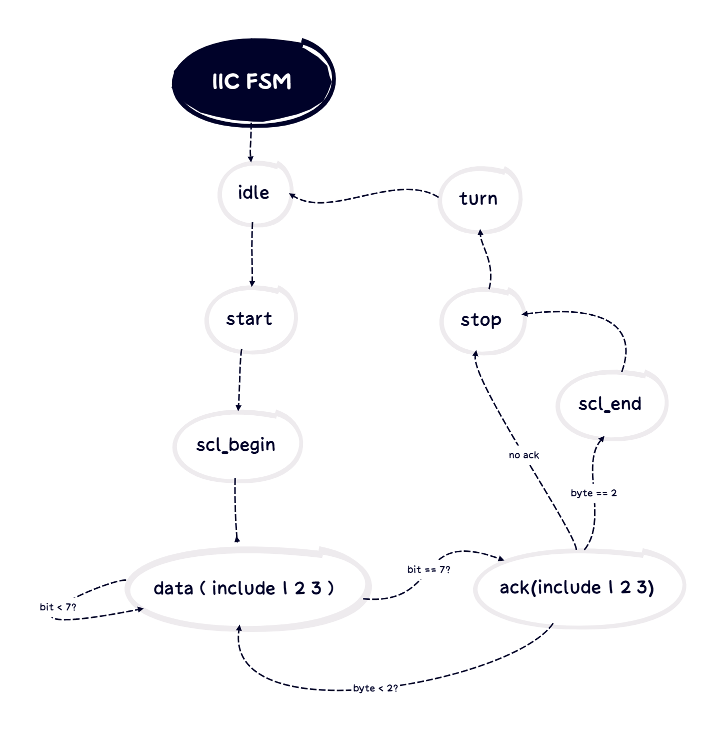

figure 9 IIC FSM

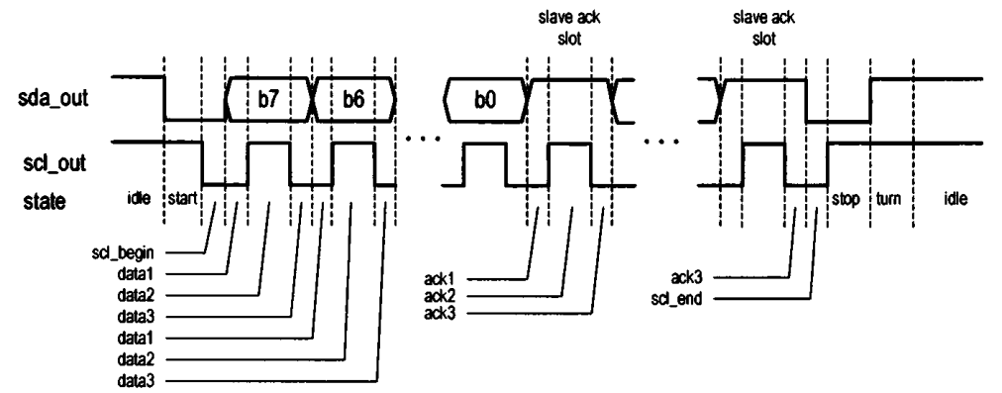

figure 10 IIC communication process.

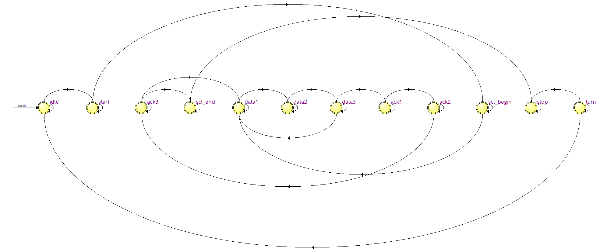

figure 11 IIC state machine

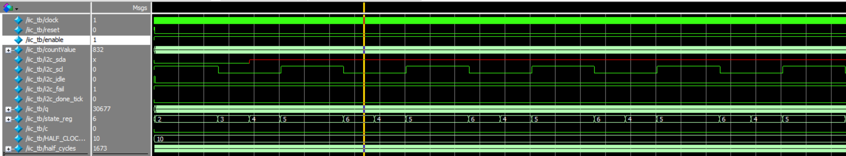

figure 12 IIC transmission process

a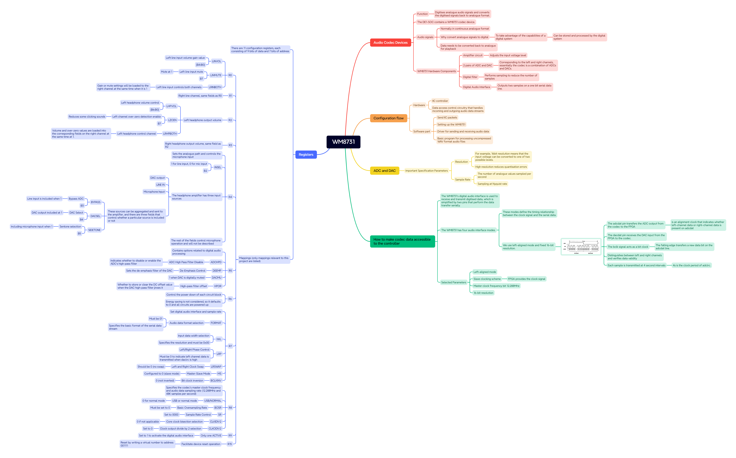

figure 13 WM8731 mind Mapping

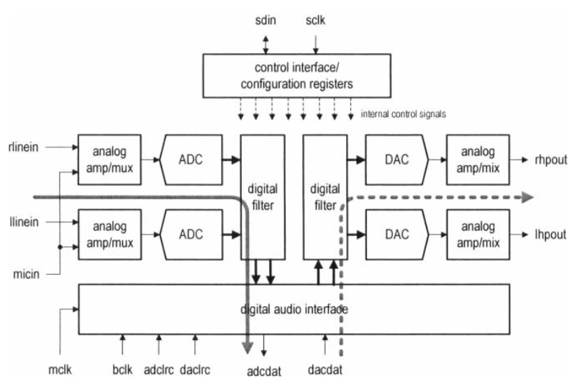

figure 14 WM8731 internal component logic

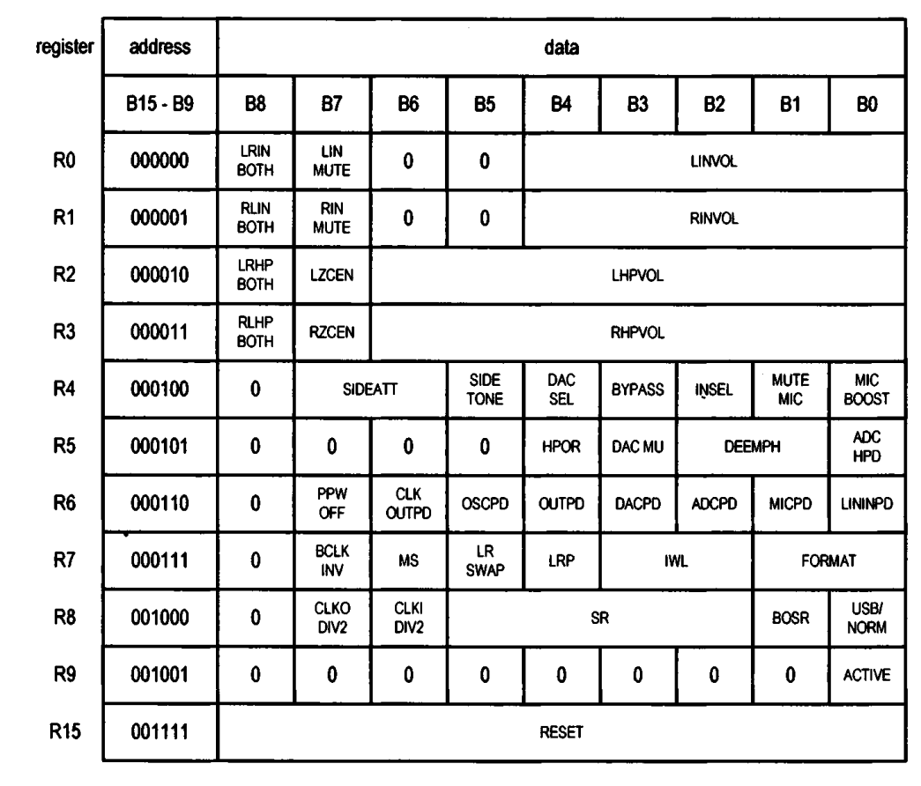

figure 15 WM8731 register definition 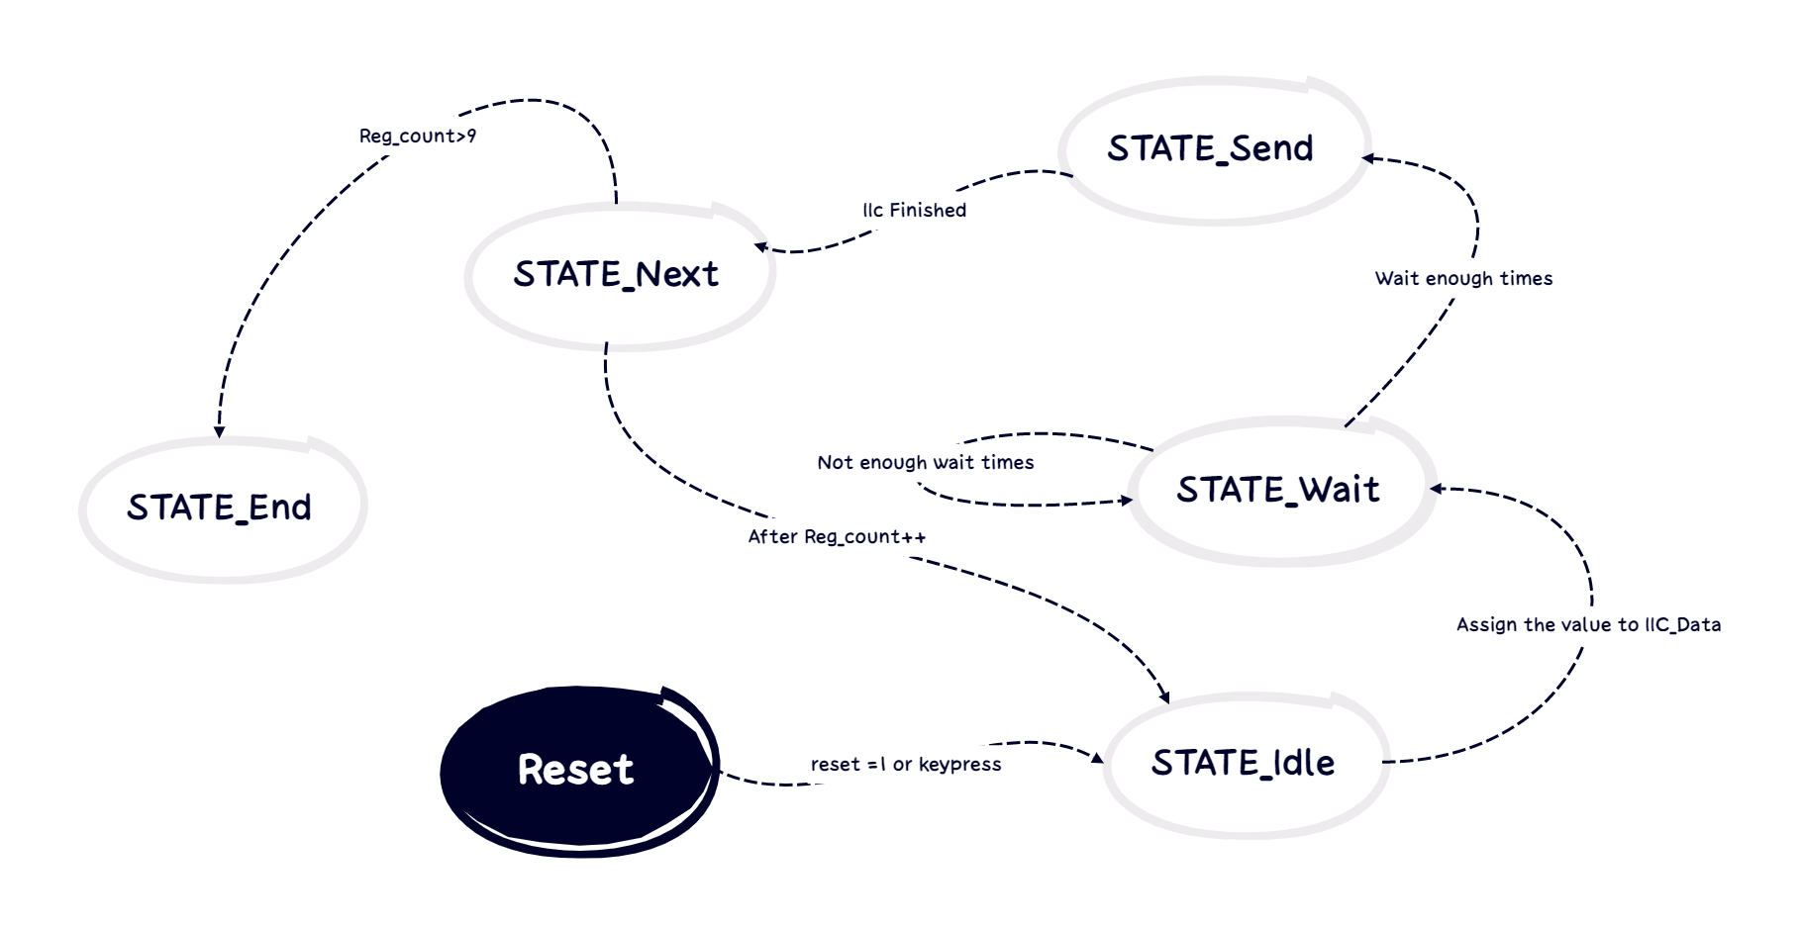

figure 16 State machine of WM8731 configuration register

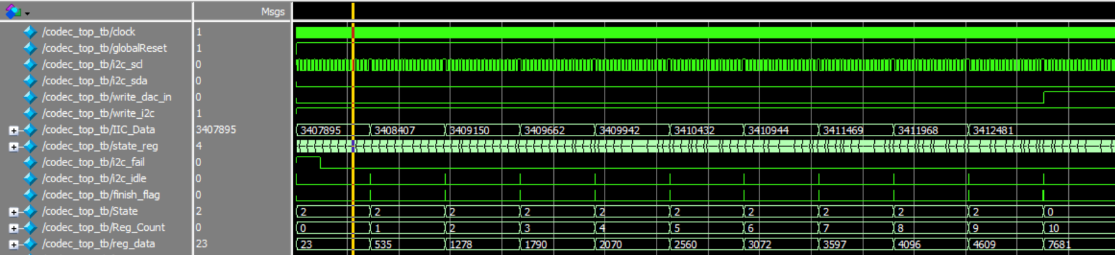

figure 17 codec_top.v testbench

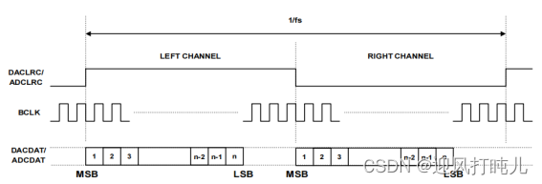

figure 18 IIS left aligned mode

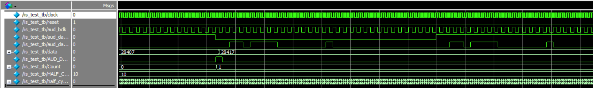

figure 19 iis_test.v testbench

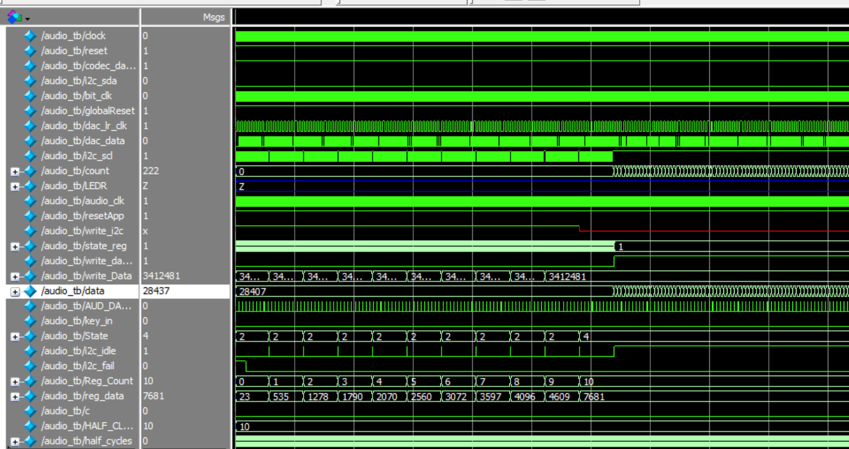

figure 20 avalon_audio.v testbench

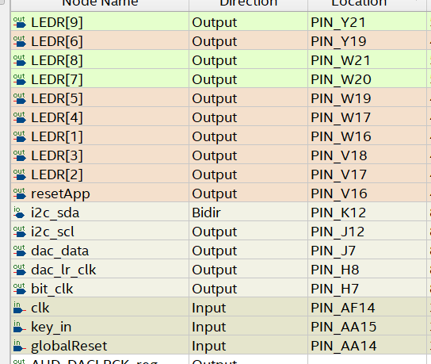

figure 21 Pin configuration

##### Module code

##### Hit.v

// Zhu Zhu

//21/04/2024

//Determine if our plane has been hit by an enemy missile.

//If our plane is hit by the enemy, 'check' returns 1.

module hit(

inputclk,

input[9:0] es_x,//The x-coordinates of the bullet fired by the enemy.

input[8:0] es_y,//The y-coordinates of the bullet fired by the enemy.

input[9:0] ms_x,// My planes's x-coordinate

input[8:0] ms_y,// My planes's y-coordinate

outputcheck

);//The initial input coordinate is the top left point of the plane.

//The size of our plane is 40x40.

//The coordinates of the bullet fired by the enemy.

reg [9:0] e_xbul;

reg [8:0] e_ybul;

//The coordinates of the center of my plane

reg [9:0] m_x;

reg [8:0] m_y;

reg in;

integer n;

always @(posedge clk) begin

e_xbul<=es_x;

e_ybul<=es_y;

m_x<=ms_x+20;

m_y<=ms_y+20;

in = 0;

n = 15;

//the bullet fired by the enemy has entered the range of our plane,

//which is roughly outlined as a rectangle.

if(e_xbul< m_x+19 && e_xbul>m_x-19 && e_ybul <m_y+19 && e_ybul >m_y-19) begin//in the square

//Exclude the blank areas of the two triangles at the top left and top right corners

//to prevent entries into these areas from being judged as collisions.

if(e_ybul<m_y) begin

if(e_xbul<m_x)begin

n= m_x- e_xbul + m_y- e_ybul;

end

else begin

n= e_xbul-m_x + m_y- e_ybul;

end

end

if(n<19) begin

in = 1;

end

end

end

assign check = in;

endmodule

/////////////////////////////////////////////////////////////////////////////////////////////////////////////////////////////////////

##### hit_tb

// Zhu Zhu

//21/04/2024

//Determine if our plane has been hit by an enemy missile.

//If our plane is hit by the enemy, 'check' returns 1.

//test bench

`timescale 1 ns/100 ps

module hit_tb;

//input signals

reg clk;

reg [9:0] es_x;//Enemy bullet's x-coordinate

reg [8:0] es_y;//Enemy bullet's y-coordinate

reg [9:0] ms_x;// My planes's x-coordinate

reg [8:0] ms_y;// My planes's y-coordinate

// Output Signals

wire check;

hit hit_dut (

.clk (clk),

.es_x (es_x),

.es_y (es_y),

.ms_x (ms_x),

.ms_y (ms_y),

.check (check)

);

//The size of the enemy bullet is: 1 .

//The size of our plane is 40x40.

integer n;

integer x;

integer y;

// Test Bench Logic

initial begin

clk = 1'b0; //Initialise the clock to zero.

end

initial begin

$display("%d ns\tSimulation Started",$time);

//$monitor("%d ns\t es_x=%d\t es_y=%d\t ms_x=%d\t ms_y=%d\t check=%d\t",$time,es_x,es_y,ms_x,ms_y,check);

for (x=0; x<80; x = x +1) begin

for (n=0; n<41; n = n +1) begin

for (y=0; y<80; y = y +1) begin

assign es_x = x;

assign es_y = y;

assign ms_x = n;

assign ms_y = n;

#1;

clk = ~clk;

end

end

end

$display("%d ns\tSimulation Finished",$time);

end

endmodule

/////////////////////////////////////////////////////////////////////////////////////////////////////////////////////////////////////

##### crash

// Zhu Zhu

//21/04/2024

//Determine if the local airplane has entered our airplane's judgment zone

//(mainly the top, left, and right are the three points).

//If one of the enemy plane's points enters, IsCrash returns 1.

module crash(

input clk,

input [9:0] e_x,//Enemy plane's x-coordinate

input [8:0] e_y,//Enemy plane's y-coordinate

input [9:0] mi_x,// My planes's x-coordinate

input [8:0] mi_y,// My planes's y-coordinate

output check

);//The initial input coordinate is the top left point of the plane.

//The size of the enemy plane is: 32 wide and 40 long.

//The size of our plane is 40x40.

reg in;

integer n;

integer x;

integer y;

//The leftmost point of the enemy plane

reg [9:0] e_xleft;

reg [8:0] e_yleft;

//The lowest point of the enemy plane

reg [9:0] e_xlow;

reg [8:0] e_ylow;

//The right most point of the enemy plane

reg [9:0] e_xright;

reg [8:0] e_yright;

//My planes

reg [9:0] m_x;

reg [8:0] m_y;

always @(posedge clk) begin

e_xleft <= e_x + 1;

e_yleft <= e_y + 15;

e_xlow <= e_x + 16;

e_ylow <= e_y + 39;

e_xright <= e_x + 31;

e_yright <= e_y + 15;

m_x <= mi_x + 20;

m_y <= mi_y + 20;

n=15;

x=15;

y=15;

in=0;

//The lowest point of the enemy plane has entered the range of our plane,

//which is roughly outlined as a rectangle.

if(e_xlow< m_x+19 && e_xlow>m_x-19 && e_ylow <m_y+19 && e_ylow >m_y-19) begin//in the square

//Exclude the blank areas of the two triangles at the top left and top right corners

//to prevent entries into these areas from being judged as collisions.

if(e_ylow<m_y) begin

if(e_xlow<m_x)begin

n= m_x- e_xlow + m_y- e_ylow;

end

else begin

n= e_xlow-m_x + m_y- e_ylow;

end

end

if(n<19) begin

in = 1;

end

end

//The leftest point of the enemy plane has entered the range of our plane,

if(e_xleft< m_x+19 && e_xleft>m_x-19 && e_yleft <m_y+19 && e_yleft >m_y-19) begin//in the square

//Exclude the blank areas of the triangles at the top left and top right corners

//to prevent entries into these areas from being judged as collisions.

if(e_yleft<m_y) begin

if(e_xleft<m_x)begin

x= m_x- e_xleft + m_y- e_yleft;

end

else begin

x= e_xleft-m_x + m_y- e_yleft;

end

end

if(x<19) begin

in = 1;

end

end

//The rightest point of the enemy plane has entered the range of our plane

if(e_xright< m_x+19 && e_xright>m_x-19 && e_yright <m_y+19 && e_yright >m_y-19) begin//in the square

//Exclude the blank areas of the two triangles at the top left and top right corners

//to prevent entries into these areas from being judged as collisions.

if(e_yleft<m_y) begin

if(e_xleft<m_x)begin

y= m_x- e_xright + m_y- e_yright;

end

else begin

y= e_xright-m_x + m_y- e_yright;

end

end

if(y<19) begin

in = 1;

end

end

end

assign check = in;

endmodule

/////////////////////////////////////////////////////////////////////////////////////////////////////////////////////////////////////

##### crash_tb

// Zhu Zhu

//21/04/2024

//Determine if the local airplane has entered our airplane's judgment zone

//(mainly the top, left, and right are the three points).

//If one of the enemy plane's points enters, IsCrash returns 1.

//test bench

`timescale 1 ns/100 ps

module crash_tb;

//input signals

reg clk;

reg [9:0] e_x;//Enemy plane's x-coordinate

reg [8:0] e_y;//Enemy plane's y-coordinate

reg [9:0] mi_x;// My planes's x-coordinate

reg [8:0] mi_y;// My planes's y-coordinate

// Output Signals

wire check;

crash crash_dut (

.clk (clk),

.e_x (e_x),

.e_y (e_y),

.mi_x (mi_x),

.mi_y (mi_y),

.check (check)

);

//The size of the enemy plane is: 32 wide and 40 long.

//The size of our plane is 40x40.

integer n;

integer x;

integer y;

// Test Bench Logic

initial begin

clk = 1'b0; //Initialise the clock to zero.

end

initial begin

$display("%d ns\tSimulation Started",$time);

$monitor("%d ns\t e_x=%d\t e_y=%d\t mi_x=%d\t mi_y=%d\t check=%d\t",$time,e_x,e_y,mi_x,mi_y,check);

for (x=0; x<50; x = x +1) begin

for (n=20; n<41; n = n +1) begin

for (y=0; y<50; y = y +1) begin

assign e_x = x;

assign e_y = y;

assign mi_x = n;

assign mi_y = n;

#5;

clk = ~clk;

end

end

end

$display("%d ns\tSimulation Finished",$time);

end

endmodule

/////////////////////////////////////////////////////////////////////////////////////////////////////////////////////////////////////

##### BCD

module BCD(

input wire [31:0] binary_input, // 32-bit binary input

output reg [39:0] bcd_output // BCD output (up to 10 decimal digits)

);

// Internal signal declaration

reg [31:0] shift_register; // Holds the binary number during processing

reg [3:0] digit[9:0]; // Array of BCD digits

integer i, j;

// Convert binary to BCD

always @(binary_input) begin

// Initialize the shift register and BCD digits

shift_register = binary_input;

for (j = 0; j < 10; j = j + 1) digit[j] = 4'd0;

// Loop to process each bit of the binary input

for (i = 0; i < 32; i = i + 1) begin

// Before shifting, apply the 'add-3' correction if any digit is 5 or more

for (j = 0; j < 10; j = j + 1) begin

if (digit[j] >= 5) digit[j] = digit[j] + 3;

end

// Shift all digits left by one

for (j = 9; j > 0; j = j - 1) begin

digit[j] = {digit[j][2:0], digit[j-1][3]};

end

digit[0] = {digit[0][2:0], shift_register[31]}; // Shift MSB of shift_register into LSB of the first BCD digit

// Shift the binary number left by one for the next iteration

shift_register = shift_register << 1;

end

// Combine all BCD digits into the output

for (j = 0; j < 10; j = j + 1) begin

bcd_output[j*4 +: 4] = digit[j];

end

end

endmodule

////////////////////////////////////////////////////////////////////////////////////////////////////

##### BCD_tb

`timescale 1ns / 1ps

module BCD_tb;

// Inputs

reg [31:0] binary_input;

// Outputs

wire [39:0] bcd_output;

// Instantiate the Unit Under Test (UUT)

BCD uut (

.binary_input(binary_input),

.bcd_output(bcd_output)

);

initial begin

// Initialize Inputs

binary_input = 0;

// Wait for global reset

#100;

// Add stimulus here

binary_input = 32'd0; // Test case 1: Minimum input

#10;

binary_input =196; // Test case 2: Normal input

#10;

binary_input = 10'd29; // Test case 3: Maximum input

#10;

binary_input = 10'd1; // Test case 4: Random input

#10;

// Complete the test

$display("Test completed");

$finish; // End simulation

end

endmodule

////////////////////////////////////////////////////////////////////////////////////////////////////

##### Seg7Device

module Seg7Device(

input clkIO,

input [31:0] data1, // 40-bit input for ten seven-segment displays (ten BCD digits)

output [6:0] HEX0, // Output for each of the seven segment displays (A-G)

output [6:0] HEX1,

output [6:0] HEX2,

output [6:0] HEX3,

output [6:0] HEX4

);

wire [39:0] data;

BCD uut1 (data1, data);

// Instantiate the Seg7Decode module for each digit

Seg7Decode seg7decoder0(

.hex(data[3:0]),

.pattern(HEX0)

);

Seg7Decode seg7decoder1(

.hex(data[7:4]),

.pattern(HEX1)

);

Seg7Decode seg7decoder2(

.hex(data[11:8]),

.pattern(HEX2)

);

Seg7Decode seg7decoder3(

.hex(data[15:12]),

.pattern(HEX3)

);

Seg7Decode seg7decoder4(

.hex(data[19:16]),

.pattern(HEX4)

);

endmodule

////////////////////////////////////////////////////////////////////////////////////////////////////

##### Seg7Decode

module Seg7Decode(

input [3:0] hex, // 4-bit Hexadecimal input

output reg [6:0] pattern// 7-segment pattern output (7 bits for A-G)

);

// Generate the pattern for 7-segment display based on the hexadecimal input

always @(hex) begin

case(hex)

4'h0: pattern = 7'b1000000; // 0

4'h1: pattern = 7'b1111001; // 1

4'h2: pattern = 7'b0100100; // 2

4'h3: pattern = 7'b0110000; // 3

4'h4: pattern = 7'b0011001; // 4

4'h5: pattern = 7'b0010010; // 5

4'h6: pattern = 7'b0000010; // 6

4'h7: pattern = 7'b1111000; // 7

4'h8: pattern = 7'b0000000; // 8

4'h9: pattern = 7'b0010000; // 9

4'hA: pattern = 7'b0001000; // A

4'hB: pattern = 7'b0000011; // B

4'hC: pattern = 7'b1000110; // C

4'hD: pattern = 7'b0100001; // D

4'hE: pattern = 7'b0000110; // E

4'hF: pattern = 7'b0001110; // F

default: pattern = 7'b1111111; // Off

endcase

end

endmodule

////////////////////////////////////////////////////////////////////////////////////////////////////

##### ShiftReg

module ShiftReg #(parameter WIDTH = 8)(

input clk, // Clock signal

input [WIDTH-1:0] pdata, // Parallel data input

output reg sout // Serial output

);

reg [WIDTH-1:0] shift_reg; // Internal shift register storage

// Move data on clock rising edge

always @(posedge clk) begin

shift_reg <= pdata; // Load parallel data into shift register

sout <= shift_reg[0]; // Output the lowest bit as serial data

shift_reg <= shift_reg >> 1; // Shift right

end

endmodule

////////////////////////////////////////////////////////////////////////////////////////////////////

##### Seg7Remap

module Seg7Remap(

input [47:0] I, // Input data, assuming 8 bits per segment display, total of 6 segment displays

output reg [47:0] O // Output data, remapped data

);

// Logic for data remapping

always @(I) begin

// For example, here simply reverse the order of each 8-bit data block

O[7:0] = I[7:0];

O[15:8] = I[15:8];

O[23:16] = I[23:16];

O[31:24] = I[31:24];

O[39:32] = I[39:32];

O[47:40] = I[47:40];

end

endmodule

////////////////////////////////////////////////////////////////////////////////////////////////////

##### Seg7Decode_tb

`timescale 1ns / 1ps

module Seg7Decode_tb;

// Inputs to the Device Under Test (DUT)

reg [3:0] data;

// Outputs from the DUT

wire [6:0] hex_pattern2;

Seg7Decode seg7decoder2(

.hex(data),

.pattern(hex_pattern2)

);

initial begin

// Initialize Inputs

data = 0;

#10;

// Initialize Inputs

data = 1;

#10;

// Initialize Inputs

data = 2;

#10;

// Initialize Inputs

data = 3;

#10;

// Initialize Inputs

data = 4;

#10;

// Initialize Inputs

data = 5;

#10;

end

endmodule

////////////////////////////////////////////////////////////////////////////////////////////////////

##### Seg7Device_tb

`timescale 1ns / 1ps

module Seg7Device_tb;

// Inputs to the Device Under Test (DUT)

reg clkIO;

reg [39:0] data; // Holds BCD values, not raw binary

// Outputs from the DUT

wire [6:0] HEX0, HEX1, HEX2, HEX3, HEX4;

// Instantiate the Unit Under Test (UUT)

Seg7Device uut2 (

.clkIO(clkIO),

.data1(data),

.HEX0(HEX0),

.HEX1(HEX1),

.HEX2(HEX2),

.HEX3(HEX3),

.HEX4(HEX4)

);

// Clock generation

initial begin

clkIO = 0;

forever #5 clkIO = ~clkIO; // Clock with a period of 10ns

end

// Test Stimuli

initial begin

$monitor("At time %t, HEX0 = %b, HEX1 = %b, HEX2 = %b, HEX3 = %b, HEX4 = %b",

$time, HEX0, HEX1, HEX2, HEX3, HEX4);

// Initialize Inputs

data = 0;

// Wait for the system to stabilize

#10;

// Simulate decimal inputs that are actually formatted as BCD

data = 1234; // Represents '1234' as BCD

#10;

data = 6789; // Represents '1234' as BCD

#10;

data = 3333; // Represents '1234' as BCD

#10;

data = 7040; // Represents '1234' as BCD

#10;

end

endmodule

////////////////////////////////////////////////////////////////////////////////////////////////////

##### switch

module switch(

input clk, // Clock signal

input rst, // Reset signal (active-high)

input [3:0] key_in, // Four user push-buttons input (active-low)

output reg [3:0] key_state, // Button state output

output reg ready // Data ready signal

);

// Constants for debounce timing

localparam DEBOUNCE_LIMIT = 100000; // Debounce time ~10 ms at 10 MHz clock

// Internal Registers

reg [19:0] debounce_counter = 0; // Counter for debounce

reg [3:0] key_state_next; // Next state of keys

reg ready_next; // Next state of ready signal

// Debounce logic

always @(posedge clk or posedge rst) begin

if (rst) begin

debounce_counter <= 0;

key_state <= 4'b1111; // Assuming active-low buttons, default state is high

ready <= 0;

end else begin

if (key_in != key_state) begin

// Increment debounce counter if keys are not stable

if (debounce_counter < DEBOUNCE_LIMIT) begin

debounce_counter <= debounce_counter + 1;

end else begin

// Update state after debounce time has passed

key_state <= key_in;

ready <= 1; // Indicate that the new key state is ready

debounce_counter <= 0; // Reset counter after state change

end

end else begin

// Reset debounce counter if input matches output

debounce_counter <= 0;

ready <= 0; // Clear ready signal until next change

end

end

end

endmodule

////////////////////////////////////////////////////////////////////////////////////////////////////

##### switch_tb

`timescale 1ns / 1ps

module switch_tb;

// Inputs to the switch module

reg clk;

reg rst;

reg [3:0] key_in;

// Outputs from the switch module

wire [3:0] key_state;

wire ready;

// Instantiate the switch module

switch uut (

.clk(clk),

.rst(rst),

.key_in(key_in),

.key_state(key_state),

.ready(ready)

);

// Clock generation with a compliant number of cycles

initial begin

clk = 0;

repeat (5000) #5 clk = ~clk; // Simulate the clock for 5000 cycles

end

// Test sequence

initial begin

// Initialize inputs

rst = 1; // Reset the system

key_in = 4'b1111; // All buttons released (active-low)

#20;

rst = 0; // Release reset

#20;

// Simulate each button being pressed and then released

press_and_release(4'b1110); // Press button 0

press_and_release(4'b1101); // Press button 1

press_and_release(4'b1011); // Press button 2

press_and_release(4'b0111); // Press button 3

// Finish the simulation

#100;

$finish;

end

// Task to simulate button press and release

task press_and_release;

input [3:0] button_state;

begin

key_in = button_state; // Press button

#50; // Wait for debounce plus some extra time

key_in = 4'b1111; // Release button

#50; // Wait for debounce reset

end

endtask

endmodule

////////////////////////////////////////////////////////////////////////////////////////////////////

##### test_switch

module test_switch(

input CLK_50, // On-board 50 MHz clock

input RESET_N, // On-board reset button, active low

input [3:0] KEY, // On-board user keys

output [6:0] HEX0, // Seven-segment display 0

output [6:0] HEX1, // Seven-segment display 1

output [6:0] HEX2, // Seven-segment display 2

output [6:0] HEX3 // Seven-segment display 3

);

wire [3:0] key_state; // Key state from the switch module

wire ready; // Data ready signal from the switch module

// Reset signal, as RESET_N on DE1-SoC is active low, we need to convert it to active high

wire rst = ~RESET_N;

// Instantiate the switch module

switch key_switch(

.clk(CLK_50),

.rst(rst),

.key_in(~KEY), // KEY button is active low, while assumed active high in the switch module

.key_state(key_state),

.ready(ready)

);

// Seven-segment decoder to display key_state

seg_decoder seg0(.bin(key_state[0]), .seg(HEX0));

seg_decoder seg1(.bin(key_state[1]), .seg(HEX1));

seg_decoder seg2(.bin(key_state[2]), .seg(HEX2));

seg_decoder seg3(.bin(key_state[3]), .seg(HEX3));

endmodule

// Simple binary to 7-segment display decoder

module seg_decoder(

input bin, // Input is a 1-bit binary number

output reg [6:0] seg // Seven-segment display output

);

always @(*) begin

case(bin)

1'b0: seg = 7'b1000000; // Display "0"

1'b1: seg = 7'b1111001; // Display "1"

default: seg = 7'b1000000; // Default to display "0"

endcase

end

endmodule

////////////////////////////////////////////////////////////////////////////////////////////////////

##### main

module main(

input clock,

//switch

input [8:0]SW,

//buttons

input [3:0] key_in,

//7Segment

output [6:0] hex0,

output [6:0] hex1,

output [6:0] hex2,

output [6:0] hex3,

output [6:0] hex4,

output [6:0] hex5,

//LED

output [8:0]ledData,

//LCD

outputresetAPP, //Application Reset

output[15:0] lcd_data, //LCD Data

outputlcd_cs_en, //LCD Chip Select Signal

outputlcd_rd_en, //

outputlcd_wr_en, //LCD Write Enable

outputlcd_rs, //LCD Registor Select Signal

outputlcd_reset_en, //LCD Reset Signal

outputlcd_On

);

reg[3:0] hp;

reg [31:0]scores;

initial begin

hp=3;

scores=32'd00000000;

end

hpToseg hptoseg(

.hex (hp),

.seg (hex5)

);

reg [31:0] clkdiv;

wire clk,clk_cover;

wire rstn = key_in[3];

reg cover;

reg finish;

reg spark;

initial begin

cover=0;

finish=0;

end

assign clk= clock&cover;

assign clk_cover=clock&(~cover)&(~finish);

reg[18:0] first;

wire[11:0] spo_first;

//clock dividers

always@(posedge clock)begin

clkdiv <= clkdiv+1'b1;

end

wire [8:0] SW_OK;

wire [39:0] segTestData;

wire [3:0] segOut;

//Used to detect if an enemy aircraft has hit our aircraft.

wire check;

wire check1;

wire check2;

wire check3;

//Used to detect if our aircraft has been hit by enemy artillery shells

wire hit_check;

wire hit_check1;

wire hit_check2;

wire hit_check3;

// Game End Conditions

always@(posedge clock)begin

if( hp > 0 ) begin

finish=(check | check1 | check2 | check3 );

end else begin

finish = 1;

end

end

reg[9:0] blood_x;

reg[9:0] blood_x1;

reg[9:0] blood_x2;

reg[8:0] blood_y;

reg[8:0] MyP_x;

reg[8:0] myplan_x;

reg[8:0] g_x; //gameover x- coordary

reg[8:0] g_y; //gameover y- coordary

reg[8:0] e_x;

reg[8:0] e_x1;

reg[8:0] e_x2;

reg[8:0] e_x3;

reg[8:0] e_y;

reg[8:0] e_y1;

reg[8:0] e_y2;

reg[8:0] e_y3;

reg[8:0] eb_x; //enermy bullet x- coordary

reg[8:0] eb_y; //enermy bullet y- coordary

reg[8:0] eb_x1;

reg[8:0] eb_y1;

reg[8:0] eb_x2;

reg[8:0] eb_y2;

reg[8:0] eb_x3;

reg[8:0] eb_y3;

reg[8:0] eb_x4;

reg[8:0] eb_y4;

reg[8:0] myb1_x;

reg[8:0] myb1_y;

reg[8:0] myb2_x;

reg[8:0] myb2_y;

reg[8:0] myb3_x;

reg[8:0] myb3_y;

reg[8:0] bo_x;

reg[8:0] bo_y;

reg[8:0] bo_x1;

reg[8:0] bo_y1;

reg[8:0] bo_x2;

reg[8:0] bo_y2;

reg[8:0] bo_x3;

reg[8:0] bo_y3;

/*reg [9:0] bullet_x = player_x; // Bullet x-coordinate

reg [8:0] bullet_y = player_y; // Bullet y-coordinate

reg[99:0] B_xl; //100

reg[89:0] B_yl; //100

*/

reg[8:0] BG_Y; //background

reg[5:0] Counter; //number of plane hit

reg[5:0] Counter1;

reg[5:0] Counter2;

reg[5:0] Counter3;

reg[5:0] Counter4;

reg flash; //plane flash

integer i=0;

integer cnt=0;

integer count = 0;

integer j=0;

integer j1=0;

integer j2=0;

integer j3=0;

integer j4=0;

localparam Left = 15;

localparam Right = 60;

localparam Ini = 9'b111_111_111; //bullet initial at ini

localparam Zero = 6'b000_000; //the state of plane which not be fired

localparam Height = 320;

//Call Whether our aircraft was hit by a local aircraft Module

crash modu(clock, e_x, e_y, MyP_x, MyP_y , check);

crash modu1(clock, e_x1, e_y1, MyP_x, MyP_y , check1);

crash modu2(clock, e_x2, e_y2, MyP_x, MyP_y , check2);

crash modu3(clock, e_x3, e_y3, MyP_x, MyP_y , check3);

//Call Our Aircraft Call Whether our aircraft has been hit by enemy aircraft missiles Module

hit hit (clock, eb_x, eb_y, MyP_x, MyP_y , hit_check);

hit hit1(clock, eb_x1,eb_y1, MyP_x, MyP_y , hit_check1);

hit hit2(clock, eb_x2,eb_y2, MyP_x, MyP_y , hit_check2);

hit hit3(clock, eb_x3,eb_y3, MyP_x, MyP_y , hit_check3);

always @(posedge clock)begin

if(flash == 1)begin

myplan_x<=MyP_x;

end else begin

myplan_x <= Ini;

end

if(cover==0) begin

BG_Y<=0;

end else begin

if(BG_Y<480&&finish==0) begin

BG_Y<=BG_Y+1;

end else if(BG_Y>=480&&finish==0) begin

BG_Y<=0;

end

end

end

always@(posedge clock)begin

if (cover == 0) begin

//Enemy aircraft initialization

e_x <= 3;

e_x1 <= 63;

e_x2 <= 123;

e_x3 <= 183;

//Initialize enemy bullet

eb_x = 19;

eb_x1= 79;

eb_x2= 139;

eb_x3= 199;

eb_y = Ini;

eb_y1= Ini;

eb_y2= Ini;

eb_y3= Ini;

//initialize boom

bo_x <=100;

bo_y <=Ini;

bo_x1 <=200;

bo_y1 <=Ini;

bo_x2 <=300;

bo_y2 <=Ini;

bo_x3 <=400;

bo_y3 <=Ini;

//initialize gameover coordinate

g_x <=100;

g_y <=140;

//blood

hp=3;

blood_x = 65;

blood_x1 =85;

blood_x2 =105;

blood_y = 410;

// Initialize the bullet where it cannot be seen on the screen

myb1_x <= Ini;

myb2_x <= Ini;

myb3_x <= Ini;

myb1_y <= Ini;

myb2_y <= Ini;

myb3_y <= Ini;

//Initialize

Counter =Zero;

Counter1 = Zero;

Counter2 = Zero;

Counter3 = Zero;

Counter4 = Zero;

//initialize socres

scores=32'd00000001;

if(count<100) begin

count = count + 1;

if(count <50) begin

spark =1;

end else begin

spark =0;

end

end else begin

count = 0;

end

end

else begin

if (finish==0)begin

cnt=0;

i=i+1;

flash = 1;

if(i==30) begin

i=0;

end

case(i)

0:begin

if(myb1_y<0 || myb1_y>Height) begin

myb1_x <= MyP_x +16;

myb1_y <= MyP_y -1;

end

end

10:begin

if(myb1_y<0 || myb1_y>Height) begin

myb2_x <= MyP_x +16;

myb2_y <= MyP_y -1;

end

end

20:begin

if(myb1_y<0 || myb1_y>Height) begin

myb3_x <= MyP_x +16;

myb3_y <= MyP_y -1;

end

end

endcase

//Aircraft spawn & enemy shells spawn

if( clkdiv[20:13]==0 && e_y>Height) begin

e_y<=0;

if(eb_y >Height) begin

eb_y = 45;

end

end

if( clkdiv[17:10]==50 && e_y1>Height) begin

e_y1<=0;

if(eb_y1 >Height) begin

eb_y1 = 30;

end

end

if( clkdiv[19:12]==100 && e_y2>Height) begin

e_y2<=0;

if(eb_y2 >Height) begin

eb_y2 = 13;

end

end

if( clkdiv[18:11]==150 && e_y3>Height) begin

e_y3<=0;

if(eb_y3 >Height) begin

eb_y3 = 27;

end

end

//bullet fly

if(eb_y < Height+1) begin

if(hit_check==0) begin

eb_y = eb_y +10;

end

else begin

eb_y =Ini;

hp = hp - 1;

end

end

if(eb_y1 < Height+1) begin

if(hit_check1==0) begin

eb_y1 = eb_y1 +10;

end else begin

eb_y1 =Ini;

hp = hp - 1;

end

end

if(eb_y2 < Height+1) begin

if(hit_check2==0) begin

eb_y2 = eb_y2 +10;

end else begin

eb_y2 =Ini;

hp = hp - 1;

end

end

if(eb_y3 < Height+1) begin

if(hit_check3==0)begin

eb_y3 = eb_y3 +10;

end else begin

eb_y3 =Ini;

hp = hp -1;

end

end

//Enemy aircraft status detection 0

if(Counter >=3)begin

bo_y <= e_y;

if(j<6) begin

j=j+1;

end else begin

bo_y <= Ini;

e_y <=Ini;

Counter =0;

scores=scores+100;

j=0;

end

end else if(e_y< Ini && Counter <3)begin

e_y<=e_y+5;

end

//Enemy aircraft status detection 1

if(Counter1 >=3)begin

bo_y1 <= e_y1;

if(j1<6) begin

j1=j1+1;

end else begin

bo_y1 <= Ini;

e_y1 <=Ini;

Counter1 =0;

scores=scores+100;

j1=0;

end

end else if(e_y1< Ini && Counter1 <3) begin

e_y1<=e_y1+5;

end

//Enemy aircraft status detection 2

if(Counter2 >=3)begin

bo_y2 <= e_y2;

if(j2<6) begin

j2=j2+1;

end else begin

bo_y2 <= Ini;

e_y2 <=Ini;

Counter2 =0;

scores=scores+100;

j2=0;

end

end else if(e_y2< Ini && Counter2 <3) begin

e_y2<=e_y2+5;

end

//Enemy aircraft status detection 3

if(Counter3 >=3)begin

bo_y3 <= e_y3;

if(j3<6) begin

j3=j3+1;

end else begin

bo_y3 <= Ini;

e_y3 <=Ini;

Counter3 =0;

scores=scores+100;

j3=0;

end

end else if(e_y3< Ini && Counter3 <3) begin

e_y3<=e_y3+5;

end

if(myb1_y<9'b111_111_100)begin

if(myb1_y<=3)begin

myb1_y <= Ini;

end else if((MyP_y>e_y)&&(myb1_x<e_x+32 && myb1_x>e_x)&& (myb1_y<e_y+40)) begin

Counter = Counter +1;

myb1_y <= Ini;

end else if((MyP_y>e_y1)&&(myb1_x<e_x1+32 && myb1_x>e_x1)&& (myb1_y<e_y1+40)) begin

Counter1 = Counter1 +1;

myb1_y <= Ini;

end else if((MyP_y>e_y2)&&(myb1_x<e_x2+32 && myb1_x>e_x2)&& (myb1_y<e_y2+40)) begin

Counter2 = Counter2 +1;

myb1_y <= Ini;

end else if((MyP_y>e_y3)&&(myb1_x<e_x3+32 && myb1_x>e_x3)&& (myb1_y<e_y3+40)) begin

Counter3 = Counter3 +1;

myb1_y <= Ini;

end else begin

myb1_y<=myb1_y-9'd6;

end

end

if(myb2_y<9'b111_111_100)begin

if(myb2_y<=3)begin

myb2_y <= Ini;

end else if((MyP_y>e_y)&&(myb2_x<e_x+32 && myb2_x>e_x)&& (myb2_y<e_y+40)) begin

Counter = Counter +1;

myb2_y <= Ini;

end else if((MyP_y>e_y1)&&(myb3_x<e_x1+32 && myb2_x>e_x1)&& (myb2_y<e_y1+40)) begin

Counter1 = Counter1 +1;

myb2_y <= Ini;

end else if((MyP_y>e_y2)&&(myb2_x<e_x2+32 && myb2_x>e_x2)&& (myb2_y<e_y2+40)) begin

Counter2 = Counter2 +1;

myb2_y <= Ini;

end else if((MyP_y>e_y3)&&(myb2_x<e_x3+32 && myb2_x>e_x3)&& (myb2_y<e_y3+40)) begin

Counter3 = Counter3 +1;

myb2_y <= Ini;

end else begin

myb2_y<=myb2_y-9'd6;

end

end

if(myb3_x<9'b111_111_100)begin

if(myb3_x<=3)begin

myb3_x <= Ini;

end else if((MyP_y>e_y)&&(myb3_x<e_x+32 && myb3_x>e_x)&& (myb3_x<e_y+40)) begin

Counter = Counter +1;

myb3_x <= Ini;

end else if((MyP_y>e_y1)&&(myb3_x<e_x1+32 && myb3_x>e_x1)&& (myb3_x<e_y1+40)) begin

Counter1 = Counter1 +1;

myb3_x <= Ini;

end else if((MyP_y>e_y2)&&(myb3_x<e_x2+32 && myb3_x>e_x2)&& (myb3_x<e_y2+40)) begin

Counter2 = Counter2 +1;

myb3_x <= Ini;

end else if((MyP_y>e_y3)&&(myb3_x<e_x3+32 && myb3_x>e_x3)&& (myb3_x<e_y3+40)) begin

Counter3 = Counter3 +1;

myb3_x <= Ini;

end else begin

myb3_x<=myb3_x-9'd6;

end

end

end// end if row:320

else begin

if(cnt < 200)begin

cnt=cnt+1;

if(cnt <50) begin

flash =0;

end else if(cnt <100) begin

flash = 1;

end else if(cnt <150) begin

flash = 0;

end else begin

flash =1;

end

end

end

end

end

//////////////////////////end////////////

wire [3:0] data_out;

wire ready;

switch key(

.clk (clock),

.rst (SW[8]),

.key_in (key_in),

.key_state (data_out),

.ready(ready)

);

always@(posedge clock)begin

if(cover==0) begin

MyP_x <=120;

if(data_out[3]==1'b0)begin

if(data_out[3]==4'b1101)begin

cover=1;

end

end

end

else begin

if(data_out[3]==1'b0)begin

if(finish ==0) begin

if(data_out[3]==4'b1011&&MyP_x>6) begin

MyP_x <= MyP_x - 10'd5;

end if(data_out[3]==4'b0111&&MyP_x<200) begin

MyP_x <= MyP_x + 10'd5;

end if(data_out[3]==4'b1110 )begin

//MyP_y <= MyP_y - 9'd5;

end

end else begin

if(data_out[3]==4'b1101)begin

cover = 0;

end

end

end

end

end

AntiJitter #(4) a0[8:0] (

.clk (clkdiv[8]),

.I(SW),

.O(SW_OK)

);

Seg7Device seg7device(

.clkIO (clock),

.data1 (scores),

.HEX0 (hex0), // Output for each of the seven segment displays

.HEX1 (hex1),

.HEX2 (hex2),

.HEX3 (hex3),

.HEX4 (hex4)

);

LCD_top lcd1(

.clock (clock),

.globalReset (SW[8]),

.resetApp (resetAPP),

.my_flighter_in_xAddr (myplan_x),

.my_bullet1_in_xAddr (myb1_x),

.my_bullet2_in_xAddr (myb2_x),

.my_bullet3_in_xAddr (myb3_x),

.my_bullet1_in_yAddr (myb1_y),

.my_bullet2_in_yAddr (myb2_y),

.my_bullet3_in_yAddr (myb3_y),

.e_flighter1_in_yAddr (e_x),

.e_flighter2_in_yAddr (e_x2),

.e_flighter3_in_yAddr (e_x3),

.e_flighter4_in_yAddr (e_x4),

.e_bullet1_in_xAddr (eb_x),

.e_bullet2_in_xAddr (eb_x1),

.e_bullet3_in_xAddr (eb_x2),

.e_bullet4_in_xAddr (eb_x3),

.e_bullet1_in_yAddr (eb_y),

.e_bullet2_in_yAddr (eb_y1),

.e_bullet3_in_yAddr (eb_y2),

.e_bullet4_in_yAddr (eb_y3),

.LCD_Data (lcd_data),

.LCD_CS_n (lcd_cs_en),

.LCD_Rd_n (lcd_rd_en),

.LCD_Wr_n (lcd_wr_en),

.LCD_RS (lcd_rs),

.LCD_Reset_n (lcd_reset_en),

.LCD_CDOn (lcd_On)

);

/*

BCD b9(

.binary_input (scores),

.bcd_output (BCD)

);

assign segTestData = BCD;

*/

assign ledData = SW;

endmodule

////////////////////////////////////////////////////////////////////////////////////////////////////

##### main_tb

`timescale 1ns / 1ps

module main_tb;

// Inputs

reg clock;

reg [8:0] SW;

reg [3:0] key_in;

// Outputs

wire [6:0] hex0, hex1, hex2, hex3, hex4, hex5;

wire [8:0] ledData;

wire resetAPP;

wire [15:0] lcd_data;

wire lcd_cs_en, lcd_rd_en, lcd_wr_en, lcd_rs, lcd_reset_en, lcd_On;

// Instantiate the Unit Under Test (UUT)

main uut (

.clock(clock),

.SW(SW),

.key_in(key_in),

.hex0(hex0),

.hex1(hex1),

.hex2(hex2),

.hex3(hex3),

.hex4(hex4),

.hex5(hex5),

.ledData(ledData),

.resetAPP(resetAPP),

.lcd_data(lcd_data),

.lcd_cs_en(lcd_cs_en),

.lcd_rd_en(lcd_rd_en),

.lcd_wr_en(lcd_wr_en),

.lcd_rs(lcd_rs),

.lcd_reset_en(lcd_reset_en),

.lcd_On(lcd_On)

);

// Clock generation

initial begin

clock = 0;

forever #5 clock = ~clock; // Generate a clock with a period of 10ns

end

// Test stimulus

initial begin

// Initialize inputs

SW = 9'b0;

key_in = 4'b1111; // Assuming active low buttons

// Reset the system

SW[8] = 1; // Assuming SW[8] is reset

#50;

SW[8] = 0;

#50;

// Simulate button presses

key_in = 4'b1110; // Press button 0

#10;

key_in = 4'b1101; // Press button 1

#10;

key_in = 4'b1011; // Press button 2

#10;

key_in = 4'b0111; // Press button 3

#10;

key_in = 4'b1111; // Release all buttons

#100;

// Observe HEX outputs for each button press

$display("HEX0: %b, HEX1: %b, HEX2: %b, HEX3: %b, HEX4: %b, HEX5: %b", hex0, hex1, hex2, hex3, hex4, hex5);

// Stop simulation

$stop;

end

endmodule

////////////////////////////////////////////////////////////////////////////////////////////////////

//// Reference: This code is from our FPGA class ////

##### LCD_Display

`define CLOG2(x) \

(x <= 2) ? 1 : \

(x <= 4) ? 2 : \

(x <= 8) ? 3 : \

(x <= 16) ? 4 : \

(x <= 32) ? 5 : \

(x <= 64) ? 6 : \

(x <= 128) ? 7 : \

(x <= 256) ? 8 : \

(x <= 512) ? 9 : \

(x <= 1024) ? 10 : \

(x <= 2048) ? 11 : \

(x <= 4096) ? 12 : \

(x <= 8192) ? 13 : \

(x <= 16384) ? 14 : \

(x <= 32768) ? 15 : \

(x <= 65536) ? 16 : \

(x <= 131072) ? 17 : \

(x <= 262144) ? 18 : \

(x <= 524288) ? 19 : \

(x <= 1048576) ? 20 : \

(x <= 2097152) ? 21 : \

(x <= 4194304) ? 22 : \

(x <= 8388608) ? 23 : \

(x <= 16777216) ? 24 : \

-1 //This one will trigger compiler error.

(* altera_attribute = "-name MESSAGE_DISABLE 10030" *)

module LCD_Display #(

parameter CLOCK_FREQ = 50000000,

parameter WIDTH = 240,

parameter HEIGHT = 320,

parameter XBITS = `CLOG2(WIDTH),

parameter YBITS = `CLOG2(HEIGHT)

)(

input clock,

input globalReset,

output resetApp,

input [XBITS-1:0] xAddr,

input [YBITS-1:0] yAddr,

input [ 15:0] pixelData,

input pixelWrite,

output reg pixelReady,

input pixelRawMode,

input [ 7:0] cmdData,

input cmdWrite,

input cmdDone,

output reg cmdReady,

output LT24Wr_n,

output LT24Rd_n,

output LT24CS_n,

output LT24RS,

output LT24Reset_n,

output [ 15:0] LT24Data,

output LT24LCDOn

);

assign LT24LCDOn = 1'b1; //Backlight always on.

wire [15:0] LCD_Data;

wire reset; //Synchronised Reset

ResetSynchroniser resetGen (

.clock (clock ), //Global clock

.resetIn (globalReset), //Global reset

.resetOut(reset ) //Synchronised reset

);

reg [6:0] initDataRomAddr;

wire [6:0] initRomMaxAddr;

wire [8:0] initData;

LT24InitialData #(

.WIDTH(WIDTH),

.HEIGHT(HEIGHT)

) initDataRom (

.clock (clock ),

.addr (initDataRomAddr),

.initData(initData ),

.maxAddr (initRomMaxAddr )

);

/*

* State Machine for display interface

*/

reg displayInitialised;

wire displayReady;

reg displayRegSelect;

reg [15:0] displayData;

reg displayWrite;

reg [15:0] xAddrTemp; //Temp address registers are 16 bits wide so that address is correctly

reg [15:0] yAddrTemp; //padded for sending to the LT24 display.

reg [15:0] pixelDataTemp;

//State Machine

reg [3:0] stateMachine;

//General States

localparam INIT_STATE = 4'b0000; //Display Initialisation

localparam LOAD_STATE = 4'b0001; //Load Initialisation Data

localparam IDLE_STATE = 4'b1111; //Idle

//Pixel Write States

localparam CASET_STATE = 4'b1110; //Column Select

localparam XHADDR_STATE = 4'b1101; //Load X-High Address

localparam XLADDR_STATE = 4'b1100; //Load X-Low Address

localparam PASET_STATE = 4'b1011; //Row Select

localparam YHADDR_STATE = 4'b1010; //Load Y-High Address

localparam YLADDR_STATE = 4'b1001; //Load Y-Low Address

localparam WRITE_STATE = 4'b1000; //Memory Write Enable

//Command Write States

localparam CMD_STATE = 4'b0111; //Send command

//State Machine Code

always @ (posedge clock or posedge reset) begin

if (reset) begin

displayRegSelect <= 1'b1;

displayData <= 16'b0;

displayWrite <= 1'b0;

displayInitialised <= 1'b0;

initDataRomAddr <= 7'b0;

cmdReady <= 1'b0; //Not ready for a command

pixelReady <= 1'b0; //Not ready for data

stateMachine <= INIT_STATE; //Come out of reset into initial state

end else begin

case (stateMachine)

INIT_STATE: begin //Power on state - initialise pins

displayInitialised <= 1'b0; //Display not yet initialised

initDataRomAddr <= 7'b0; //Set initial ROM address one cycle early

stateMachine <= LOAD_STATE; //Begin load of ROM data into LT24

end

LOAD_STATE: begin //Load the initialisation data

if (displayReady) begin //Load next cycle when display is ready

//Send initialisation command/data for previous address. (ROM has one cycle latency)

displayData <= {8'hFF,initData[7:0]}; //Repackage ROM payload

displayRegSelect <= initData[8];//Select command or data

displayWrite <= 1'b1; //Issue a write

//Prepare next address and state

if (initDataRomAddr < initRomMaxAddr) begin

//If we have not yet sent all ROM data

initDataRomAddr <= initDataRomAddr + 7'b1; //Increment to address

end else begin

//Otherwise all initialisation data has been loaded

stateMachine <= IDLE_STATE; //Move to Idle state to await commands.

end

end

end

IDLE_STATE: begin

displayInitialised <= 1'b1; //Display is fully initialised once in Idle state.

if (displayReady && cmdWrite) begin

//If command write requested (this has priority)

cmdReady <= 1'b1; //Accepted command

pixelReady <= 1'b0; //Not ready for data

//Issue first write in sequence

displayData <= {8'b0,cmdData};//Load command data onto display output

displayWrite <= 1'b1; //Issue a write

displayRegSelect <= 1'b0; //Loading a command word

stateMachine <= CMD_STATE; //Jump to command state for payload

end else if (displayReady && pixelWrite) begin

//Otherwise if pixel write requested

cmdReady <= 1'b0;//Not ready for a command

pixelReady <= 1'b1; //Accepted data

//Backup pixel information for later in the state machine

xAddrTemp <= {{(16-XBITS){1'b0}},xAddr}; //Store the current x

yAddrTemp <= {{(16-YBITS){1'b0}},yAddr}; //and y addresses

pixelDataTemp <= pixelData; //Store the current pixel data

if (pixelRawMode) begin

//If in raw pixel mode, just load the data

displayRegSelect<= 1'b1; //Loading a pixel data word

displayData <= pixelData; //Load raw pixel data

end else begin

//If in normal mode, go through setting of X-Y coordinates.

displayRegSelect<= 1'b0;//Loading a command word

displayData <= 16'h2A; //Load CASET command onto display output

stateMachine <= CASET_STATE; //Jump to CASET state

end

//Issue first write in sequence

displayWrite <= 1'b1; //Issue a write

end else begin

//Otherwise we are not ready until an access is requested

cmdReady <= 1'b0; //Not ready for a command

pixelReady <= 1'b0; //Not ready for data

displayWrite <= 1'b0; //Don't perform write while in Idle

end

end

CMD_STATE: begin

cmdReady <= displayReady; //Control flow of data into command port based on when display is ready

if (displayReady && cmdWrite) begin

//If additional payload, load next byte

displayData <= {8'b0,cmdData}; //Load command data onto display output

displayWrite <= 1'b1; //Issue a write

if (cmdDone) begin

//If this is the last command, go to cleanup state

stateMachine <= IDLE_STATE;

end

end else begin

displayWrite <= 1'b0; //Write done

end

end

CASET_STATE: begin //Column Select

pixelReady <= 1'b0; //Not ready for next pixel.

if (displayReady) begin

//Once the display is ready for next transfer

displayRegSelect <= 1'b1; //Next display write is a payload

displayData <= {8'b0,xAddrTemp[15:8]};//Load X-High payload onto display output

displayWrite <= 1'b1; //Issue a write

stateMachine <= XHADDR_STATE; //Next payload will be X-High

end

end

XHADDR_STATE: begin //Load X-High Address

if (displayReady) begin

//Once the display is ready for next transfer

displayRegSelect <= 1'b1; //Next display write is a payload

displayData <= {8'b0,xAddrTemp[7:0]}; //Load X-Low payload onto display output

displayWrite <= 1'b1; //Issue a write

stateMachine <= XLADDR_STATE; //Next payload will be X-Low

end

end

XLADDR_STATE: begin //Load X-Low Address

if (displayReady) begin

//Once the display is ready for next transfer

stateMachine <= PASET_STATE; //Next command will be PASET

displayRegSelect <= 1'b0; //Next display write is a command

displayData <= 16'h2B; //Load PASET command onto display output

displayWrite <= 1'b1; //Issue a write

end

end

PASET_STATE: begin //Row Select

if (displayReady) begin

//Once the display is ready for next transfer

stateMachine <= YHADDR_STATE; //Next payload will be Y-High

displayRegSelect <= 1'b1; //Next display write is a payload

displayData <= {8'b0,yAddrTemp[15:8]}; //Load Y-High payload onto display output

displayWrite <= 1'b1; //Issue a write

end

end

YHADDR_STATE: begin //Load Y-High Address

if (displayReady) begin

//Once the display is ready for next transfer

stateMachine <= YLADDR_STATE; //Next payload will be Y-Low

displayRegSelect <= 1'b1; //Next display write is a payload

displayData <= {8'b0,yAddrTemp[7:0]}; //Load Y-Low payload onto display output

displayWrite <= 1'b1; //Issue a write

end

end

YLADDR_STATE: begin //Load Y-Low Address

if (displayReady) begin

//Once the display is ready for next transfer

stateMachine <= WRITE_STATE; //Next command will be Memory Write

displayRegSelect <= 1'b0; //Next display write is a command

displayData <= 16'h2C; //Load WRITE command onto display output

displayWrite <= 1'b1; //Issue a write

end

end

WRITE_STATE: begin //Memory Write Enable

if (displayReady) begin

//Once the display is ready for next transfer

stateMachine <= IDLE_STATE; //Next payload will be Pixel Data and we are done.

displayRegSelect <= 1'b1; //Next display write is pixel data

displayData <= pixelDataTemp;//Load pixel data onto display output

displayWrite <= 1'b1; //Issue a write

end

end

default: begin

stateMachine <= INIT_STATE; //If something goes wrong, reinit the display.

end

endcase

end

end

//Hold application in reset until display initialised.

assign resetApp = reset || !displayInitialised;

/*

* Generate interface signals for LT24

*/

LT24DisplayInterface #(

.CLOCK_FREQ(CLOCK_FREQ)

) LT24Interface (

//Clock/Reset

.clock (clock ), //Global clock

.reset (reset ), //Synchronised reset

//FPGA Display Interface

.regSelect (displayRegSelect),

.data (displayData ),

.write (displayWrite ),

.ready (displayReady ),

//LT24 Interface

.LCD_Wr_n (LCD_Wr_n ),

.LCD_Rd_n (LCD_Rd_n ),

.LCD_CS_n (LCD_CS_n ),

.LCD_RS (LCD_RS ),

.LCD_Reset_n(LCD_Reset_n ),

.LCD_Data (LCD_Data)

);

endmodule

/*

* LT24 Display Interface

* --------------------------------

* Generates transations on the LT24 display interface to

* send data or commands.

*

* The FPGA interface signals should not change while ready is 0

*/

module LT24DisplayInterface #(

parameter CLOCK_FREQ = 64'd50000000

)(

input clock,

input reset,

//FPGA Interface

input regSelect, //1 = Pixel Data, 0 = Command

input [15:0]data,

input write, //Assert for 1 cycle to initialise write

output ready, //Indicates the LCD is ready to receive data/command

//LCD Interface

output LCD_Wr_n,

output LCD_Rd_n,

output LCD_CS_n,

output LCD_RS,

output [15:0] LCD_Data,

output LCD_Reset_n

);

/*

* Reset pause timing

*/

//Determine requirements for power on reset

`ifdef MODEL_TECH //For Simulation

localparam RESETTIME = 64'd0; //ms - Skip delay during simulation.

`else //For Synthesis

localparam RESETTIME = 64'd120; //ms - 120ms is required by display

`endif //End preprocessor block

localparam RESETCOUNT = (RESETTIME * CLOCK_FREQ) / 64'd1000;

localparam RESETBITS = `CLOG2(RESETCOUNT+1); //The +1 ensures we always have room for counter to == RESETCOUNT

//These help make parameterised widths easier.

localparam ZERO = 0;

localparam ONE = 1;

//Reset delay counter

reg [RESETBITS-1:0] counter;

always @ (posedge clock or posedge reset) begin

if (reset) begin

counter <= ZERO[RESETBITS-1:0]; //Initially counter is zero

end else if (counter < RESETCOUNT) begin //Once we are out of reset

//If we haven't had a long enough reset pause

counter <= counter + ONE[RESETBITS-1:0]; //Increment counter

end

end

/*

* Write control

*/

//Writes take two cycles, so track second cycle.

reg writeDly = 1'b0;

always @ (posedge clock) begin

writeDly <= write && !writeDly;

end

//Assert ready after the reset pause and when we are not in the first write cycle

assign ready = !(counter < RESETCOUNT) && !(write && !writeDly);

/*

* External interface

*/

assign LCD_CS_n = 1'b0;

assign LCD_Rd_n = 1'b1;

assign LCD_Data = data;

assign LCD_RS = regSelect;

assign LCD_Wr_n = writeDly;

assign LCD_Reset_n = !reset;

endmodule

/*

* Simple Reset Synchroniser

* --------------------------------

* This will generate a few clock cycle reset at power on

* or when the input reset is asserted.

*/

module ResetSynchroniser (

input clock,

input resetIn,

output resetOut

);

//Reset synchroniser to avoid metastability if external push-button used

reg [3:0] resetSync = 4'hF;

always @ (posedge clock or posedge resetIn) begin

if (resetIn) begin

resetSync <= 4'hF; //Assert reset asynchronously

end else begin

resetSync <= {resetSync[2:0],1'b0}; //Deassert reset synchronously

end

end

assign resetOut = resetSync[3];

endmodule

/*

* Initialisation Data Lookup Table

* --------------------------------

* Contains initialisation data for LT24 Display

*/

module LT24InitialData #(

parameter WIDTH = 240,

parameter HEIGHT = 320

)(

input clock,

input [6:0] addr,

output reg [8:0] initData,

output [6:0] maxAddr

);

localparam MAX_X_PIXEL = WIDTH - 1;

localparam MAX_Y_PIXEL = HEIGHT - 1;

localparam INIT_LENGTH = 102;

assign maxAddr = INIT_LENGTH[6:0]; //This can be used to determine when full ROM has been read.

localparam ROM_LENGTH = 2**(`CLOG2(INIT_LENGTH)); //Find next highest power of two that will fit the init data.

reg [8:0] ROM [ROM_LENGTH-1:0];

integer i;

initial begin

//Note - this is ugly. A better approach is to use a .mif file.

ROM[7'd000] <= {1'b0,8'hEF};

ROM[7'd001] <= {1'b1,8'h03};

ROM[7'd002] <= {1'b1,8'h80};

ROM[7'd003] <= {1'b1,8'h02};

ROM[7'd004] <= {1'b0,8'hCF};

ROM[7'd005] <= {1'b1,8'h00};

ROM[7'd006] <= {1'b1,8'h81};

ROM[7'd007] <= {1'b1,8'hc0};

ROM[7'd008] <= {1'b0,8'hED};

ROM[7'd009] <= {1'b1,8'h64};

ROM[7'd010] <= {1'b1,8'h03};

ROM[7'd011] <= {1'b1,8'h12};

ROM[7'd012] <= {1'b1,8'h81};

ROM[7'd013] <= {1'b0,8'hE8};

ROM[7'd014] <= {1'b1,8'h85};

ROM[7'd015] <= {1'b1,8'h01};

ROM[7'd016] <= {1'b1,8'h78};

ROM[7'd017] <= {1'b0,8'hCB};

ROM[7'd018] <= {1'b1,8'h39};

ROM[7'd019] <= {1'b1,8'h2C};

ROM[7'd020] <= {1'b1,8'h00};

ROM[7'd021] <= {1'b1,8'h34};

ROM[7'd022] <= {1'b1,8'h02};

ROM[7'd023] <= {1'b0,8'hF7};

ROM[7'd024] <= {1'b1,8'h20};

ROM[7'd025] <= {1'b0,8'hEA};

ROM[7'd026] <= {1'b1,8'h00};

ROM[7'd027] <= {1'b1,8'h00};

ROM[7'd028] <= {1'b0,8'hC0};

ROM[7'd029] <= {1'b1,8'h23};

ROM[7'd030] <= {1'b0,8'hC1};

ROM[7'd031] <= {1'b1,8'h10};

ROM[7'd032] <= {1'b0,8'hC5};

ROM[7'd033] <= {1'b1,8'h3E};

ROM[7'd034] <= {1'b1,8'h28};

ROM[7'd035] <= {1'b0,8'hC7};

ROM[7'd036] <= {1'b1,8'h86};

ROM[7'd037] <= {1'b0,8'h36};

ROM[7'd038] <= {1'b1,8'h48};

ROM[7'd039] <= {1'b0,8'h3A};

ROM[7'd040] <= {1'b1,8'h55};

ROM[7'd041] <= {1'b0,8'hB1};

ROM[7'd042] <= {1'b1,8'h00};

ROM[7'd043] <= {1'b1,8'h1b};

ROM[7'd044] <= {1'b0,8'hB6};

ROM[7'd045] <= {1'b1,8'h08};

ROM[7'd046] <= {1'b1,8'h82};

ROM[7'd047] <= {1'b1,8'h27};

ROM[7'd048] <= {1'b0,8'hF2};

ROM[7'd049] <= {1'b1,8'h00};

ROM[7'd050] <= {1'b0,8'h26};

ROM[7'd051] <= {1'b1,8'h01};

ROM[7'd052] <= {1'b0,8'hE0};

ROM[7'd053] <= {1'b1,8'h0F};

ROM[7'd054] <= {1'b1,8'h31};

ROM[7'd055] <= {1'b1,8'h2B};

ROM[7'd056] <= {1'b1,8'h0C};

ROM[7'd057] <= {1'b1,8'h0E};

ROM[7'd058] <= {1'b1,8'h08};

ROM[7'd059] <= {1'b1,8'h4E};

ROM[7'd060] <= {1'b1,8'hF1};

ROM[7'd061] <= {1'b1,8'h37};

ROM[7'd062] <= {1'b1,8'h07};

ROM[7'd063] <= {1'b1,8'h10};

ROM[7'd064] <= {1'b1,8'h03};

ROM[7'd065] <= {1'b1,8'h0E};

ROM[7'd066] <= {1'b1,8'h09};

ROM[7'd067] <= {1'b1,8'h00};

ROM[7'd068] <= {1'b0,8'hE1};

ROM[7'd069] <= {1'b1,8'h00};

ROM[7'd070] <= {1'b1,8'h0E};

ROM[7'd071] <= {1'b1,8'h14};

ROM[7'd072] <= {1'b1,8'h03};

ROM[7'd073] <= {1'b1,8'h11};

ROM[7'd074] <= {1'b1,8'h07};

ROM[7'd075] <= {1'b1,8'h31};

ROM[7'd076] <= {1'b1,8'hC1};

ROM[7'd077] <= {1'b1,8'h48};

ROM[7'd078] <= {1'b1,8'h08};

ROM[7'd079] <= {1'b1,8'h0F};

ROM[7'd080] <= {1'b1,8'h0C};

ROM[7'd081] <= {1'b1,8'h31};

ROM[7'd082] <= {1'b1,8'h36};

ROM[7'd083] <= {1'b1,8'h0f};

ROM[7'd084] <= {1'b0,8'hB1};

ROM[7'd085] <= {1'b1,8'h00};

ROM[7'd086] <= {1'b1,8'h01};

ROM[7'd087] <= {1'b0,8'hf6};

ROM[7'd088] <= {1'b1,8'h01};

ROM[7'd089] <= {1'b1,8'h10};

ROM[7'd090] <= {1'b1,8'h00};

ROM[7'd091] <= {1'b0,8'h11};

ROM[7'd092] <= {1'b0,8'h2A};

ROM[7'd093] <= {1'b1,8'h00};

ROM[7'd094] <= {1'b1,8'h00};

ROM[7'd095] <= {1'b1,MAX_X_PIXEL[15:8]};

ROM[7'd096] <= {1'b1,MAX_X_PIXEL[ 7:0]};

ROM[7'd097] <= {1'b0,8'h2B};

ROM[7'd098] <= {1'b1,8'h00};

ROM[7'd099] <= {1'b1,8'h00};

ROM[7'd100] <= {1'b1,MAX_Y_PIXEL[15:8]};

ROM[7'd101] <= {1'b1,MAX_Y_PIXEL[ 7:0]};

ROM[7'd102] <= {1'b0,8'h29};

for (i = INIT_LENGTH+1; i < ROM_LENGTH; i=i+1) begin

ROM[i] <= {1'b0,8'h00}; //Pad others as NOP command.

end

end

always @ (posedge clock) begin

initData <= ROM[addr];

end

endmodule

////////////////////////////////////////////////////////////////////////////////////////////////////

##### module LCD_top (

input clock,// - Clock

input globalReset,// - Global Reset

output resetApp,

input my_flighter_in_xAddr,

input my_bullet1_in_xAddr,

input my_bullet2_in_xAddr,

input my_bullet3_in_xAddr,

input my_bullet1_in_yAddr,

input my_bullet2_in_yAddr,

input my_bullet3_in_yAddr,

input e_flighter1_in_yAddr,

input e_flighter2_in_yAddr,

input e_flighter3_in_yAddr,

input e_flighter4_in_yAddr,

input e_bullet1_in_xAddr,

input e_bullet2_in_xAddr,

input e_bullet3_in_xAddr,

input e_bullet4_in_xAddr,

input e_bullet1_in_yAddr,

input e_bullet2_in_yAddr,

input e_bullet3_in_yAddr,

input e_bullet4_in_yAddr,

output LCD_Wr_n,

output LCD_Rd_n,

output LCD_CS_n,

output LCD_RS,

output LCD_Reset_n,

output reg [15:0]LCD_Data,

output LCD_LCDOn

);

//

// Local Variables

//

//Cover

reg [ 7:0] Cover_xAddr;

reg [ 8:0] Cover_yAddr;

reg [15:0] Cover_TempData;

wire Cover_pixelReady;

reg Cover_Write;

wire CoverWr_n;

wire CoverRd_n;

wire CoverRS;

wire CoverReset_n;

wire [15:0] CoverData;

wire CoverLCDOn;

wire Cover_resetApp;

//my_flighter

reg [ 5:0] my_flighter_xAddr;

reg [ 5:0] my_flighter_yAddr;

reg [15:0] my_flighter_TempData;

wire my_flighter_pixelReady;

reg my_flighter_Write;

wire my_flighter_Wr_n;

wire my_flighter_Rd_n;

wire my_flighter_RS;

wire my_flighter_Reset_n;

wire [15:0] my_flighter_Data;

wire my_flighter_LCDOn;

wire my_flighter_resetApp;

//my_bullet1

reg [ 2:0] my_bullet1_xAddr;

reg [ 2:0] my_bullet1_yAddr;

reg [15:0] my_bullet1_TempData;

wire my_bullet1_pixelReady;

reg my_bullet1_Write;

wire my_bullet1_Wr_n;

wire my_bullet1_Rd_n;

wire my_bullet1_RS;

wire my_bullet1_Reset_n;

wire [15:0] my_bullet1_Data;

wire my_bullet1_LCDOn;

wire my_bullet1_resetApp;

//my_bullet2

reg [ 2:0] my_bullet2_xAddr;

reg [ 2:0] my_bullet2_yAddr;

reg [15:0] my_bullet2_TempData;

wire my_bullet2_pixelReady;

reg my_bullet2_Write;

wire my_bullet2_Wr_n;

wire my_bullet2_Rd_n;

wire my_bullet2_RS;

wire my_bullet2_Reset_n;

wire [15:0] my_bullet2_Data;

wire my_bullet2_LCDOn;

wire my_bullet2_resetApp;

//my_bullet3

reg [ 2:0] my_bullet3_xAddr;

reg [ 2:0] my_bullet3_yAddr;

reg [15:0] my_bullet3_TempData;

wire my_bullet3_pixelReady;

reg my_bullet3_Write;

wire my_bullet3_Wr_n;

wire my_bullet3_Rd_n;

wire my_bullet3_RS;

wire my_bullet3_Reset_n;

wire [15:0] my_bullet3_Data;

wire my_bullet3_LCDOn;

wire my_bullet3_resetApp;

//e_flighter1

reg [ 4:0] e_flighter1_xAddr;

reg [ 5:0] e_flighter1_yAddr;

reg [15:0] e_flighter1_TempData;

wire e_flighter1_pixelReady;

reg e_flighter1_Write;

reg e_flighter_Write;

wire e_flighter1_Wr_n;

wire e_flighter1_Rd_n;

wire e_flighter1_RS;

wire e_flighter1_Reset_n;

wire [15:0] e_flighter1_Data;

wire e_flighter1_LCDOn;

wire e_flighter1_resetApp;

//e_flighter2

reg [ 4:0] e_flighter2_xAddr;

reg [ 5:0] e_flighter2_yAddr;

reg [15:0] e_flighter2_TempData;

wire e_flighter2_pixelReady;

reg e_flighter2_Write;

wire e_flighter2_Wr_n;

wire e_flighter2_Rd_n;

wire e_flighter2_RS;

wire e_flighter2_Reset_n;

wire [15:0] e_flighter2_Data;

wire e_flighter2_LCDOn;

wire e_flighter2_resetApp;

//e_flighter3

reg [ 4:0] e_flighter3_xAddr;

reg [ 5:0] e_flighter3_yAddr;

reg [15:0] e_flighter3_TempData;

wire e_flighter3_pixelReady;

reg e_flighter3_Write;

wire e_flighter3_Wr_n;

wire e_flighter3_Rd_n;

wire e_flighter3_RS;

wire e_flighter3_Reset_n;

wire [15:0] e_flighter3_Data;

wire e_flighter3_LCDOn;

wire e_flighter3_resetApp;

//e_flighter4

reg [ 4:0] e_flighter4_xAddr;

reg [ 5:0] e_flighter4_yAddr;

reg [15:0] e_flighter4_TempData;

wire e_flighter4_pixelReady;

reg e_flighter4_Write;

wire e_flighter4_Wr_n;

wire e_flighter4_Rd_n;

wire e_flighter4_RS;

wire e_flighter4_Reset_n;

wire [15:0] e_flighter4_Data;

wire e_flighter4_LCDOn;

wire e_flighter4_resetApp;

//e_bullet1

reg [ 2:0] e_bullet1_xAddr;

reg [ 2:0] e_bullet1_yAddr;

reg [15:0] e_bullet1_TempData;

wire e_bullet1_pixelReady;

reg e_bullet1_Write;

wire e_bullet1_Wr_n;

wire e_bullet1_Rd_n;

wire e_bullet1_RS;

wire e_bullet1_Reset_n;

wire [15:0] e_bullet1_Data;

wire e_bullet1_LCDOn;

wire e_bullet1_resetApp;

//e_bullet2

reg [ 2:0] e_bullet2_xAddr;

reg [ 2:0] e_bullet2_yAddr;

reg [15:0] e_bullet2_TempData;

wire e_bullet2_pixelReady;

reg e_bullet2_Write;

wire e_bullet2_Wr_n;

wire e_bullet2_Rd_n;

wire e_bullet2_RS;

wire e_bullet2_Reset_n;

wire [15:0] e_bullet2_Data;

wire e_bullet2_LCDOn;

wire e_bullet2_resetApp;

//e_bullet3

reg [ 2:0] e_bullet3_xAddr;

reg [ 2:0] e_bullet3_yAddr;

reg [15:0] e_bullet3_TempData;

wire e_bullet3_pixelReady;

reg e_bullet3_Write;

wire e_bullet3_Wr_n;

wire e_bullet3_Rd_n;

wire e_bullet3_RS;

wire e_bullet3_Reset_n;

wire [15:0] e_bullet3_Data;

wire e_bullet3_LCDOn;

wire e_bullet3_resetApp;

//e_bullet4

reg [ 2:0] e_bullet4_xAddr;

reg [ 2:0] e_bullet4_yAddr;

reg [15:0] e_bullet4_TempData;

wire e_bullet4_pixelReady;

reg e_bullet4_Write;

wire e_bullet4_Wr_n;

wire e_bullet4_Rd_n;

wire e_bullet4_RS;

wire e_bullet4_Reset_n;

wire [15:0] e_bullet4_Data;

wire e_bullet4_LCDOn;

wire e_bullet4_resetApp;

//wire [15:0] my_plane_pixel;

//wire [15:0]enemy_plane_pixel;

//reg my_plane_active;

//reg enemy_plane_active;

// parameters of display

localparam Cover_WIDTH = 240;

localparam Cover_HEIGHT = 320;

localparam my_flighter_WIDTH = 40;

localparam my_flighter_HEIGHT = 40;

localparam e_flighter_WIDTH = 32;

localparam e_flighter_HEIGHT = 40;

localparam my_bullet_WIDTH = 6;

localparam my_bullet_HEIGHT = 6;

localparam e_bullet_WIDTH = 6;

localparam e_bullet_HEIGHT = 6;

localparam MEM_DEPTH = 76800;

localparam my_flighter_DEPTH = 1600;

localparam e_flighter_DEPTH = 1280;

localparam my_bullet_DEPTH = 36;

localparam e_bullet_DEPTH = 36;

LCD_Display #(

.WIDTH (Cover_WIDTH ),

.HEIGHT (Cover_HEIGHT ),

.CLOCK_FREQ (50000000 )

) Cover_Display (

//Clock and Reset In

.clock (clock ),

.globalReset (globalReset),

//Reset for User Logic

.resetApp (Cover_resetApp ),

//Pixel Interface

.xAddr (Cover_xAddr ),

.yAddr (Cover_yAddr ),

.pixelData (Cover_TempData ),

.pixelWrite (Cover_Write ),

.pixelReady (Cover_pixelReady ),

//Use pixel addressing mode

.pixelRawMode(1'b0 ),

//Unused Command Interface

.cmdData (8'b0 ),

.cmdWrite (1'b0 ),

.cmdDone (1'b0 ),

.cmdReady ( ),

//Display Connections

.LT24Wr_n (CoverWr_n ),

.LT24Rd_n (CoverRd_n ),

.LT24CS_n (CoverCS_n ),

.LT24RS (CoverRS ),

.LT24Reset_n (CoverReset_n),

.LT24Data (CoverData ),

.LT24LCDOn (CoverLCDOn )

);

LCD_Display #(

.WIDTH (my_flighter_WIDTH ),

.HEIGHT (my_flighter_HEIGHT ),

.CLOCK_FREQ (50000000 )

) my_flighter_Display (

//Clock and Reset In

.clock (clock ),

.globalReset (globalReset),

//Reset for User Logic

.resetApp (my_flighter_resetApp),

//Pixel Interface

.xAddr (my_flighter_xAddr ),

.yAddr (my_flighter_yAddr ),

.pixelData (my_flighter_TempData ),

.pixelWrite (my_flighter_Write ),

.pixelReady (my_flighter_pixelReady ),

//Use pixel addressing mode

.pixelRawMode(1'b0 ),

//Unused Command Interface

.cmdData (8'b0 ),

.cmdWrite (1'b0 ),

.cmdDone (1'b0 ),

.cmdReady ( ),

//Display Connections

.LT24Wr_n (my_flighter_Wr_n ),

.LT24Rd_n (my_flighter_Rd_n ),

.LT24CS_n (CoverCS_n ),

.LT24RS (my_flighter_RS ),

.LT24Reset_n (my_flighter_Reset_n),

.LT24Data (my_flighter_Data ),

.LT24LCDOn (my_flighter_LCDOn )

);

LCD_Display #(

.WIDTH (e_flighter_WIDTH ),

.HEIGHT (e_flighter_HEIGHT ),

.CLOCK_FREQ (50000000 )

) e_flighter1_Display (

//Clock and Reset In

.clock (clock ),

.globalReset (globalReset),

//Reset for User Logic

.resetApp (e_flighter1_resetApp),

//Pixel Interface

.xAddr (e_flighter1_xAddr ),

.yAddr (e_flighter1_yAddr ),

.pixelData (e_flighter1_TempData ),

.pixelWrite (e_flighter1_Write ),

.pixelReady (e_flighter1_pixelReady ),

//Use pixel addressing mode

.pixelRawMode(1'b0 ),

//Unused Command Interface

.cmdData (8'b0 ),

.cmdWrite (1'b0 ),

.cmdDone (1'b0 ),

.cmdReady ( ),

//Display Connections

.LT24Wr_n (e_flighter1_Wr_n ),

.LT24Rd_n (e_flighter1_Rd_n ),

.LT24CS_n (CoverCS_n ),

.LT24RS (e_flighter1_RS ),

.LT24Reset_n (e_flighter1_Reset_n),

.LT24Data (e_flighter1_Data ),

.LT24LCDOn (e_flighter1_LCDOn )

);

LCD_Display #(

.WIDTH (e_flighter_WIDTH ),

.HEIGHT (e_flighter_HEIGHT ),

.CLOCK_FREQ (50000000 )

) e_flighter2_Display (

//Clock and Reset In

.clock (clock ),

.globalReset (globalReset),

//Reset for User Logic

.resetApp (e_flighter2_resetApp ),

//Pixel Interface

.xAddr (e_flighter2_xAddr ),

.yAddr (e_flighter2_yAddr ),

.pixelData (e_flighter2_TempData ),

.pixelWrite (e_flighter2_Write ),

.pixelReady (e_flighter2_pixelReady ),

//Use pixel addressing mode

.pixelRawMode(1'b0 ),

//Unused Command Interface

.cmdData (8'b0 ),

.cmdWrite (1'b0 ),

.cmdDone (1'b0 ),

.cmdReady ( ),

//Display Connections

.LT24Wr_n (e_flighter2_Wr_n ),

.LT24Rd_n (e_flighter2_Rd_n ),

.LT24CS_n (CoverCS_n ),

.LT24RS (e_flighter2_RS ),

.LT24Reset_n (e_flighter2_Reset_n),

.LT24Data (e_flighter2_Data ),

.LT24LCDOn (e_flighter2_LCDOn )

);

LCD_Display #(

.WIDTH (e_flighter_WIDTH ),

.HEIGHT (e_flighter_HEIGHT ),

.CLOCK_FREQ (50000000 )

) e_flighter3_Display (

//Clock and Reset In

.clock (clock ),

.globalReset (globalReset),

//Reset for User Logic

.resetApp (e_flighter3_resetApp ),

//Pixel Interface

.xAddr (e_flighter3_xAddr ),

.yAddr (e_flighter3_yAddr ),

.pixelData (e_flighter3_TempData ),

.pixelWrite (e_flighter3_Write ),

.pixelReady (e_flighter3_pixelReady ),

//Use pixel addressing mode

.pixelRawMode(1'b0 ),

//Unused Command Interface

.cmdData (8'b0 ),

.cmdWrite (1'b0 ),

.cmdDone (1'b0 ),

.cmdReady ( ),

//Display Connections

.LT24Wr_n (e_flighter3_Wr_n ),

.LT24Rd_n (e_flighter3_Rd_n ),

.LT24CS_n (CoverCS_n ),

.LT24RS (e_flighter3_RS ),

.LT24Reset_n (e_flighter3_Reset_n),

.LT24Data (e_flighter3_Data ),

.LT24LCDOn (e_flighter3_LCDOn )

);

LCD_Display #(

.WIDTH (e_flighter_WIDTH ),

.HEIGHT (e_flighter_HEIGHT ),

.CLOCK_FREQ (50000000 )

) e_flighter4_Display (

//Clock and Reset In

.clock (clock ),

.globalReset (globalReset),

//Reset for User Logic

.resetApp (e_flighter4_resetApp ),

//Pixel Interface

.xAddr (e_flighter4_xAddr ),

.yAddr (e_flighter4_yAddr ),

.pixelData (e_flighter4_TempData ),

.pixelWrite (e_flighter4_Write ),

.pixelReady (e_flighter4_pixelReady ),

//Use pixel addressing mode

.pixelRawMode(1'b0 ),

//Unused Command Interface

.cmdData (8'b0 ),

.cmdWrite (1'b0 ),

.cmdDone (1'b0 ),

.cmdReady ( ),

//Display Connections

.LT24Wr_n (e_flighter4_Wr_n ),

.LT24Rd_n (e_flighter4_Rd_n ),

.LT24CS_n (CoverCS_n ),

.LT24RS (e_flighter4_RS ),

.LT24Reset_n (e_flighter4_Reset_n),

.LT24Data (e_flighter4_Data ),

.LT24LCDOn (e_flighter4_LCDOn )

);

LCD_Display #(

.WIDTH (my_bullet_WIDTH ),

.HEIGHT (my_bullet_HEIGHT ),

.CLOCK_FREQ (50000000 )

) my_bullet1_Display (

//Clock and Reset In

.clock (clock ),

.globalReset (globalReset),

//Reset for User Logic

.resetApp (my_bullet1_resetApp ),

//Pixel Interface

.xAddr (my_bullet1_xAddr ),

.yAddr (my_bullet1_yAddr ),

.pixelData (my_bullet1_TempData ),

.pixelWrite (my_bullet1_Write ),

.pixelReady (my_bullet1_pixelReady ),

//Use pixel addressing mode

.pixelRawMode(1'b0 ),

//Unused Command Interface

.cmdData (8'b0 ),

.cmdWrite (1'b0 ),

.cmdDone (1'b0 ),

.cmdReady ( ),

//Display Connections

.LT24Wr_n (my_bullet1_Wr_n ),

.LT24Rd_n (my_bullet1_Rd_n ),

.LT24CS_n (CoverCS_n ),

.LT24RS (my_bullet1_RS ),

.LT24Reset_n (my_bullet1_Reset_n),

.LT24Data (my_bullet1_Data ),

.LT24LCDOn (my_bullet1_LCDOn )

);

LCD_Display #(

.WIDTH (my_bullet_WIDTH ),

.HEIGHT (my_bullet_HEIGHT ),

.CLOCK_FREQ (50000000 )

) my_bullet2_Display (

//Clock and Reset In

.clock (clock ),

.globalReset (globalReset),

//Reset for User Logic

.resetApp (my_bullet2_resetApp ),

//Pixel Interface

.xAddr (my_bullet2_xAddr ),

.yAddr (my_bullet2_yAddr ),

.pixelData (my_bullet2_TempData ),

.pixelWrite (my_bullet2_Write ),

.pixelReady (my_bullet2_pixelReady ),

//Use pixel addressing mode

.pixelRawMode(1'b0 ),

//Unused Command Interface

.cmdData (8'b0 ),

.cmdWrite (1'b0 ),

.cmdDone (1'b0 ),

.cmdReady ( ),

//Display Connections

.LT24Wr_n (my_bullet2_Wr_n ),

.LT24Rd_n (my_bullet2_Rd_n ),

.LT24CS_n (CoverCS_n ),

.LT24RS (my_bullet2_RS ),

.LT24Reset_n (my_bullet2_Reset_n),

.LT24Data (my_bullet2_Data ),

.LT24LCDOn (my_bullet2_LCDOn )

);

LCD_Display #(

.WIDTH (my_bullet_WIDTH ),

.HEIGHT (my_bullet_HEIGHT ),

.CLOCK_FREQ (50000000 )

) my_bullet3_Display (

//Clock and Reset In

.clock (clock ),

.globalReset (globalReset),

//Reset for User Logic

.resetApp (my_bullet3_resetApp ),

//Pixel Interface

.xAddr (my_bullet3_xAddr ),

.yAddr (my_bullet3_yAddr ),

.pixelData (my_bullet3_TempData ),

.pixelWrite (my_bullet3_Write ),

.pixelReady (my_bullet3_pixelReady ),

//Use pixel addressing mode

.pixelRawMode(1'b0 ),

//Unused Command Interface

.cmdData (8'b0 ),

.cmdWrite (1'b0 ),

.cmdDone (1'b0 ),

.cmdReady ( ),

//Display Connections

.LT24Wr_n (my_bullet3_Wr_n ),

.LT24Rd_n (my_bullet3_Rd_n ),

.LT24CS_n (CoverCS_n ),

.LT24RS (my_bullet3_RS ),

.LT24Reset_n (my_bullet3_Reset_n),

.LT24Data (my_bullet3_Data ),

.LT24LCDOn (my_bullet3_LCDOn )

);

LCD_Display #(

.WIDTH (e_bullet_WIDTH ),

.HEIGHT (e_bullet_HEIGHT ),

.CLOCK_FREQ (50000000 )

) e_bullet1_Display (

//Clock and Reset In

.clock (clock ),

.globalReset (globalReset),

//Reset for User Logic

.resetApp (e_bullet1_resetApp ),

//Pixel Interface

.xAddr (e_bullet1_xAddr ),

.yAddr (e_bullet1_yAddr ),

.pixelData (e_bullet1_TempData ),

.pixelWrite (e_bullet1_Write ),

.pixelReady (e_bullet1_pixelReady ),

//Use pixel addressing mode

.pixelRawMode(1'b0 ),

//Unused Command Interface

.cmdData (8'b0 ),

.cmdWrite (1'b0 ),

.cmdDone (1'b0 ),

.cmdReady ( ),

//Display Connections

.LT24Wr_n (e_bullet1_Wr_n ),

.LT24Rd_n (e_bullet1_Rd_n ),

.LT24CS_n (CoverCS_n ),

.LT24RS (e_bullet1_RS ),

.LT24Reset_n (e_bullet1_Reset_n),

.LT24Data (e_bullet1_Data ),

.LT24LCDOn (e_bullet1_LCDOn )

);

LCD_Display #(

.WIDTH (e_bullet_WIDTH ),

.HEIGHT (e_bullet_HEIGHT ),

.CLOCK_FREQ (50000000 )

) e_bullet2_Display (

//Clock and Reset In

.clock (clock ),

.globalReset (globalReset),

//Reset for User Logic

.resetApp (e_bullet2_resetApp ),

//Pixel Interface

.xAddr (e_bullet2_xAddr ),

.yAddr (e_bullet2_yAddr ),

.pixelData (e_bullet2_TempData ),

.pixelWrite (e_bullet2_Write ),

.pixelReady (e_bullet2_pixelReady ),

//Use pixel addressing mode

.pixelRawMode(1'b0 ),

//Unused Command Interface

.cmdData (8'b0 ),

.cmdWrite (1'b0 ),

.cmdDone (1'b0 ),

.cmdReady ( ),

//Display Connections

.LT24Wr_n (e_bullet2_Wr_n ),

.LT24Rd_n (e_bullet2_Rd_n ),

.LT24CS_n (CoverCS_n ),

.LT24RS (e_bullet2_RS ),

.LT24Reset_n (e_bullet2_Reset_n),

.LT24Data (e_bullet2_Data ),

.LT24LCDOn (e_bullet2_LCDOn )

);

LCD_Display #(

.WIDTH (e_bullet_WIDTH ),

.HEIGHT (e_bullet_HEIGHT ),

.CLOCK_FREQ (50000000 )

) e_bullet3_Display (

//Clock and Reset In

.clock (clock ),

.globalReset (globalReset),

//Reset for User Logic

.resetApp (e_bullet3_resetApp ),

//Pixel Interface

.xAddr (e_bullet3_xAddr ),

.yAddr (e_bullet3_yAddr ),

.pixelData (e_bullet3_TempData ),

.pixelWrite (e_bullet3_Write ),

.pixelReady (e_bullet3_pixelReady ),

//Use pixel addressing mode

.pixelRawMode(1'b0 ),

//Unused Command Interface

.cmdData (8'b0 ),

.cmdWrite (1'b0 ),

.cmdDone (1'b0 ),

.cmdReady ( ),

//Display Connections

.LT24Wr_n (e_bullet3_Wr_n ),

.LT24Rd_n (e_bullet3_Rd_n ),

.LT24CS_n (CoverCS_n ),

.LT24RS (e_bullet3_RS ),

.LT24Reset_n (e_bullet3_Reset_n),

.LT24Data (e_bullet3_Data ),

.LT24LCDOn (e_bullet3_LCDOn )

);

LCD_Display #(

.WIDTH (e_bullet_WIDTH ),

.HEIGHT (e_bullet_HEIGHT ),

.CLOCK_FREQ (50000000 )

) e_bullet4_Display (

//Clock and Reset In

.clock (clock ),

.globalReset (globalReset),

//Reset for User Logic

.resetApp (e_bullet4_resetApp ),

//Pixel Interface

.xAddr (e_bullet4_xAddr ),

.yAddr (e_bullet4_yAddr ),

.pixelData (e_bullet4_TempData ),

.pixelWrite (e_bullet4_Write ),

.pixelReady (e_bullet4_pixelReady ),

//Use pixel addressing mode

.pixelRawMode(1'b0 ),

//Unused Command Interface

.cmdData (8'b0 ),

.cmdWrite (1'b0 ),

.cmdDone (1'b0 ),

.cmdReady ( ),

//Display Connections

.LT24Wr_n (e_bullet4_Wr_n ),

.LT24Rd_n (e_bullet4_Rd_n ),

.LT24CS_n (CoverCS_n ),

.LT24RS (e_bullet4_RS ),

.LT24Reset_n (e_bullet4_Reset_n),

.LT24Data (e_bullet4_Data ),

.LT24LCDOn (e_bullet4_LCDOn )

);

//// Cover

//X Counter

wire [8:0] Cover_yCount;

UpCounterNbit #(

.WIDTH ( 9),

.MAX_VALUE(Cover_HEIGHT-1)

) Cover_xCounter (

.clock (clock ),

.reset (Cover_resetApp ),

.enable (Cover_pixelReady),

.countValue(Cover_yCount )

);

// Y Counter

wire [7:0] Cover_xCount;

wire Cover_xCntEnable = Cover_pixelReady && (Cover_yCount == (Cover_HEIGHT-1));

UpCounterNbit #(

.WIDTH ( 8),

.MAX_VALUE(Cover_WIDTH-1)

) Cover_yCounter (

.clock (clock ),

.reset (Cover_resetApp ),

.enable (Cover_xCntEnable),

.countValue(Cover_xCount )

);

wire [16:0] Cover_Count;

UpCounterNbit #(

.WIDTH ( 17),

.MAX_VALUE(MEM_DEPTH-1)

) Cover (

.clock (clock ),

.reset (Cover_resetApp ),

.enable (Cover_pixelReady),

.countValue(Cover_Count )

);

wire [15:0] Cover_pixel;

CoverIP CoverIP(

.address (Cover_Count),

.clock (clock),

.q ( Cover_pixel )

);

////my_flighter

// X Counter

wire [8:0] my_flighter_yCount;

UpCounterNbit #(

.WIDTH ( 9),

.MAX_VALUE(my_flighter_HEIGHT-1)

) my_flighter_xCounter (

.clock (clock ),

.reset (my_flighter_resetApp ),

.enable (my_flighter_pixelReady),

.countValue(my_flighter_yCount )

);

// Y Counter

wire [7:0] my_flighter_xCount;

wire my_flighter_xCntEnable = my_flighter_pixelReady && (my_flighter_yCount == (my_flighter_HEIGHT-1));

UpCounterNbit #(

.WIDTH ( 8),

.MAX_VALUE(my_flighter_WIDTH-1)

) my_flighter_yCounter (

.clock (clock ),

.reset (my_flighter_resetApp ),

.enable (my_flighter_xCntEnable),

.countValue(my_flighter_xCount )

);

wire [16:0] my_flighter_Count;

UpCounterNbit #(

.WIDTH ( 17),

.MAX_VALUE(my_flighter_DEPTH-1)

) my_flighter_Counter (

.clock (clock ),

.reset (my_flighter_resetApp ),

.enable (my_flighter_pixelReady),

.countValue(my_flighter_Count )

);

wire [15:0] my_flighter_pixel;

my_flighter my_flighter (

.address(my_flighter_Count),

.clock(clock),

.q(my_flighter_pixel)

);

//////e_flighter

// X Counter

wire [8:0] e_flighter1_yCount;

UpCounterNbit #(

.WIDTH ( 9),

.MAX_VALUE(e_flighter_HEIGHT-1)

) e_flighter1_xCounter (

.clock (clock ),

.reset (e_flighter1_resetApp ),

.enable (e_flighter1_pixelReady),

.countValue(e_flighter1_yCount )

);

// Y Counter

wire [7:0] e_flighter1_xCount;

wire e_flighter1_xCntEnable = e_flighter1_pixelReady && (e_flighter1_yCount == (e_flighter_HEIGHT-1));

UpCounterNbit #(

.WIDTH ( 8),

.MAX_VALUE(e_flighter_WIDTH-1)

) e_flighter1_yCounter (

.clock (clock ),

.reset (e_flighter1_resetApp ),

.enable (e_flighter1_xCntEnable),

.countValue(e_flighter1_xCount )

);

wire [16:0] e_flighter1_Count;

UpCounterNbit #(

.WIDTH ( 17),

.MAX_VALUE(e_flighter_DEPTH-1)

) e_flighter1_Counter (

.clock (clock ),

.reset (e_flighter1_resetApp ),

.enable (e_flighter1_pixelReady),

.countValue(e_flighter1_Count )

);

wire [15:0] e_flighter1_pixel;

e_flighter e_flighter1 (

.address(e_flighter1_Count),

.clock(clock),

.q(e_flighter1_pixel)

);

wire [8:0] e_flighter2_yCount;

UpCounterNbit #(

.WIDTH ( 9),

.MAX_VALUE(e_flighter_HEIGHT-1)

) e_flighter2_xCounter (

.clock (clock ),

.reset (e_flighter2_resetApp ),

.enable (e_flighter2_pixelReady),

.countValue(e_flighter2_yCount )

);

// Y Counter

wire [7:0] e_flighter2_xCount;

wire e_flighter2_xCntEnable = e_flighter2_pixelReady && (e_flighter2_yCount == (e_flighter_HEIGHT-1));

UpCounterNbit #(

.WIDTH ( 8),

.MAX_VALUE(e_flighter_WIDTH-1)

) e_flighter2_yCounter (

.clock (clock ),

.reset (e_flighter2_resetApp ),

.enable (e_flighter2_xCntEnable),

.countValue(e_flighter2_xCount )

);

wire [16:0] e_flighter2_Count;

UpCounterNbit #(

.WIDTH ( 17),

.MAX_VALUE(e_flighter_DEPTH-1)

) e_flighter2_Counter (

.clock (clock ),

.reset (e_flighter2_resetApp ),

.enable (e_flighter2_pixelReady),

.countValue(e_flighter2_Count )

);

wire [15:0] e_flighter2_pixel;

e_flighter e_flighter2 (

.address(e_flighter2_Count),

.clock(clock),

.q(e_flighter2_pixel)

);

wire [8:0] e_flighter3_yCount;

UpCounterNbit #(

.WIDTH ( 9),

.MAX_VALUE(e_flighter_HEIGHT-1)

) e_flighter3_xCounter (

.clock (clock ),

.reset (e_flighter3_resetApp ),

.enable (e_flighter3_pixelReady),

.countValue(e_flighter3_yCount )

);

// Y Counter

wire [7:0] e_flighter3_xCount;

wire e_flighter3_xCntEnable = e_flighter3_pixelReady && (e_flighter3_yCount == (e_flighter_HEIGHT-1));

UpCounterNbit #(

.WIDTH ( 8),

.MAX_VALUE(e_flighter_WIDTH-1)

) e_flighter3_yCounter (

.clock (clock ),

.reset (e_flighter3_resetApp ),

.enable (e_flighter3_xCntEnable),

.countValue(e_flighter3_xCount )

);

wire [16:0] e_flighter3_Count;

UpCounterNbit #(

.WIDTH ( 17),

.MAX_VALUE(e_flighter_DEPTH-1)

) e_flighter3_Counter (

.clock (clock ),

.reset (e_flighter3_resetApp ),

.enable (e_flighter3_pixelReady),

.countValue(e_flighter3_Count )

);

wire [15:0] e_flighter3_pixel;

e_flighter e_flighter (

.address(e_flighter3_Count),

.clock(clock),

.q(e_flighter3_pixel)

);

wire [8:0] e_flighter4_yCount;

UpCounterNbit #(

.WIDTH ( 9),

.MAX_VALUE(e_flighter_HEIGHT-1)

) e_flighter4_xCounter (

.clock (clock ),

.reset (e_flighter4_resetApp ),

.enable (e_flighter4_pixelReady),

.countValue(e_flighter4_yCount )

);

// Y Counter

wire [7:0] e_flighter4_xCount;

wire e_flighter4_xCntEnable = e_flighter4_pixelReady && (e_flighter4_yCount == (e_flighter_HEIGHT-1));

UpCounterNbit #(

.WIDTH ( 8),

.MAX_VALUE(e_flighter_WIDTH-1)

) e_flighter4_yCounter (

.clock (clock ),

.reset (e_flighter4_resetApp ),

.enable (e_flighter4_xCntEnable),

.countValue(e_flighter4_xCount )

);

wire [16:0] e_flighter4_Count;

UpCounterNbit #(

.WIDTH ( 17),

.MAX_VALUE(e_flighter_DEPTH-1)

) e_flighter4_Counter (

.clock (clock ),

.reset (e_flighter4_resetApp ),

.enable (e_flighter4_pixelReady),

.countValue(e_flighter4_Count )

);

wire [15:0] e_flighter4_pixel;

e_flighter e_flighter4 (

.address(e_flighter4_Count),

.clock(clock),

.q(e_flighter4_pixel)

);

////my bullet

// X Counter

wire [8:0] my_bullet1_yCount;

UpCounterNbit #(

.WIDTH ( 9),

.MAX_VALUE(my_bullet_HEIGHT-1)

) my_bullet1_xCounter (

.clock (clock ),

.reset (my_bullet1_resetApp ),

.enable (my_bullet1_pixelReady),

.countValue(my_bullet1_yCount )

);

// Y Counter

wire [7:0] my_bullet1_xCount;

wire my_bullet1_xCntEnable = my_bullet1_pixelReady && (my_bullet1_yCount == (my_bullet_HEIGHT-1));

UpCounterNbit #(

.WIDTH ( 8),

.MAX_VALUE(my_bullet_WIDTH-1)

) my_bullet1_yCounter (

.clock (clock ),

.reset (my_bullet1_resetApp ),

.enable (my_bullet1_xCntEnable),

.countValue(my_bullet1_xCount )

);

wire [16:0] my_bullet1_Count;

UpCounterNbit #(

.WIDTH ( 17),

.MAX_VALUE(my_bullet_DEPTH-1)

) my_bullet1_Counter (

.clock (clock ),

.reset (my_bullet1_resetApp ),

.enable (my_bullet1_pixelReady),

.countValue(my_bullet1_Count )

);

wire [15:0]my_bullet1_pixel;

my_bullet my_bullet1 (

.address(my_bullet1_Count),

.clock(clock),

.q(my_bullet1_pixel)

);

wire [8:0] my_bullet2_yCount;

UpCounterNbit #(

.WIDTH ( 9),

.MAX_VALUE(my_bullet_HEIGHT-1)

) my_bullet2_xCounter (

.clock (clock ),

.reset (my_bullet2_resetApp ),

.enable (my_bullet2_pixelReady),

.countValue(my_bullet2_yCount )

);

// Y Counter

wire [7:0] my_bullet2_xCount;

wire my_bullet2_xCntEnable = my_bullet2_pixelReady && (my_bullet2_yCount == (my_bullet_HEIGHT-1));

UpCounterNbit #(

.WIDTH ( 8),

.MAX_VALUE(my_bullet_WIDTH-1)

) my_bullet2_yCounter (

.clock (clock ),

.reset (my_bullet2_resetApp ),

.enable (my_bullet2_xCntEnable),

.countValue(my_bullet2_xCount )

);

wire [16:0] my_bullet2_Count;

UpCounterNbit #(

.WIDTH ( 17),

.MAX_VALUE(my_bullet_DEPTH-1)

) my_bullet2_Counter (

.clock (clock ),

.reset (my_bullet2_resetApp ),

.enable (my_bullet2_pixelReady),

.countValue(my_bullet2_Count )

);

wire [15:0]my_bullet2_pixel;

my_bullet my_bullet2 (

.address(my_bullet2_Count),

.clock(clock),

.q(my_bullet2_pixel)

);

wire [8:0] my_bullet3_yCount;

UpCounterNbit #(

.WIDTH ( 9),

.MAX_VALUE(my_bullet_HEIGHT-1)

) my_bullet3_xCounter (

.clock (clock ),

.reset (my_bullet3_resetApp ),

.enable (my_bullet3_pixelReady),

.countValue(my_bullet3_yCount )

);

// Y Counter

wire [7:0] my_bullet3_xCount;

wire my_bullet3_xCntEnable = my_bullet3_pixelReady && (my_bullet3_yCount == (my_bullet_HEIGHT-1));

UpCounterNbit #(

.WIDTH ( 8),

.MAX_VALUE(my_bullet_WIDTH-1)

) my_bullet3_yCounter (

.clock (clock ),

.reset (my_bullet3_resetApp ),

.enable (my_bullet3_xCntEnable),

.countValue(my_bullet3_xCount )

);

wire [16:0] my_bullet3_Count;

UpCounterNbit #(

.WIDTH ( 17),

.MAX_VALUE(my_bullet_DEPTH-1)

) my_bullet3_Counter (

.clock (clock ),

.reset (my_bullet3_resetApp ),

.enable (my_bullet3_pixelReady),

.countValue(my_bullet3_Count )

);

wire [15:0]my_bullet3_pixel;

my_bullet my_bullet3 (

.address(my_bullet3_Count),

.clock(clock),

.q(my_bullet3_pixel)

);

////e bullet

// X Counter

wire [8:0] e_bullet1_yCount;

UpCounterNbit #(

.WIDTH ( 9),

.MAX_VALUE(e_bullet_HEIGHT-1)

) e_bullet1_xCounter (

.clock (clock ),

.reset (e_bullet1_resetApp ),

.enable (e_bullet1_pixelReady),

.countValue(e_bullet1_yCount )

);

// Y Counter

wire [7:0] e_bullet1_xCount;

wire e_bullet1_xCntEnable = e_bullet1_pixelReady && (e_bullet1_yCount == (e_bullet_HEIGHT-1));

UpCounterNbit #(

.WIDTH ( 8),

.MAX_VALUE(e_bullet_WIDTH-1)

) e_bullet1_yCounter (

.clock (clock ),

.reset (e_bullet1_resetApp ),

.enable (e_bullet1_xCntEnable),

.countValue(e_bullet1_xCount )

);

wire [16:0] e_bullet1_Count;

UpCounterNbit #(

.WIDTH ( 17),

.MAX_VALUE(e_bullet_DEPTH-1)

) e_bullet1_Counter (

.clock (clock ),

.reset (e_bullet1_resetApp ),

.enable (e_bullet1_pixelReady),

.countValue(e_bullet1_Count )

);

wire [15:0]e_bullet1_pixel;

e_bullet e_bullet1 (

.address(e_bullet1_Count),

.clock(clock),

.q(e_bullet1_pixel)

);

wire [8:0] e_bullet2_yCount;

UpCounterNbit #(

.WIDTH ( 9),

.MAX_VALUE(e_bullet_HEIGHT-1)

) e_bullet2_xCounter (

.clock (clock ),

.reset (e_bullet2_resetApp ),

.enable (e_bullet2_pixelReady),

.countValue(e_bullet2_yCount )

);

// Y Counter

wire [7:0] e_bullet2_xCount;

wire e_bullet2_xCntEnable = e_bullet2_pixelReady && (e_bullet2_yCount == (e_bullet_HEIGHT-1));

UpCounterNbit #(

.WIDTH ( 8),

.MAX_VALUE(e_bullet_WIDTH-1)

) e_bullet2_yCounter (

.clock (clock ),

.reset (e_bullet2_resetApp ),

.enable (e_bullet2_xCntEnable),

.countValue(e_bullet2_xCount )

);

wire [16:0] e_bullet2_Count;

UpCounterNbit #(

.WIDTH ( 17),

.MAX_VALUE(e_bullet_DEPTH-1)

) e_bullet2_Counter (

.clock (clock ),

.reset (e_bullet2_resetApp ),

.enable (e_bullet2_pixelReady),

.countValue(e_bullet2_Count )

);

wire [15:0]e_bullet2_pixel;

e_bullet e_bullet2 (

.address(e_bullet2_Count),

.clock(clock),

.q(e_bullet2_pixel)

);

wire [8:0] e_bullet3_yCount;

UpCounterNbit #(

.WIDTH ( 9),

.MAX_VALUE(e_bullet_HEIGHT-1)

) e_bullet3_xCounter (

.clock (clock ),

.reset (e_bullet3_resetApp ),

.enable (e_bullet3_pixelReady),

.countValue(e_bullet3_yCount )

);

// Y Counter

wire [7:0] e_bullet3_xCount;

wire e_bullet3_xCntEnable = e_bullet3_pixelReady && (e_bullet3_yCount == (e_bullet_HEIGHT-1));

UpCounterNbit #(

.WIDTH ( 8),

.MAX_VALUE(e_bullet_WIDTH-1)

) e_bullet3_yCounter (

.clock (clock ),

.reset (e_bullet3_resetApp ),

.enable (e_bullet3_xCntEnable),

.countValue(e_bullet3_xCount )

);

wire [16:0] e_bullet3_Count;

UpCounterNbit #(

.WIDTH ( 17),

.MAX_VALUE(e_bullet_DEPTH-1)

) e_bullet3_Counter (

.clock (clock ),

.reset (e_bullet3_resetApp ),

.enable (e_bullet3_pixelReady),

.countValue(e_bullet3_Count )

);

wire [15:0]e_bullet3_pixel;

e_bullet e_bullet3 (

.address(e_bullet3_Count),

.clock(clock),

.q(e_bullet3_pixel)

);

wire [8:0] e_bullet4_yCount;

UpCounterNbit #(

.WIDTH ( 9),

.MAX_VALUE(e_bullet_HEIGHT-1)

) e_bullet4_xCounter (

.clock (clock ),

.reset (e_bullet4_resetApp ),

.enable (e_bullet4_pixelReady),

.countValue(e_bullet4_yCount )

);

// Y Counter

wire [7:0] e_bullet4_xCount;

wire e_bullet4_xCntEnable = e_bullet4_pixelReady && (e_bullet4_yCount == (e_bullet_HEIGHT-1));

UpCounterNbit #(

.WIDTH ( 8),

.MAX_VALUE(e_bullet_WIDTH-1)

) e_bullet4_yCounter (

.clock (clock ),

.reset (e_bullet4_resetApp ),

.enable (e_bullet4_xCntEnable),

.countValue(e_bullet4_xCount )

);

wire [16:0] e_bullet4_Count;

UpCounterNbit #(

.WIDTH ( 17),

.MAX_VALUE(e_bullet_DEPTH-1)

) e_bullet4_Counter (

.clock (clock ),

.reset (e_bullet4_resetApp ),

.enable (e_bullet4_pixelReady),

.countValue(e_bullet4_Count )

);

wire [15:0]e_bullet4_pixel;

e_bullet e_bullet4 (

.address(e_bullet4_Count),

.clock(clock),

.q(e_bullet4_pixel)

);

//// Pixel Write

//Cover

always @ (posedge clock or posedge Cover_resetApp) begin

if (Cover_resetApp) begin

Cover_Write <= 1'b0;

Cover_TempData <= 16'b0;

Cover_xAddr <= 8'b0;

Cover_yAddr <= 9'b0;

end else begin

Cover_Write <= 1'b1;

Cover_xAddr <= Cover_xCount;

Cover_yAddr <= Cover_yCount;

Cover_TempData <= Cover_pixel;

end

end

//my_flighter

always @ (posedge clock or posedge my_flighter_resetApp) begin

if (my_flighter_resetApp) begin

my_flighter_Write <= 1'b0;

my_flighter_TempData <= 16'b0;

my_flighter_xAddr <= 8'b0;

my_flighter_yAddr <= 9'b0;

end else begin

my_flighter_Write <= 1'b1;

my_flighter_xAddr <= my_flighter_xCount + my_flighter_in_xAddr;

my_flighter_yAddr <= my_flighter_yCount;

my_flighter_TempData <= my_flighter_pixel;

end

end

//e_flighter1

always @ (posedge clock or posedge e_flighter1_resetApp) begin

if (e_flighter1_resetApp) begin

e_flighter1_Write <= 1'b0;

e_flighter1_TempData <= 16'b0;

e_flighter1_xAddr <= 8'b0;

e_flighter1_yAddr <= 9'b0;

end else begin

e_flighter1_Write <= 1'b1;

e_flighter1_xAddr <= 8'd50;

e_flighter1_yAddr <= e_flighter1_yCount;

e_flighter1_TempData <= e_flighter1_pixel;

end

end

//e_flighter2

always @ (posedge clock or posedge e_flighter2_resetApp) begin

if (e_flighter2_resetApp) begin

e_flighter2_Write <= 1'b0;

e_flighter2_TempData <= 16'b0;

e_flighter2_xAddr <= 8'b0;

e_flighter2_yAddr <= 9'b0;

end else begin

e_flighter2_Write <= 1'b1;

e_flighter2_xAddr <= 8'd125;

e_flighter2_yAddr <= e_flighter2_yCount;

e_flighter2_TempData <= e_flighter2_pixel;

end

end

//e_flighter3

always @ (posedge clock or posedge e_flighter3_resetApp) begin

if (e_flighter3_resetApp) begin

e_flighter3_Write <= 1'b0;

e_flighter3_TempData <= 16'b0;

e_flighter3_xAddr <= 8'b0;

e_flighter3_yAddr <= 9'b0;

end else begin

e_flighter3_Write <= 1'b1;

e_flighter3_xAddr <= 8'd200;

e_flighter3_yAddr <= e_flighter3_yCount;

e_flighter3_TempData <= e_flighter3_pixel;

end

end

//e_flighter4

always @ (posedge clock or posedge e_flighter4_resetApp) begin

if (e_flighter4_resetApp) begin

e_flighter4_Write <= 1'b0;

e_flighter4_TempData <= 16'b0;

e_flighter4_xAddr <= 8'b0;

e_flighter4_yAddr <= 9'b0;

end else begin

e_flighter4_Write <= 1'b1;

e_flighter4_xAddr <= 8'd50;

e_flighter4_yAddr <= e_flighter4_yCount;

e_flighter4_TempData <= e_flighter4_pixel;

end

end

//my_bullet1

always @ (posedge clock or posedge my_bullet1_resetApp) begin

if (my_bullet1_resetApp) begin

my_bullet1_Write <= 1'b0;

my_bullet1_TempData <= 16'b0;

my_bullet1_xAddr <= 8'b0;

my_bullet1_yAddr <= 9'b0;

end else begin

my_bullet1_Write <= 1'b1;

my_bullet1_xAddr <= my_bullet1_xCount;

my_bullet1_yAddr <= my_bullet1_yCount;

my_bullet1_TempData <= my_bullet1_pixel;

end

end

//my_bullet2

always @ (posedge clock or posedge my_bullet2_resetApp) begin

if (my_bullet2_resetApp) begin

my_bullet2_Write <= 1'b0;

my_bullet2_TempData <= 16'b0;

my_bullet2_xAddr <= 3'b0;

my_bullet2_yAddr <= 3'b0;

end else begin

my_bullet2_Write <= 1'b1;

my_bullet2_xAddr <= my_bullet2_xCount;

my_bullet2_yAddr <= my_bullet2_yCount;

my_bullet2_TempData <= my_bullet2_pixel;

end

end

//my_bullet3

always @ (posedge clock or posedge my_bullet3_resetApp) begin

if (my_bullet3_resetApp) begin

my_bullet3_Write <= 1'b0;

my_bullet3_TempData <= 16'b0;

my_bullet3_xAddr <= 3'b0;

my_bullet3_yAddr <= 3'b0;

end else begin

my_bullet3_Write <= 1'b1;

my_bullet3_xAddr <= my_bullet3_xCount;

my_bullet3_yAddr <= my_bullet3_yCount;

my_bullet3_TempData <= my_bullet3_pixel;

end

end

//e_bullet1

always @ (posedge clock or posedge e_bullet1_resetApp) begin

if (e_bullet1_resetApp) begin

e_bullet1_Write <= 1'b0;

e_bullet1_TempData <= 16'b0;

e_bullet1_xAddr <= 3'b0;

e_bullet1_yAddr <= 3'b0;

end else begin

e_bullet1_Write <= 1'b1;

e_bullet1_xAddr <= e_bullet1_xCount;

e_bullet1_yAddr <= e_bullet1_yCount;

e_bullet1_TempData <= e_bullet1_pixel;

end

end

//e_bullet2

always @ (posedge clock or posedge e_bullet2_resetApp) begin

if (e_bullet2_resetApp) begin

e_bullet2_Write <= 1'b0;

e_bullet2_TempData <= 16'b0;

e_bullet2_xAddr <= 3'b0;

e_bullet2_yAddr <= 3'b0;

end else begin

e_bullet2_Write <= 1'b1;

e_bullet2_xAddr <= e_bullet2_xCount;

e_bullet2_yAddr <= e_bullet2_yCount;

e_bullet2_TempData <= e_bullet2_pixel;

end

end

//e_bullet3

always @ (posedge clock or posedge e_bullet3_resetApp) begin

if (e_bullet3_resetApp) begin

e_bullet3_Write <= 1'b0;

e_bullet3_TempData <= 16'b0;

e_bullet3_xAddr <= 3'b0;

e_bullet3_yAddr <= 3'b0;

end else begin

e_bullet3_Write <= 1'b1;

e_bullet3_xAddr <= e_bullet3_xCount;

e_bullet3_yAddr <= e_bullet3_yCount;

e_bullet3_TempData <= e_bullet3_pixel;

end

end

//e_bullet4

always @ (posedge clock or posedge e_bullet4_resetApp) begin

if (e_bullet4_resetApp) begin

e_bullet4_Write <= 1'b0;

e_bullet4_TempData <= 16'b0;

e_bullet4_xAddr <= 3'b0;

e_bullet4_yAddr <= 3'b0;

end else begin

e_bullet4_Write <= 1'b1;

e_bullet4_xAddr <= e_bullet4_xCount;

e_bullet4_yAddr <= e_bullet4_yCount;

e_bullet4_TempData <= e_bullet4_pixel;

end

end

////logic from top to bottom////

always @* begin

if (globalReset) begin

LCD_Data <= 16'd0;

end

if (Cover_pixelReady) begin

LCD_Data <= CoverData;

end

if (my_bullet1_TempData != 16'd0) begin

LCD_Data <= my_bullet1_TempData;

end

if (my_bullet2_TempData != 16'd0) begin

LCD_Data <= my_bullet2_TempData;

end

if (my_bullet3_TempData != 16'd0) begin

LCD_Data <= my_bullet3_TempData;

end

if (e_bullet1_TempData != 16'd0) begin

LCD_Data <= e_bullet1_TempData;

end

if (e_bullet2_TempData != 16'd0) begin

LCD_Data <= e_bullet2_TempData;

end

if (e_bullet3_TempData != 16'd0) begin

LCD_Data <= e_bullet3_TempData;

end

if (e_bullet4_TempData != 16'd0) begin

LCD_Data <= e_bullet4_TempData;

end

if (my_flighter_TempData != 16'd0) begin

LCD_Data <= my_flighter_TempData;

end

if (e_flighter1_TempData != 16'd0) begin

LCD_Data <= e_flighter1_TempData;

end

if (e_flighter2_TempData != 16'd0) begin

LCD_Data <= e_flighter2_TempData;

end

if (e_flighter3_TempData != 16'd0) begin

LCD_Data <= e_flighter3_TempData;

end

if (e_flighter4_TempData != 16'd0) begin

LCD_Data <= e_flighter4_TempData;

end else begin

LCD_Data <= 16'h0000; // Default to black if no active pixel

end

end

endmodule

module UpCounterNbit #(

parameter WIDTH = 10, //10bit wide

parameter INCREMENT = 1, //Value to increment counter by each cycle

parameter MAX_VALUE = (2**WIDTH)-1 //Maximum value default is 2^WIDTH - 1

)(

input clock,

input reset,

input enable, //Increments when enable is high

output reg [(WIDTH-1):0] countValue //Output is declared as "WIDTH" bits wide

);

always @ (posedge clock) begin

if (reset) begin

//When reset is high, set back to 0

countValue <= {(WIDTH){1'b0}};

end else if (enable) begin

//Otherwise counter is not in reset

if (countValue >= MAX_VALUE[WIDTH-1:0]) begin

//If the counter value is equal or exceeds the maximum value

countValue <= {(WIDTH){1'b0}}; //Reset back to 0

end else begin

//Otherwise increment

countValue <= countValue + INCREMENT[WIDTH-1:0];

end

end

end

endmodule

////////////////////////////////////////////////////////////////////////////////////////////////////

`timescale 1ns / 100ps

##### module LCD_top_tb;

// Inputs

reg clock;

reg globalReset;

// Outputs

wire resetApp;

wire LCD_Wr_n;

wire LCD_Rd_n;

wire LCD_CS_n;

wire LCD_RS;

wire LCD_Reset_n;

wire [15:0] LCD_Data;

wire LCD_CDOn;

// Input signals to the LCD_top module

reg my_flighter_in_xAddr;

reg my_bullet1_in_xAddr;

reg my_bullet2_in_xAddr;

reg my_bullet3_in_xAddr;

reg my_bullet1_in_yAddr;

reg my_bullet2_in_yAddr;

reg my_bullet3_in_yAddr;

reg e_flighter1_in_yAddr;

reg e_flighter2_in_yAddr;

reg e_flighter3_in_yAddr;

reg e_flighter4_in_yAddr;

reg e_bullet1_in_xAddr;

reg e_bullet2_in_xAddr;

reg e_bullet3_in_xAddr;

reg e_bullet4_in_xAddr;

reg e_bullet1_in_yAddr;

reg e_bullet2_in_yAddr;

reg e_bullet3_in_yAddr;

reg e_bullet4_in_yAddr;

// Instantiate the Unit Under Test (UUT)

LCD_top uut(

.clock(clock),// - Clock

.globalReset(globalReset),// - Global Reset

.resetApp(resetApp),

.my_flighter_in_xAddr(my_flighter_in_xAddr),

.my_bullet1_in_xAddr(my_bullet1_in_xAddr),

.my_bullet2_in_xAddr(my_bullet2_in_xAddr),

.my_bullet3_in_xAddr(my_bullet3_in_xAddr),

.my_bullet1_in_yAddr(my_bullet1_in_yAddr),

.my_bullet2_in_yAddr(my_bullet2_in_yAddr),

.my_bullet3_in_yAddr(my_bullet3_in_yAddr),

.e_flighter1_in_yAddr(e_flighter1_in_yAddr),

.e_flighter2_in_yAddr(e_flighter2_in_yAddr),

.e_flighter3_in_yAddr(e_flighter3_in_yAddr),

.e_flighter4_in_yAddr(e_flighter4_in_yAddr),

.e_bullet1_in_xAddr(e_bullet1_in_xAddr),

.e_bullet2_in_xAddr(e_bullet2_in_xAddr),

.e_bullet3_in_xAddr(e_bullet3_in_xAddr),

.e_bullet4_in_xAddr(e_bullet4_in_xAddr),

.e_bullet1_in_yAddr(e_bullet1_in_yAddr),

.e_bullet2_in_yAddr(e_bullet2_in_yAddr),

.e_bullet3_in_yAddr(e_bullet3_in_yAddr),

.e_bullet4_in_yAddr(e_bullet4_in_yAddr),

.LCD_Wr_n(LCD_Wr_n),

.LCD_Rd_n(LCD_Rd_n),

.LCD_CS_n(LCD_CS_n),

.LCD_RS(LCD_RS),

.LCD_Reset_n(LCD_Reset_n),

.LCD_Data(LCD_Data),

.LCD_LCDOn(LCD_LCDOn)

);

initial begin

// Initialize Inputs

clock = 0;

forever #10 clock = ~clock;

globalReset = 1;

#300;

globalReset = 0;

my_flighter_in_xAddr = 16'd30;

my_bullet1_in_xAddr = 16'd30;

my_bullet2_in_xAddr = 16'd200;

my_bullet3_in_xAddr = 16'd200;

my_bullet1_in_yAddr = 16'd200;

my_bullet2_in_yAddr = 16'd200;

my_bullet3_in_yAddr = 16'd200;

e_flighter1_in_yAddr = 16'd200;

e_flighter2_in_yAddr = 16'd200;

e_flighter3_in_yAddr = 16'd200;

e_flighter4_in_yAddr = 16'd200;

e_bullet1_in_xAddr = 16'd200;

e_bullet2_in_xAddr = 16'd200;

e_bullet3_in_xAddr = 16'd200;

e_bullet4_in_xAddr = 16'd200;

e_bullet1_in_yAddr = 16'd200;

e_bullet2_in_yAddr = 16'd200;

e_bullet3_in_yAddr = 16'd200;

e_bullet4_in_yAddr = 16'd200;

// Wait 100 ns for global reset to finish

globalReset = 1;

#100;

globalReset = 0;

// Add stimulus here

#50;

my_flighter_in_xAddr = 5'd20; // Example change to input

#50;

my_flighter_in_xAddr = 7'd120; // Reset input

$monitor("Time=%t, Reset=%b, my_flighter_in_xAddr=%b, LCD Data=%h", $time, globalReset, my_flighter_in_xAddr, LCD_Data);

end

endmodule

////////////////////////////////////////////////////////////////////////////////////////////////////

# Requre quartus project

package require ::quartus::project

##### # Set pin locations for LCD on GPIO 0

set_location_assignment PIN_AJ17 -to LT24Data[0]

set_location_assignment PIN_AJ19 -to LT24Data[1]

set_location_assignment PIN_AK19 -to LT24Data[2]

set_location_assignment PIN_AK18 -to LT24Data[3]

set_location_assignment PIN_AE16 -to LT24Data[4]

set_location_assignment PIN_AF16 -to LT24Data[5]

set_location_assignment PIN_AG17 -to LT24Data[6]

set_location_assignment PIN_AA18 -to LT24Data[7]

set_location_assignment PIN_AA19 -to LT24Data[8]

set_location_assignment PIN_AE17 -to LT24Data[9]

set_location_assignment PIN_AC20 -to LT24Data[10]

set_location_assignment PIN_AH19 -to LT24Data[11]

set_location_assignment PIN_AJ20 -to LT24Data[12]

set_location_assignment PIN_AH20 -to LT24Data[13]

set_location_assignment PIN_AK21 -to LT24Data[14]

set_location_assignment PIN_AD19 -to LT24Data[15]

set_location_assignment PIN_AG20 -to LT24Reset_n

set_location_assignment PIN_AG16 -to LT24RS

set_location_assignment PIN_AD20 -to LT24CS_n

set_location_assignment PIN_AH18 -to LT24Rd_n

set_location_assignment PIN_AH17 -to LT24Wr_n

set_location_assignment PIN_AJ21 -to LT24LCDOn

# Set pin location for Clock

set_location_assignment PIN_AA16 -to clock

# Set pin location for globalReset

set_location_assignment PIN_AA14 -to globalReset

# Set pin location for resetApp

set_location_assignment PIN_V16 -to resetApp

# Commit assignments

export_assignments

////////////////////////////////////////////////////////////////////////////////////////////////////

// synopsys translate_off

`timescale 1ns / 100ps

// synopsys translate_on

##### module CoverIP (

address,

clock,

q);

input [16:0] address;

input clock;

output [15:0] q;

`ifndef ALTERA_RESERVED_QIS

// synopsys translate_off

`endif

tri1 clock;

`ifndef ALTERA_RESERVED_QIS

// synopsys translate_on

`endif

wire [15:0] sub_wire0;

wire [15:0] q = sub_wire0[15:0];

altsyncram altsyncram_component (

.address_a (address),

.clock0 (clock),

.data_a (),

.wren_a (1'b1),

.q_a (sub_wire0),

.aclr0 (1'b0),

.aclr1 (1'b0),

.address_b (1'b1),

.addressstall_a (1'b0),

.addressstall_b (1'b0),

.byteena_a (1'b1),

.byteena_b (1'b1),

.clock1 (1'b1),

.clocken0 (1'b1),

.clocken1 (1'b1),

.clocken2 (1'b1),

.clocken3 (1'b1),

.data_b (1'b1),

.eccstatus (),

.q_b (),

.rden_a (1'b1),

.rden_b (1'b1),

.wren_b (1'b0));

defparam

altsyncram_component.clock_enable_input_a = "BYPASS",

altsyncram_component.clock_enable_output_a = "BYPASS",

altsyncram_component.init_file = "C:/Users/46981/Documents/GitHub/ELEC5566M-Mini-Project-Group-19/MIF/Cover_16bit.mif",

altsyncram_component.intended_device_family = "Cyclone V",

altsyncram_component.lpm_hint = "ENABLE_RUNTIME_MOD=NO",

altsyncram_component.lpm_type = "altsyncram",

altsyncram_component.numwords_a = 76800,

altsyncram_component.operation_mode = "SINGLE_PORT",

altsyncram_component.outdata_aclr_a = "NONE",

altsyncram_component.outdata_reg_a = "UNREGISTERED",

altsyncram_component.power_up_uninitialized = "FALSE",

altsyncram_component.read_during_write_mode_port_a = "NEW_DATA_NO_NBE_READ",

altsyncram_component.widthad_a = 17,

altsyncram_component.width_a = 16,

altsyncram_component.width_byteena_a = 1;

endmodule

////////////////////////////////////////////////////////////////////////////////////////////////////

// synopsys translate_off

`timescale 1ns / 100ps

// synopsys translate_on

##### module my_flighter (

address,

clock,

q);

input [16:0] address;

input clock;

output [15:0] q;

`ifndef ALTERA_RESERVED_QIS

// synopsys translate_off

`endif

tri1 clock;

`ifndef ALTERA_RESERVED_QIS

// synopsys translate_on

`endif

wire [15:0] sub_wire0;

wire [15:0] q = sub_wire0[15:0];

altsyncram altsyncram_component (

.address_a (address),

.clock0 (clock),

.data_a ({16{1'b1}}),

.wren_a (1'b0),

.q_a (sub_wire0),

.aclr0 (1'b0),

.aclr1 (1'b0),

.address_b (1'b1),

.addressstall_a (1'b0),

.addressstall_b (1'b0),

.byteena_a (1'b1),

.byteena_b (1'b1),

.clock1 (1'b1),

.clocken0 (1'b1),

.clocken1 (1'b1),

.clocken2 (1'b1),

.clocken3 (1'b1),

.data_b (1'b1),

.eccstatus (),

.q_b (),

.rden_a (1'b1),

.rden_b (1'b1),

.wren_b (1'b0));

defparam

altsyncram_component.clock_enable_input_a = "BYPASS",

altsyncram_component.clock_enable_output_a = "BYPASS",

altsyncram_component.init_file = "../MIF/my_flighter_40x40.mif",

altsyncram_component.intended_device_family = "Cyclone V",

altsyncram_component.lpm_hint = "ENABLE_RUNTIME_MOD=NO",

altsyncram_component.lpm_type = "altsyncram",

altsyncram_component.numwords_a = 1600,

altsyncram_component.operation_mode = "SINGLE_PORT",

altsyncram_component.outdata_aclr_a = "NONE",

altsyncram_component.outdata_reg_a = "UNREGISTERED",

altsyncram_component.power_up_uninitialized = "FALSE",

altsyncram_component.read_during_write_mode_port_a = "NEW_DATA_NO_NBE_READ",

altsyncram_component.widthad_a = 17,

altsyncram_component.width_a = 16,

altsyncram_component.width_byteena_a = 1;

endmodule

////////////////////////////////////////////////////////////////////////////////////////////////////

// synopsys translate_off

`timescale 1ns / 100ps

// synopsys translate_on

##### module my_bullet (

address,

clock,

q);

input [16:0] address;

input clock;

output [15:0] q;

`ifndef ALTERA_RESERVED_QIS

// synopsys translate_off

`endif

tri1 clock;

`ifndef ALTERA_RESERVED_QIS

// synopsys translate_on

`endif

wire [15:0] sub_wire0;

wire [15:0] q = sub_wire0[15:0];

altsyncram altsyncram_component (

.address_a (address),

.clock0 (clock),

.data_a ({16{1'b1}}),

.wren_a (1'b0),

.q_a (sub_wire0),

.aclr0 (1'b0),

.aclr1 (1'b0),

.address_b (1'b1),

.addressstall_a (1'b0),

.addressstall_b (1'b0),

.byteena_a (1'b1),

.byteena_b (1'b1),

.clock1 (1'b1),

.clocken0 (1'b1),

.clocken1 (1'b1),

.clocken2 (1'b1),

.clocken3 (1'b1),

.data_b (1'b1),

.eccstatus (),

.q_b (),

.rden_a (1'b1),

.rden_b (1'b1),

.wren_b (1'b0));

defparam

altsyncram_component.clock_enable_input_a = "BYPASS",

altsyncram_component.clock_enable_output_a = "BYPASS",

altsyncram_component.init_file = "../MIF/my_bullet.mif",

altsyncram_component.intended_device_family = "Cyclone V",

altsyncram_component.lpm_hint = "ENABLE_RUNTIME_MOD=NO",

altsyncram_component.lpm_type = "altsyncram",

altsyncram_component.numwords_a = 64,

altsyncram_component.operation_mode = "SINGLE_PORT",

altsyncram_component.outdata_aclr_a = "NONE",

altsyncram_component.outdata_reg_a = "UNREGISTERED",

altsyncram_component.power_up_uninitialized = "FALSE",

altsyncram_component.read_during_write_mode_port_a = "NEW_DATA_NO_NBE_READ",

altsyncram_component.widthad_a = 17,

altsyncram_component.width_a = 16,

altsyncram_component.width_byteena_a = 1;

endmodule

////////////////////////////////////////////////////////////////////////////////////////////////////

// synopsys translate_off

`timescale 1ns / 100ps

// synopsys translate_on

##### module e_bullet (

address,

clock,

q);

input [16:0] address;

input clock;

output [15:0] q;

`ifndef ALTERA_RESERVED_QIS

// synopsys translate_off

`endif

tri1 clock;

`ifndef ALTERA_RESERVED_QIS

// synopsys translate_on

`endif

wire [15:0] sub_wire0;

wire [15:0] q = sub_wire0[15:0];

altsyncram altsyncram_component (

.address_a (address),

.clock0 (clock),

.data_a ({16{1'b1}}),

.wren_a (1'b0),

.q_a (sub_wire0),

.aclr0 (1'b0),

.aclr1 (1'b0),

.address_b (1'b1),

.addressstall_a (1'b0),

.addressstall_b (1'b0),

.byteena_a (1'b1),

.byteena_b (1'b1),

.clock1 (1'b1),

.clocken0 (1'b1),

.clocken1 (1'b1),

.clocken2 (1'b1),

.clocken3 (1'b1),

.data_b (1'b1),

.eccstatus (),

.q_b (),

.rden_a (1'b1),

.rden_b (1'b1),

.wren_b (1'b0));

defparam

altsyncram_component.clock_enable_input_a = "BYPASS",

altsyncram_component.clock_enable_output_a = "BYPASS",

altsyncram_component.init_file = "../MIF/e_bullet.mif",

altsyncram_component.intended_device_family = "Cyclone V",

altsyncram_component.lpm_hint = "ENABLE_RUNTIME_MOD=NO",

altsyncram_component.lpm_type = "altsyncram",

altsyncram_component.numwords_a = 36,

altsyncram_component.operation_mode = "SINGLE_PORT",

altsyncram_component.outdata_aclr_a = "NONE",

altsyncram_component.outdata_reg_a = "UNREGISTERED",

altsyncram_component.power_up_uninitialized = "FALSE",

altsyncram_component.read_during_write_mode_port_a = "NEW_DATA_NO_NBE_READ",

altsyncram_component.widthad_a = 17,

altsyncram_component.width_a = 16,

altsyncram_component.width_byteena_a = 1;

endmodule

////////////////////////////////////////////////////////////////////////////////////////////////////

// synopsys translate_off

`timescale 1ns / 100ps

// synopsys translate_on

##### module e_flighter (

address,

clock,

q);

input [16:0] address;

input clock;

output [15:0] q;

`ifndef ALTERA_RESERVED_QIS

// synopsys translate_off

`endif

tri1 clock;

`ifndef ALTERA_RESERVED_QIS

// synopsys translate_on

`endif

wire [15:0] sub_wire0;

wire [15:0] q = sub_wire0[15:0];

altsyncram altsyncram_component (

.address_a (address),

.clock0 (clock),

.data_a (),

.wren_a (1'b1),

.q_a (sub_wire0),

.aclr0 (1'b0),

.aclr1 (1'b0),

.address_b (1'b1),

.addressstall_a (1'b0),

.addressstall_b (1'b0),

.byteena_a (1'b1),

.byteena_b (1'b1),

.clock1 (1'b1),

.clocken0 (1'b1),

.clocken1 (1'b1),

.clocken2 (1'b1),

.clocken3 (1'b1),

.data_b (1'b1),

.eccstatus (),

.q_b (),

.rden_a (1'b1),

.rden_b (1'b1),

.wren_b (1'b0));

defparam

altsyncram_component.clock_enable_input_a = "BYPASS",

altsyncram_component.clock_enable_output_a = "BYPASS",

altsyncram_component.init_file = "../MIF/e_flighter.mif",

altsyncram_component.intended_device_family = "Cyclone V",

altsyncram_component.lpm_hint = "ENABLE_RUNTIME_MOD=NO",

altsyncram_component.lpm_type = "altsyncram",

altsyncram_component.numwords_a = 1280,

altsyncram_component.operation_mode = "SINGLE_PORT",

altsyncram_component.outdata_aclr_a = "NONE",

altsyncram_component.outdata_reg_a = "UNREGISTERED",

altsyncram_component.power_up_uninitialized = "FALSE",

altsyncram_component.read_during_write_mode_port_a = "NEW_DATA_NO_NBE_READ",

altsyncram_component.widthad_a = 17,

altsyncram_component.width_a = 16,

altsyncram_component.width_byteena_a = 1;

endmodule

////////////////////////////////////////////////////////////////////////////////////////////////////

##### Audio/CounterNBit.v

/*

* N-Bit Counter

* =============

*

---------------------

* For: University of Leeds

* Date: 27/04/2024

* By: Thomas Carpenter

* Developer: Junnan Liu

* ID: 201715540

*

*

* Description

* ------------

* The module is witten for N-Bit Counter.

*

*

*/

module CounterNBit #(

//Parameter list within the #(...)

//Default to 10bits wide

parameter WIDTH = 10,

//Amount to increment counter by each cycle

parameter INCREMENT = 1

)(

//Port list within the (...) as before

input wire clock,

input wire reset,

input wire enable,

//Output is declared as "WIDTH" bits wide

output wire [(WIDTH-1):0] countValue

);

reg [WIDTH-1:0] count;

//A local parameter. The value 0, WIDTH bits wide.

localparam ZERO = {(WIDTH){1'b0}};

reg enable_buf;

always @( posedge clock ) begin

enable_buf <= enable;

end

//...

always @( posedge clock ) begin

if ((countValue == 2**WIDTH-1 && (enable && !enable_buf)) || reset) begin

count <= 0;

//+1 will only be detected when rising edge is detected

end else if(enable && !enable_buf) begin

count <= count + INCREMENT;

end

end

assign countValue = count;

initial begin

count = 0;

end

endmodule

##### Audio/ ResetSynchroniser.v

/*

* Simple Reset Synchroniser

* --------------------------------

* This will generate a few clock cycle reset at power on

* or when the input reset is asserted.

*/

##### Audio/CounterNBit_tb.v

// // /*!\notex{

// // CounterNBit Test Bench

// // ---------------------------

// // By: Thomas Carpenter

// // For: University of Leeds

// // Date: 29th December 2017

// // Developed by : Junnan Liu

// // Short Description

// // -----------------

// // This is a simple test bench module to test the DFlipFlop.

// // module with a few stimulii.

// //

// // }!*/

/*

* Synchronous Test Bench

* ======================

*

* Add description here

*

*/

`timescale 1 ns/100 ps

module CounterNBit_tb;

//

// Parameter Declarations

//

localparam NUM_CYCLES = 50000; //Simulate this many clock cycles. Max. 1 billion

localparam CLOCK_FREQ = 50000000; //Clock frequency (in Hz)

localparam RST_CYCLES = 2; //Number of cycles of reset at beginning.

//

// Test Bench Generated Signals

//

reg clock;

reg reset;

reg enable;

//

// Device Under Test

//

parameter WIDTH = 8;

wire [(WIDTH-1):0]countValue;

CounterNBit dut (

.clock ( clock ),

.enable ( enable ),

.reset (reset),

.countValue ( countValue )

);

//

// Test Bench Logic

//

//

// Reset Logic

//

initial begin

reset = 1'b1; //Start in reset.

repeat(RST_CYCLES) @(posedge clock); //Wait for a couple of clocks

reset = 1'b0; //Then clear the reset signal.

end

//

//Clock generator + simulation time limit.

//

initial begin

enable = 1'b1;

clock = 1'b0; //Initialise the clock to zero.

end

//Next we convert our clock period to nanoseconds and half it

//to work out how long we must delay for each half clock cycle

//Note how we convert the integer CLOCK_FREQ parameter it a real

real HALF_CLOCK_PERIOD = (1e9 / $itor(CLOCK_FREQ)) / 2.0;

//Now generate the clock

integer half_cycles = 0;

always begin

//Generate the next half cycle of clock

#(HALF_CLOCK_PERIOD); //Delay for half a clock period.

clock = ~clock; //Toggle the clock

half_cycles = half_cycles + 1; //Increment the counter

//Check if we have simulated enough half clock cycles

if (half_cycles == (2*NUM_CYCLES)) begin

//Once the number of cycles has been reached

half_cycles = 0; //Reset half cycles

$stop; //Break the simulation

//Note: We can continue the simualation after this breakpoint using

//"run -all", "run -continue" or "run ### ns" in modelsim.

end

end

endmodule

##### Audio/pll_audio.v

// megafunction wizard: %PLL Intel FPGA IP v22.1%

// GENERATION: XML

// pll_audio.v

// Generated using ACDS version 22.1 922

##### test_rom.v

// megafunction wizard: %ROM: 1-PORT%

// GENERATION: STANDARD

// VERSION: WM1.0

// MODULE: altsyncram

// ============================================================

// File Name: test_rom.v

// Megafunction Name(s):

// altsyncram

//

// Simulation Library Files(s):

// altera_mf

// ============================================================

##### Audio/ rom_tb.v

// rom_tb.v

/*

* rom test bench

* ---------------------

* For: University of Leeds

* Date: 27/04/2024

* By: Thomas Carpenter

* Developer: Junnan Liu

* ID: 201715540

*

*

* Description

* ------------

* The module is witten for test the rom code.

*

*

*/

`timescale 1 ns/100 ps

module rom_tb;

//

// Parameter Declarations

//

localparam NUM_CYCLES = 100; //Simulate this many clock cycles. Max. 1 billion

localparam CLOCK_FREQ = 50000000; //Clock frequency (in Hz)

localparam RST_CYCLES = 2; //Number of cycles of reset at beginning.

//

// Test Bench Generated Signals

//

reg clock;

reg reset;

reg enable;

parameter WIDTH = 17;

wire [(WIDTH-1):0]countValue;

wire [15:0] q;

//

// Device Under Test

//

gameover_rom ROM_test11(

.address(countValue),

.clock(clock),

.q(q)

);

CounterNBit#(

.WIDTH(WIDTH),

.INCREMENT(1)

) dut11

(

.clock (clock),

.reset (reset),

.enable (enable),

.countValue (countValue)

);

//

// Test Bench Logic

//

// Reset Logic

//

initial begin

reset = 1'b1; //Start in reset.

#100 reset = 1;

repeat(RST_CYCLES) @(posedge clock); //Wait for a couple of clocks

reset = 1'b0; //Then clear the reset signal.

end

//

//Clock generator + simulation time limit.

//

initial begin

clock = 1'b0; //Initialise the clock to zero.

enable = 1'b1;

end

//Next we convert our clock period to nanoseconds and half it

//to work out how long we must delay for each half clock cycle

//Note how we convert the integer CLOCK_FREQ parameter it a real

real HALF_CLOCK_PERIOD = (1e9 / $itor(CLOCK_FREQ)) / 2.0;

//Now generate the clock

integer half_cycles = 0;

always begin

//Generate the next half cycle of clock

#(HALF_CLOCK_PERIOD); //Delay for half a clock period.

clock = ~clock; //Toggle the clock

half_cycles = half_cycles + 1; //Increment the counter

//Check if we have simulated enough half clock cycles

if (half_cycles == (2*NUM_CYCLES)) begin

//Once the number of cycles has been reached

half_cycles = 0; //Reset half cycles

$stop; //Break the simulation

//Note: We can continue the simualation after this breakpoint using

//"run -all", "run -continue" or "run ### ns" in modelsim.

end

end

endmodule

##### Audio/ iic_driver.v

// IIc Driver.v

/*

* IIC Driver

* ---------------------

* For: University of Leeds

* Date: 23/04/2024

* developer: Junnan Liu

* ID: 201715540

* Author : <Embedded SoPC design with NIOS II processor and Verilog Examples>

* Description

* ------------

* The module is a driver for iic.

*

*

*/

//========================================================================

// Module definition

//========================================================================

module iic_driver

(

// iic clock ， which is equal to 50MHZ

input wire clk,

// iic reset signal

input wire reset,

// 24bit input data

input wire [23:0] message_in,

// Used to control the start and stop of data transmission

input wire write_i2c,

// The input of the sda in i2c

inout wire i2c_sda,

// Indicate the state of the scl

output wire i2c_scl,

// Indicate the state of the i2c is idle

output wire i2c_idle,

// Indicate the state of the i2c is fail or not

output wire i2c_fail,

// Indicate how many times of the transimission is finished in the i2c

output wire i2c_done_tick,

// state reg

output reg [3:0]state_reg

);

//========================================================================

// State Occupancy Time Constant

//========================================================================

// IIC clock cycle / DEV-SOC clock cycle / 2 = 10us / 20ns / 2 = 250

localparam HALF_CIRCLE = 249;

// IIC clock cycle / DEV-SOC clock cycle / 4 = 10us / 20ns / 4 = 125

localparam QUARTER_CIRCLE = 124;

//========================================================================

// State machine state variable declaration

//========================================================================

localparam [3:0] idle = 4'd1;

localparam [3:0] start = 4'd2;

localparam [3:0] scl_begin = 4'd3;

localparam [3:0] data1 = 4'd4;

localparam [3:0] data2 = 4'd5;

localparam [3:0] data3 = 4'd6;

localparam [3:0] ack1 = 4'd7;

localparam [3:0] ack2 = 4'd8;

localparam [3:0] ack3 = 4'd9;

localparam [3:0] scl_end = 4'd10;

localparam [3:0] stop = 4'd11;

localparam [3:0] turn = 4'd12;

//========================================================================

// Signal declaration

//========================================================================

// Variables for state storage(1-12) and

// variables used for transitioning between states

reg [3:0] state_next;

// Clock cycle counting variable(0-249)

// and transition state variable

reg [7:0] count_reg, count_next;

// Data signal variable(24 bits) and

// data signal state transition variable

reg [23:0] data_reg, data_next;

// Transmission bit count recording variable(0-3)

// and state transition variable

reg [2:0] bit_reg, bit_next;

// Variables for recording transmitted bytes（0-2）

// and state transition

reg [1:0] byte_reg, byte_next;

// SDA and SCL buffer variables

reg sda_out, sda_reg, scl_out, scl_reg;

// Acknowledgement status recording variable(buffer)

// and next state variable.

reg ack_reg, ack_next;

// Variable representing whether I2C is in

// idle (unfinished) state and finished state.

reg i2c_idle_i,i2c_done_tick_i;

//========================================================================

// Output Buffer Part

//========================================================================

// always block, runs on each clock rising edge

// or on reset.

always @(posedge clk, posedge reset) begin

// When reset is 1,

// the levels of SDA and SCL are both high.(Buffer)

if(reset)begin

sda_reg <= 1'b1;

scl_reg <= 1'b1;

// Otherwise clk = 1, the value of SDA should be

// the last bit (0) of data_reg.(Buffer)

end else begin

sda_reg <= sda_out;

scl_reg <= scl_out;

end

end

// The I2C SCL equals the value of the SCL buffer.

// Only the master device can pull the SCL level low.

assign i2c_scl = scl_reg;

// When the SDA buffer value is 1.

// The level of the I2C SDA line is undefined;

// otherwise, it's 0.

assign i2c_sda = sda_reg ? 1'bz : 1'b0;

// The ack_reg is set to 1 only when the slave device

// fails to respond with a correct acknowledgment.

assign i2c_fail = ack_reg;

// The buffer value of the idle state is passed to i2c_idle.

assign i2c_idle = i2c_idle_i;

// Pass the buffer value of the I2C completion

// status to the actual done variable.

assign i2c_done_tick = i2c_done_tick_i;

//========================================================================

// FSM Part

//========================================================================

// always block, runs on each clock rising edge

// or on reset.

always @(posedge clk, posedge reset) begin

// Upon receiving the reset signal, restore the initial state.

// Set the state to idle and the clock count to 0.

// Bit and byte counts are set to 0, and data is cleared.

// The ack_reg is reset to 1, and when it's 0,

// it indicates a successful acknowledgment.

if (reset)begin

state_reg <= idle;

count_reg <= 0;

bit_reg <= 0;

byte_reg <= 0;

data_reg <= 0;

ack_reg <= 1'b1;

// In general, the state transitions

// occur on the rising edge of the clock.

end else begin

state_reg <= state_next;

count_reg <= count_next;

bit_reg <= bit_next;

byte_reg <= byte_next;

data_reg <= data_next;

ack_reg <= ack_next;

end

end

//========================================================================

// The logic implementation part for the next state.

//========================================================================

// The always block executes whenever any variable changes.

always @* begin

// Synchronize the value of the next state variable.

state_next = state_reg;

// By default, the clock signal is high.

scl_out = 1'b1;

// By default, the SDA signal is high.

sda_out = 1'b1;

// In the default condition, the count continuously counts.

count_next = count_reg + 1;

// The updated tracking value of the bit is assigned to bit_next.

bit_next = bit_reg;

// The updated tracking value of the byte is assigned to byte_next.

byte_next = byte_reg;

// The updated tracking value of the data is assigned to data_next.

data_next = data_reg;

// The updated tracking value of the acknowledgment is assigned to ack_next.

ack_next = ack_reg;

// The completion status is set to false.

i2c_done_tick_i = 1'b0;

// The idle state is set to false.

i2c_idle_i = 1'b0;

// Update state_reg

case (state_reg)

// When in the idle state, i2c_idle_i is 1.

// And when initiating data transfer,

// Update data_next with the input data.

// The rest of the counters are set to 0.

// Transition to the next state to start.

idle: begin

i2c_idle_i = 1'b1;

if (write_i2c) begin

data_next = message_in;

bit_next = 0;

byte_next = 0;

count_next = 0;

state_next = start;

end

end

// When in the start state, pull down the SDA signal (buffer).

// And when the time reaches half of the transmission period,

// Reset the counters and prepare to transition to the scl_begin state.

start: begin

sda_out = 1'b0;

if (count_reg == HALF_CIRCLE) begin

count_next = 0;

state_next = scl_begin;

end

end

// When in the scl_begin state,

// pull down the SCL signal to indicate readiness

// to start transmitting signals.

scl_begin: begin

scl_out = 1'b0;

if (count_reg == QUARTER_CIRCLE) begin

count_next = 0;

state_next = data1;

end

end

// The purpose of the data1 state : stabilizing data.

// First, assign the last bit of data to SDA to determine

// whether it's a read or write operation.

// Then, pull down SCL, same as the previous state.

// Additionally, a quarter-cycle

// of counting is used to align the time for data1.

data1: begin

sda_out = data_reg[23];

scl_out = 1'b0;

if (count_reg == QUARTER_CIRCLE) begin

count_next = 0;

state_next = data2;

end

end

// The purpose of the data2 state : transferring data.

// SDA determines the direction.

// Data2 occupies half of the I2C cycle,

// and the next state is data3.

data2: begin

sda_out = data_reg[23];

if (count_reg == HALF_CIRCLE) begin

count_next = 0;

state_next = data3;

end

end

// The purpose of the data3 state: determining if the transfer is complete.

// Upon transferring 7 bits, enter the ack1 state.

// Otherwise, increment bit by 1 and return to the data1 state

// to continue transmission.

data3: begin

sda_out = data_reg[23];

scl_out = 1'b0;

if(count_reg == QUARTER_CIRCLE) begin

count_next = 0;

if (bit_reg == 7) begin

state_next = ack1;

end else begin

data_next = {data_reg[22:0] , 1'b0};

bit_next = bit_reg + 1;

state_next = data1;

end

end

end

// The purpose of the ack1 state: stabilizing data.

// Pull down the SCL level and wait for 1/4 of the I2C cycle

// before transitioning to the ack2 state.

ack1: begin

scl_out = 1'b0;

if (count_reg == QUARTER_CIRCLE) begin

count_next = 0;

state_next = ack2;

end

end

// The purpose of the ack2 state: determining if SDA is pulled down.

// After half of the I2C cycle,

ack2: begin

if(count_reg == HALF_CIRCLE) begin

count_next = 0;

state_next = ack3;

ack_next = i2c_sda;

end

end

// The purpose of the ack3 state: determining whether to end the I2C

// or continue back to data1 for transmission.

// If not yet transferred to 2 bytes, continue back to data1 for transmission.

// If the ack flag is set to 1, it indicates the end,

// and then enter the scl_end state.

ack3: begin

scl_out = 1'b0;

if(count_reg == QUARTER_CIRCLE) begin

count_next = 0;

if( ack_reg) begin

state_next = scl_end;

end else begin

if (byte_reg == 2) begin

state_next = scl_end;

end else begin

bit_next = 0;

byte_next = byte_reg + 1;

data_next = {data_reg[22:0] , 1'b0};

state_next = data1;

end

end

end

end

// The purpose of the scl_end state:

// generating sufficient low level time for SDA.

scl_end: begin

scl_out = 1'b0;

sda_out = 1'b0;

if(count_reg == QUARTER_CIRCLE) begin

count_next = 0;

state_next = stop;

end

end

// The purpose of the stop state: pulling down SDA.

stop: begin

sda_out = 1'b0;

if(count_reg == HALF_CIRCLE) begin

count_next = 0;

state_next = turn;

end

end

// The purpose of the turn state:

// providing half a cycle for transition time.

// Increment the completion status count by 1.

turn: begin

if(count_reg == HALF_CIRCLE) begin

state_next = idle;

i2c_done_tick_i = 1'b1;

end

end

endcase

end

endmodule

##### Audio/ iic_tb.v

```verilog

// iic_tb.v

/*

* iic test bench

* ---------------------

* For: University of Leeds

* Date: 27/04/2024

* Author: Junnan Liu

* ID: 201715540

*

* Description

* ------------

* The module is written to test the IIC code.

*

*

*/

`timescale 1 ns/100 ps

//========================================================================

// Module definition

//========================================================================

module iic_tb;

//

// Parameter Declarations

//

// Simulate this many clock cycles. Max. 1 billion

localparam NUM_CYCLES = 50000;

localparam CLOCK_FREQ = 50000000; // Clock frequency (in Hz)

// Number of cycles of reset at beginning.

localparam RST_CYCLES = 5;

// Test Bench Generated Signals

//

reg clock;

reg reset;

reg enable;

parameter WIDTH = 24;

wire [(WIDTH-1):0] countValue;

// The input of the sda in i2c

wire i2c_sda;

// Indicate the state of the scl

wire i2c_scl;

// Indicate the state of the i2c is idle

wire i2c_idle;

// Indicate the state of the i2c is fail or not

wire i2c_fail;

// Indicate how many times of the transmission is finished in the i2c

wire i2c_done_tick;

// Data read from IP core: ROM

wire [15:0] q;

// Indicate the state of the IIC,

// which can test whether the IIC process is running successfully

wire [3:0] state_reg;

//========================================================================

// Module Instantiation

//========================================================================

// Function: Traverse from 0 - 2^24 counting

CounterNBit #(

.WIDTH(24), // Number of bits to traverse

.INCREMENT(1) // Increment step

) dut

(

// Clock

.clock (clock),

// Reset

.reset (reset),

// Enable

.enable (enable),

// Count value

.countValue (countValue)

);

//========================================================================

// Model Instantiate

//========================================================================

// IIC driver module call

// Purpose: Send the value read from ROM through IIC

iic_driver iic_dut(

.clk (clock),

.reset (reset),

.message_in (q),

.write_i2c (enable),

.i2c_sda (i2c_sda),

.i2c_scl (i2c_scl),

.i2c_idle (i2c_idle),

.i2c_fail (i2c_fail),

.i2c_done_tick (i2c_done_tick),

.state_reg (state_reg)

);

// This module is the IP core of ROM, which calls the MIF file,

// and then obtains the value according to the address

test_rom ROM_test(

.address (countValue),

.clock (clock),

.q (q)

);

//========================================================================

// Test Bench Logic

//========================================================================

//

// Reset Logic

//

initial begin

reset = 1'b1; // Start in reset.

repeat(RST_CYCLES) @(posedge clock); // Wait for a couple of clocks

reset = 1'b0; // Then clear the reset signal.

end

//

// Clock generator + simulation time limit.

//

reg c;

// Pull up the SDA bit of IIC to start IIC transmission

assign i2c_sda = 1'b0;

initial begin

c = 0;

clock = 1'b0; // Initialise the clock to zero.

enable = 1'b1;

while(state_reg > 0 && state_reg != 11)begin

c = #1 c+1;

end

end

// Next we convert our clock period to nanoseconds and half it

// to work out how long we must delay for each half clock cycle

// Note how we convert the integer CLOCK_FREQ parameter it a real

real HALF_CLOCK_PERIOD = (1e9 / $itor(CLOCK_FREQ)) / 2.0;

// Now generate the clock

integer half_cycles = 0;

always begin

// Generate the next half cycle of clock

#(HALF_CLOCK_PERIOD); // Delay for half a clock period.

clock = ~clock; // Toggle the clock

half_cycles = half_cycles + 1; // Increment the counter

// Check if we have simulated enough half clock cycles

if (half_cycles == (2*NUM_CYCLES)) begin

// Once the number of cycles has been reached

half_cycles = 0; // Reset half cycles

$stop; // Break the simulation

// Note: We can continue the simulation after this breakpoint using

// "run -all", "run -continue" or "run ### ns" in modelsim.

end

end

endmodule

##### Audio/codec_top.v

// codec_top.v

/*

* Codec top file

* ---------------------

* For: University of Leeds

* Date: 24/04/2024

* Developer: Junnan Liu

* Author: <Embedded SoPC design with NIOS II processor and Verilog Examples>

* ID: 201715540

*

* Description

* ------------

* The module is witten for the top of the audio codec.

*

*

*/

//============================================================================

// Module definition

//============================================================================

module codec_top

#(

parameter FIFO_SIZE = 8

)

(

// Clock and reset signals

input wire clk, reset,

// I2C SDA data signal

input wire i2c_sda,

// Key input signal

input wire key_in, // Volume adjustment signal input

// DAC write enable signal

output reg write_dac_in,

// I2C write signal

input wire write_i2c,

// I2C execution status and ACK status

output wire i2c_fail, i2c_idle,

// I2C SCL signal

output wire i2c_scl,

// State register

output wire [3:0] state_reg,

output reg [23:0] IIC_Data,

output reg [2:0] State,

output reg [6:0] Reg_Count,

output reg [15:0] reg_data,

// I2C completion flag

output wire finish_flag

);

//============================================================================

// Variable Definition

//============================================================================

// Signal declaration

// DAC input signal value

wire [31:0] dac_data_in;

// DAC completion signal

wire dac_done_tick;

//============================================================================

// reg / wire definition

//============================================================================

localparam STATE_IDLE = 2'd0,

STATE_Wait = 2'd1,

STATE_Send = 2'd2,

STATE_Next = 2'd3,

STATE_End = 3'd4;

reg [3:0] Wait_Count = 4'd0;

localparam Wait_Num = 4'd10;

initial begin

IIC_Data[23:0] <= 24'd0;

State[1:0] <= 2'd0;

Reg_Count <= 6'd0;

reg_data <= 16'd0;

write_dac_in <= 1'b0;

end

//============================================================================

// WM8731 Device Address, Register Definition

//============================================================================

// Reset address for R15

`define Audio_Device_Address { 7'b0011_010 , 1'b0 }

//============================================================================

// Line Input Control Register

//============================================================================

// Left and right input channel control

// Line input mute control 1: enable

reg LINMUTE = 1'b0;

// Left channel input volume gain, default is 10111 0dB gain

reg [4:0] LINVOL = 5'b10111;

// Line input mute control 1: enable

reg RINMUTE = 1'b0;

// Right channel input volume gain, default is 10111 0dB gain

reg [4:0] RINVOL = 5'b10111;

`define LIN_ADDR_R0 7'b0000_000

`define LIN_DATA_R0 { 1'b0 , LINMUTE , 2'b00 , LINVOL }

`define RIN_ADDR_R1 7'b0000_001

`define RIN_DATA_R1 { 1'b0 , RINMUTE , 2'b00 , RINVOL }

//============================================================================

// Headphone Output Control Register

//============================================================================

// Left and right input channel control

// Left zero crossing detection enable, reduces popping

reg LZCEN = 1'b1;

// Left headphone volume: control the volume of the left headphone output. Default is 1111001 (defined as 0 dB)

reg [6:0] LHPVOL = 7'd126;

// Headphone output volume changes only when the signal is low, reducing popping 1: enable

reg RZCEN = 1'b1;

// Line input volume control, default is 7'b1111_001, 0~47: mute 47~127: volume adjustment

reg [6:0] RHPVOL = 7'd126;

`define LOUT_ADDR_R2 7'b0000_010

`define LOUT_DATA_R2 { 1'b0 , LZCEN , LHPVOL }

`define ROUT_ADDR_R3 7'b0000_011

`define ROUT_DATA_R3 { 1'b0 , RZCEN , RHPVOL }

//============================================================================

// Analog Audio Signal Path Control Register

//============================================================================

// Side tone mode attenuation coefficient

reg [1:0] SIDEATT = 2'b00;

// Side tone mode, sends the microphone signal to the line output 1: open

reg SIDETONE = 1'b0;

// Send the DAC output signal to the line output 1: select DAC as output

reg DACSEL = 1'b1;

// Bypass line input signal: directly send line input signal to line output 1: enable bypass

reg BYPASS = 1'b0;

// Select microphone/line input to ADC 0 select microphone, 1 select line input

reg INSEL = 1'b1;

// Microphone to ADC channel mute 1: enable mute

reg MUTEMIC = 1'b1;

// Whether microphone gain is on 1: turn on

reg MICBOOST = 1'b0;

`define MIC_ADDR_R4 7'b0000_100

`define MIC_DATA_R4 { 1'b0 , SIDEATT , SIDETONE , DACSEL , BYPASS , INSEL , MUTEMIC , MICBOOST }

//============================================================================

// Digital Audio Signal Path Control Register

//============================================================================

// Store DC offset when high pass filter is disabled, 1: store 0: clear

reg HPOR = 1'b0;

// DAC output software mute 1: turn on software mute

reg DACMU = 1'b0;

// De-emphasis control selection 00: not used

reg [1:0] DEEMP = 2'b00;

// ADC high pass filter enable 0: enable 1: disable

reg ADCHPD = 1'b0;

`define DIG_ADDR_R5 7'b0000_101

`define DIG_DATA_R5 { 4'b0000 , HPOR , DACMU , DEEMP , ADCHPD }

//============================================================================

// Power Management Control Register

//============================================================================

// Shutdown mode

reg PPWOFF = 1'b0;

// Sleep mode, clock output sleep

reg CLKOUTPD = 1'b0;

// Sleep mode, crystal sleep

reg OSCPD = 1'b0;

// Sleep mode, audio output section sleep

reg OUTPD = 1'b0;

// Sleep mode, DAC sleep

reg DACPD = 1'b0;

// Sleep mode, ADC sleep

reg ADCPD = 1'b0;

// Sleep mode, microphone sleep

reg MICPD = 1'b0;

// Sleep mode, line input section sleep

reg LININPD = 1'b0;

`define POW_ADDR_R6 7'b0000_110

`define POW_DATA_R6 { 1'b0 , PPWOFF , CLKOUTPD , OSCPD , OUTPD , DACPD , ADCPD , MICPD , LININPD }

//============================================================================

// Digital Audio Interface Format Control Register

//============================================================================

// Bit CLK bit clock inversion 1: enable

reg BCLKINV = 1'b0;

// Master/slave mode selection 1: master 0: slave

reg MS = 1'b0;

// DAC left and right clock selection, 1: swap 0: no swap

reg LRSWAP = 1'b0;

// Phase control of DACLRC signal

// 1: DACLRC is high for right channel data

// 0: DACLRC is high for left channel data (IIS mode)

reg LRP = 1'b0;

// Input audio data bit width 00: 16 bits 01: 20 bits 10: 24 bits 11: 32 bits

reg [1:0] IWL = 2'b11;

// Mode selection 10: IIS mode 01:left justified mode

reg [1:0] FORMAT = 2'b01;

`define DIG_ADDR_R7 7'b0000_111

`define DIG_DATA_R7 { 1'b0 , BCLKINV , MS , LRSWAP , LRP , IWL , FORMAT }

//============================================================================

// Audio Sampling Control Register

//============================================================================

// Output clock division 1: divide by 2

reg CLKODIV2 = 1'b0;

// Input clock division 1: divide by 2

reg CLKIDIV2 = 1'b0;

// Sampling rate control for ADC and DAC

reg [3:0] SR = 4'b0000;

// Basic oversampling rate 1: 384fs 0: 256fs

reg BOSR = 1'b0;

// Mode selection 1: USB mode, 0: normal mode

reg USBNORM = 1'b0;

`define SAM_CTRL_ADDR_R8 7'b0001_000

`define SAM_CTRL_DATA_R8 { 1'b0 , CLKODIV2 , CLKIDIV2 , SR , BOSR , USBNORM }

//============================================================================

// Chip Activation Control Register

//============================================================================

// Activate digital audio interface status 1: activate 0: deactivate

reg ACTIVE = 1'b1;

`define ACTIVE_ADDR_R9 7'b0001_001

`define ACTIVE_DATA_R9 { 8'h0 , ACTIVE }

//============================================================================

// Chip Reset Control Register

//============================================================================

// Reset signal, write any value to reset the chip

reg RESET_n = 1'b1;

`define RESET_ADDR_R15 7'b0001_111

`define RESET_DATA_R15 { 8'h0 , RESET_n }

//============================================================================

// Structural coding

//============================================================================

// WM8731 register assignment

always @ ( Reg_Count ) begin

case ( Reg_Count )

0: reg_data <= { `LIN_ADDR_R0 , `LIN_DATA_R0 };

1: reg_data <= { `RIN_ADDR_R1 , `RIN_DATA_R1 };

2: reg_data <= { `LOUT_ADDR_R2 , `LOUT_DATA_R2 };

3: reg_data <= { `ROUT_ADDR_R3 , `ROUT_DATA_R3 };

4: reg_data <= { `MIC_ADDR_R4 , `MIC_DATA_R4 };

5: reg_data <= { `DIG_ADDR_R5 , `DIG_DATA_R5 };

6: reg_data <= { `POW_ADDR_R6 , `POW_DATA_R6 };

7: reg_data <= { `DIG_ADDR_R7 , `DIG_DATA_R7 };

8: reg_data <= { `SAM_CTRL_ADDR_R8 , `SAM_CTRL_DATA_R8 };

9: reg_data <= { `ACTIVE_ADDR_R9 , `ACTIVE_DATA_R9 };

default:reg_data <= { `RESET_ADDR_R15 , `RESET_DATA_R15 };

endcase

end

// State machine related code

always @ ( posedge clk or posedge reset or posedge key_in) begin

if( reset || key_in) begin

Reg_Count <= 6'd0;

State <= STATE_IDLE;

end

else if( Reg_Count <= 6'd9 ) begin

case ( State )

STATE_IDLE: begin

IIC_Data <= { `Audio_Device_Address , reg_data };

State <= STATE_Wait;

end

STATE_Wait: begin

if( Wait_Count >= Wait_Num ) begin

Wait_Count <= 4'd0;

State <= STATE_Send;

end else begin

Wait_Count <= Wait_Count + 4'd1;

end

end

STATE_Send: begin

if( i2c_idle ) begin

if( !finish_flag ) begin

State <= STATE_Next;

end else begin

State <= STATE_IDLE;

end

end

end

STATE_Next: begin

Reg_Count <= Reg_Count + 4'd1;

State <= STATE_IDLE;

end

STATE_End:begin

State <= STATE_End;

end

endcase

end else begin

if(i2c_idle)begin

write_dac_in <= 1'b1;

end

State <= STATE_End;

end

end

always @(posedge key_in) begin

if(key_in)begin

LHPVOL <= LHPVOL + 5;

RHPVOL <= RHPVOL + 5;

if( RHPVOL < 47 ) begin RHPVOL <= 47; end

if( LHPVOL < 47 ) begin LHPVOL <= 47; end

end

end

//============================================================================

// Module Instantiation

//============================================================================

// body

// instantiate i2c unit

iic_driver i2c_unit(

// input

.clk (clk),

.reset (reset),

.write_i2c (write_i2c),

.message_in (IIC_Data),

// output

.i2c_scl (i2c_scl),

.i2c_sda (i2c_sda),

.i2c_idle (i2c_idle),

.i2c_fail (i2c_fail),

.i2c_done_tick (finish_flag),

.state_reg (state_reg)

);

endmodule

##### Audio/codec_top_tb.v

// codec_top_tb.v

/*

* codec test bench

* ---------------------

* For: University of Leeds

* Date: 28/04/2024

* updater: Junnan Liu

* Author: Thomas Carpenter

* ID: 201715540

*

* Description

* ------------

* The module is witten for test the codec code.

*

*

*/

`timescale 1 ns/100 ps

module codec_top_tb;

//

// Parameter Declarations

//

localparam NUM_CYCLES = 500000; //Simulate this many clock cycles. Max. 1 billion

localparam CLOCK_FREQ = 50000000; //Clock frequency (in Hz)

localparam RST_CYCLES = 2; //Number of cycles of reset at beginning.

//

// Test Bench Generated Signals

//

reg clock;

// reg reset;

reg globalReset;

//

// Device Under Test

//

// conduit interface to codec chip

wire i2c_scl;

wire i2c_sda;

wire key_in;

wire write_dac_in;

reg write_i2c;

wire [23:0] IIC_Data;

wire [3:0] state_reg;

// wire [31:0] data;

wire i2c_fail, i2c_idle, finish_flag;

wire [2:0] State;

wire [6:0] Reg_Count;

wire [15:0] reg_data;

codec_top #( .FIFO_SIZE(3)) test (

.clk ( clock ),

.reset (!globalReset),

.i2c_sda ( i2c_sda ),

.key_in (key_in),

.write_dac_in (write_dac_in),

.write_i2c (write_i2c),

.i2c_fail (i2c_fail),

.i2c_idle (i2c_idle),

.i2c_scl (i2c_scl),

.state_reg (state_reg),

.IIC_Data (IIC_Data),

.State (State),

.Reg_Count (Reg_Count),

.reg_data (reg_data),

.finish_flag (finish_flag)

);

//

// Reset Logic

//

initial begin

globalReset = 1'b0; //Start in reset.

repeat(RST_CYCLES) @(posedge clock); //Wait for a couple of clocks

globalReset = 1'b1; //Then clear the reset signal.

end

//

//Clock generator + simulation time limit.

//

assign i2c_sda = 1'b0;

reg c;

initial begin

clock = 1'b0; //Initialise the clock to zero.

write_i2c = 1'b1;

c = 0;

while(state_reg > 0 && state_reg != 11)begin

c = #1 c+1;

end

end

//Next we convert our clock period to nanoseconds and half it

//to work out how long we must delay for each half clock cycle

//Note how we convert the integer CLOCK_FREQ parameter it a real

real HALF_CLOCK_PERIOD = (1e9 / $itor(CLOCK_FREQ)) / 2.0;

//Now generate the clock

integer half_cycles = 0;

always begin

//Generate the next half cycle of clock

#(HALF_CLOCK_PERIOD); //Delay for half a clock period.

clock = ~clock; //Toggle the clock

half_cycles = half_cycles + 1; //Increment the counter

//Check if we have simulated enough half clock cycles

if (half_cycles == (2*NUM_CYCLES)) begin

//Once the number of cycles has been reached

half_cycles = 0; //Reset half cycles

$stop; //Break the simulation

//Note: We can continue the simualation after this breakpoint using

//"run -all", "run -continue" or "run ### ns" in modelsim.

end

end

endmodule

##### Audio/iis_test.v

// iis_test.v

/*

* iis code

* ---------------------

* For: University of Leeds

* Date: 27/04/2024

* Author: ffxx283

* Developer: Junnan Liu

* ID: 201715540

*

* Description

* ------------

* The module is written for the IIS code.

*

*

*/

module iis_test

(

//input

clk_in, // Input clock 50MHz

reset, // Reset signal input

data,

//output

AUD_BCLK, // Bit clock output

AUD_DACLRCK, // Output left and right channel clock

AUD_DACDAT, // Output data line

AUD_DACLRCK_reg,

);

//-------------------------------------------------------

// `define definition

//-------------------------------------------------------

`define MCLK 18432000

`define DATA_WIDTH 32

`define SAMPLE_RATE 48000

`define CHANNEL_NUM 2

`define BIT_CLK_NUM `MCLK/(`SAMPLE_RATE*`DATA_WIDTH*`CHANNEL_NUM*2)-1

`define LRC_CLK_NUM `DATA_WIDTH-1

//-------------------------------------------------------

// reg / wire definition

//-------------------------------------------------------

// Input clock 50MHz

input wire clk_in;

// Reset signal input

input wire reset;

input wire [15:0] data;

// Bit clock output

output reg AUD_BCLK = 1'b0;

// Output left and right channel clock

output reg AUD_DACLRCK = 1'b0;

// Output data line

output wire AUD_DACDAT;

output wire AUD_DACLRCK_reg;

// Bit clock count

reg [7:0] BIT_CLK_Count = 8'd0;

// Left-right channel clock count

reg [7:0] LRC_CLK_Count = 8'd0;

// Data buffer for sending

reg [31:0] Send_Data_Buff = 32'd0;

// Buffered data shifted left by 15 bits

wire [31:0] Send_Data_Buff2 = Send_Data_Buff<<15;

reg write_en; // Write enable

reg read_en; // Read enable

wire empty; // FIFO empty flag

wire full; // FIFO full flag

wire [15:0] read_data; // Data read from FIFO

reg [5:0] SIN_Cont = 6'd0; // SIN control

assign full = 1'b0; // Always set full to 0

reg [4:0] SEL_Cont; // Select control

//-------------------------------------------------------

// Structural coding

//-------------------------------------------------------

/*

Generate bit clock

*/

always @ ( posedge clk_in or posedge reset ) begin

if(reset) begin

BIT_CLK_Count <= 8'd0; // Reset bit clock count

AUD_BCLK <= 1'b0; // Reset bit clock

end

else begin

if( BIT_CLK_Count >= `BIT_CLK_NUM ) begin

BIT_CLK_Count <= 8'd0; // Reset bit clock count

AUD_BCLK <= ~AUD_BCLK; // Toggle bit clock

end

else

// Increment bit clock count

BIT_CLK_Count <= BIT_CLK_Count + 8'd1;

end

end

initial begin

write_en = 1'b1; // Initialize write enable

read_en = 1'b1; // Initialize read enable

end

/*

Generate LRCK clock, 32 division of AUD_BCLK

*/

always @ ( posedge AUD_BCLK or posedge reset ) begin

if(reset) begin

LRC_CLK_Count <= 8'd0; // Reset left-right channel clock count

AUD_DACLRCK <= 1'b0; // Reset left-right channel clock

end

else begin

if( LRC_CLK_Count >= `LRC_CLK_NUM ) begin

LRC_CLK_Count <= 8'd0; // Reset left-right channel clock count

AUD_DACLRCK <= ~ AUD_DACLRCK; // Toggle left-right channel clock

end

else begin

// Increment left-right channel clock count

LRC_CLK_Count <= LRC_CLK_Count + 8'd1;

end

end

end

reg AUD_DACLRCK_buf;

always @ ( posedge AUD_BCLK or posedge reset ) begin

if(reset) begin

AUD_DACLRCK_buf <= 0; // Reset left-right channel clock buffer

end

else begin

// Update left-right channel clock buffer

AUD_DACLRCK_buf <= AUD_DACLRCK;

end

end

// High in the last cycle, low in this one, so it is falling edge

// Generate left-right channel clock register

assign AUD_DACLRCK_reg = (AUD_DACLRCK_buf && !AUD_DACLRCK);

always@(posedge AUD_BCLK or posedge reset)

begin

if(reset)

Send_Data_Buff <= 0; // Reset data buffer

else if(AUD_DACLRCK_reg)begin

// Load data into buffer on LRCK rising edge

Send_Data_Buff <= data[15:0];

end else begin

// Keep data buffer unchanged

Send_Data_Buff <= Send_Data_Buff;

end

end

/*

Output data

*/

always@(posedge AUD_BCLK or posedge reset)

begin

if(reset)

SEL_Cont <= 0; // Reset select control

else begin

if(SEL_Cont >= `DATA_WIDTH)

SEL_Cont <= 0; // Reset select control if exceeds data width

else

SEL_Cont <= SEL_Cont+1; // Increment select control

end

end

// Output data based on select control

assign AUD_DACDAT = Send_Data_Buff2[ ~ SEL_Cont ];

endmodule

##### Audio/iis_test_tb.v

// iis_test_tb.v

/*

* iis test bench

* ---------------------

* For: University of Leeds

* Date: 27/04/2024

* updater: Junnan Liu

* Author: Thomas Carpenter

* ID: 201715540

*

* Description

* ------------

* The module is witten for test the iis code.

*

*

*/

`timescale 1 ns/100 ps

module iis_test_tb;

//

// Parameter Declarations

//

localparam NUM_CYCLES = 100000; //Simulate this many clock cycles. Max. 1 billion

localparam CLOCK_FREQ = 50000000; //Clock frequency (in Hz)

localparam RST_CYCLES = 2; //Number of cycles of reset at beginning.

//

// Test Bench Generated Signals

//

reg clock;

reg reset;

//

// Device Under Test

//

wire aud_bclk;

wire aud_daclrck;

wire aud_dacdat;

wire [15:0] data;

wire AUD_DACLRCK_reg;

iis_test iis_dut (

.clk_in (clock),

.rst_n (reset),

.data (data),

.AUD_BCLK (aud_bclk),

.AUD_DACLRCK (aud_daclrck),

.AUD_DACDAT (aud_dacdat),

.AUD_DACLRCK_reg(AUD_DACLRCK_reg)

);

wire [15:0] Count;

//

// Test Bench Logic

CounterNBit#(

.WIDTH(16),

.INCREMENT(1)

) dut_counter

(

.clock (clock),

.reset (reset),

.enable (AUD_DACLRCK_reg),

.countValue (Count)

);

test_rom audio1_test1(

.address (Count),

.clock (clock),

.q ( data )

);

//

// Reset Logic

//

initial begin

reset = 1'b1; //Start in reset.

repeat(RST_CYCLES) @(posedge clock); //Wait for a couple of clocks

reset = 1'b0; //Then clear the reset signal.

end

//

//Clock generator + simulation time limit.

//

initial begin

clock = 1'b0; //Initialise the clock to zero.

end

//Next we convert our clock period to nanoseconds and half it

//to work out how long we must delay for each half clock cycle

//Note how we convert the integer CLOCK_FREQ parameter it a real

real HALF_CLOCK_PERIOD = (1e9 / $itor(CLOCK_FREQ)) / 2.0;

//Now generate the clock

integer half_cycles = 0;

always begin

//Generate the next half cycle of clock

#(HALF_CLOCK_PERIOD); //Delay for half a clock period.

clock = ~clock; //Toggle the clock

half_cycles = half_cycles + 1; //Increment the counter

//Check if we have simulated enough half clock cycles

if (half_cycles == (2*NUM_CYCLES)) begin

//Once the number of cycles has been reached

half_cycles = 0; //Reset half cycles

$stop; //Break the simulation

//Note: We can continue the simualation after this breakpoint using

//"run -all", "run -continue" or "run ### ns" in modelsim.

end

end

endmodule

##### Audio/Avalon_audio.v

// avalon_audio.v

/*

* avalon interface for audio

* ---------------------

* For: University of Leeds

* Date: 25/04/2024

* Developer: Junnan Liu

* Author: <Embedded SoPC design with NIOS II processor and Verilog Examples>

* ID: 201715540

*

* Description

* ------------

* The module is written for avalon interface for audio.

*

*

*/

//========================================================================

// Module definition

//========================================================================

module avalon_audio

#(

parameter FIFO_SIZE = 16, // 2^FIFO_SIZE words

parameter ADDR_SIZE = 16,

parameter DATA_SIZE = 16

)

(

// input

input wire clk,

// DAC write enable signal

output wire write_dac_in,

// Conduit interface to other systems in FPGA

// I2C SDA signal

// WM8731 bit signal

inout wire i2c_sda,

output wire bit_clk,

// - Global Reset

input wire globalReset,

input wire key_in,

// output

output reg write_i2c,

output wire [23:0] write_Data,

// Conduit interface to codec chip

// Clock signal between audio module and external DAC.

output wire dac_lr_clk,

// DAC data output signal.

output wire dac_data,

// I2C clock signal

output wire i2c_scl,

output wire [ADDR_SIZE-1:0] Count,

output [ 9: 0] LEDR,

output wire audio_clk,

output wire resetApp,

// State register

output wire [3:0] state_reg,

output wire [DATA_SIZE-1:0] data,

output wire AUD_DACLRCK_reg,

output wire [2:0] State,

output wire i2c_idle, i2c_fail,

output wire [6:0] Reg_Count,

output wire [15:0] reg_data,

output wire reset

);

//========================================================================

// Rom data write & read

//========================================================================

always @(*)begin

if(Reg_Count > 9)begin

write_i2c <= 1'b0;

end else begin

write_i2c <= 1'b1;

end

end

wire finish_flag;

// Hold application in reset until display initialised.

assign resetApp = reset;

// assign i2c_sda = !write_i2c;

// Body

//========================================================================

// Instantiate codec controller

//========================================================================

// Synchronous reset

ResetSynchroniser resetGen1 (

.clock (clk ), // Global clock

.resetIn (globalReset), // Global reset

.resetOut(reset ) // Synchronised reset

);

// Call WM8731-related modules for operations

codec_top #(

.FIFO_SIZE(FIFO_SIZE)

) codec_top11 (

// input

.clk (clk),

.reset (!globalReset),

.i2c_sda (i2c_sda),

.key_in (key_in),

.write_dac_in (write_dac_in),

.write_i2c (write_i2c),

// output

.i2c_scl (i2c_scl),

.i2c_idle (i2c_idle),

.i2c_fail (i2c_fail),

.state_reg (state_reg),

.IIC_Data (write_Data),

.State (State),

.reg_data (reg_data),

.Reg_Count (Reg_Count),

.finish_flag (finish_flag)

);

CounterNBit#(

.WIDTH(ADDR_SIZE),

.INCREMENT(1)

) add_address (

.clock (clk),

.reset (!globalReset),

.enable (write_dac_in && AUD_DACLRCK_reg),

.countValue (Count)

);

test_rom audio1_test11 (

.address (Count),

.clock (clk),

.q (data)

);

// IP instantiation

// PLL module, audio_clk: 12.5MHz

pll_audio pll_audio1 (

.refclk(clk), // refclk.clk

.rst( !globalReset), // reset.reset

.outclk_0(audio_clk), // outclk0.clk

.locked(LEDR[9]) // locked.export

);

// IIS interface

iis_test IIS_1 (

// input

.clk_in(audio_clk), // Input clock 12.5MHz

.rst_n(!globalReset), // Reset signal input

.data (data),

// output

.AUD_BCLK(bit_clk), // Bit synchronous clock

.AUD_DACLRCK(dac_lr_clk), // Output left and right channel clock

.AUD_DACDAT(dac_data), // Output data line

.AUD_DACLRCK_reg(AUD_DACLRCK_reg) // Falling edge signal

);

Endmodule

##### Audio/audio_tb.v

// audio_tb.v

/*

* audio test bench

* ---------------------

* For: University of Leeds

* Date: 27/04/2024

* updater: Junnan Liu

* Author: Thomas Carpenter

* ID: 201715540

*

* Description

* ------------

* The module is written to test the audio code.

*

*

*/

`timescale 1 ns/100 ps

module audio_tb;

//

// Parameter Declarations

//

// Simulate this many clock cycles. Max. 1 billion

localparam NUM_CYCLES = 500000;

// Clock frequency (in Hz)

localparam CLOCK_FREQ = 50000000;

// Number of cycles of reset at the beginning.

localparam RST_CYCLES = 2;

// Test Bench Generated Signals

//

reg clock;

wire reset;

//

// Device Under Test

//

// Conduit interface to codec chip

// Conduit interface to other systems in FPGA

// Control signals between the audio module and the external codec.

wire codec_dac_wr;

// I2C SDA signal

// WM8731 bit signal

wire i2c_sda, bit_clk;

// Data signals between the audio module and the external codec.

// input wire [31:0] codec_dac_data_in,

// - Global Reset

reg globalReset;

// output

// Audio read data signal, data output from the audio module

// output wire [31:0] audio_readdata,

// Conduit interface to codec chip

// Clock signal between the audio module and the external DAC.

wire dac_lr_clk;

// DAC data output signal.

wire dac_data;

// I2C clock signal

wire i2c_scl;

// Counter

wire [15:0] count;

// LED array

wire [9:0] LEDR;

// IIS master clock

wire audio_clk;

// Software reset variable

wire resetApp;

// I2C write signal enable

wire write_i2c;

// IIC state register

wire [3:0] state_reg;

// Indicates whether the IIC has finished configuring the WM8731 register

wire write_dac_in;

// Indicates the value configured to the WM8731,

// which is the value sent to the WM8731 by IIC

wire [23:0] write_Data;

// Data transmitted when data transfer is enabled for ordered transmission

wire [15:0] data;

// Falling edge signal

wire AUD_DACLRCK_reg;

// Key variable, increases the volume when KEY1 is pressed

wire key_in;

wire [2:0] State;

wire i2c_idle, i2c_fail;

wire [6:0] Reg_Count;

wire [15:0] reg_data;

avalon_audio #(

.FIFO_SIZE(3),

.ADDR_SIZE(16),

.DATA_SIZE(32)

) test1111 (

.clk (clock),

.write_dac_in (write_dac_in),

.i2c_sda (i2c_sda),

.bit_clk (bit_clk),

.globalReset (globalReset),

.write_i2c (write_i2c),

.write_Data (write_Data),

.key_in (key_in),

.dac_lr_clk (dac_lr_clk),

.dac_data (dac_data),

.i2c_scl (i2c_scl),

.Count (count),

.LEDR (LEDR),

.State (State),

.audio_clk (audio_clk),

.resetApp (resetApp),

.state_reg (state_reg),

.i2c_idle (i2c_idle),

.i2c_fail (i2c_fail),

.data (data),

.reset (reset),

.Reg_Count (Reg_Count),

.reg_data (reg_data),

.AUD_DACLRCK_reg(AUD_DACLRCK_reg)

);

//

// Test Bench Logic

// initial begin

// //print to console that the simulation has started. $time is the current sim time.

// $display("%d ns\tsimulation started",$time);

// //monitor changes to any values listed, and automatically print to the console

// //when they change. there can only be one $monitor per simulation.

// $monitor("%b ns\tclock=%b\t",$time,clock);

// $display("%d ns\tsimulation finished",$time); //finished

// //there are no other processes running in this testbench, so "run -all" in

// //modelsim will finish the simulation automatically now.

// //we can also use $stop(); to finish the simulation whenever we want.

// end

//

// Reset Logic

//

initial begin

globalReset = 1'b0;

//Start in reset.

repeat(RST_CYCLES) @(posedge clock); //Wait for a couple of clocks

//Then clear the reset signal.

globalReset = 1'b1;

end

//

//Clock generator + simulation time limit.

//

assign i2c_sda = 1'b0;

reg c;

assign key_in = 1'b0;

assign codec_dac_wr = 1'b1;

assign write_i2c = 1'b1;

// assign write_Data

endmodule

```

##### Audio/ set_AUDIO_pin_locs.tcl

# Requre quartus project

package require ::quartus::project

# Set pin location for Audio CODEC

set_location_assignment PIN_H8 -to dac_lr_clk

set_location_assignment PIN_J7 -to dac_data

set_location_assignment PIN_AF14 -to clk

set_location_assignment PIN_J12 -to i2c_scl

set_location_assignment PIN_K12 -to i2c_sda

# set_location_assignment PIN_G7 -to audio_clk

set_location_assignment PIN_H7 -to bit_clk

set_location_assignment PIN_AA15 -to key_in

# Set pin location for Clock

# set_location_assignment PIN_AA16 -to clk

# Set pin location for globalReset

set_location_assignment PIN_AA14 -to globalReset

# Set pin location for resetApp

set_location_assignment PIN_V16 -to resetApp

# Commit assignments

export_assignments

##### Audio/Audio_Wav2mif.m

function [memory_depth,data] = Audio_Wav2mif(filename)

% Read wav audio files

[data, sample_rate] = audioread(filename);

% min number

min_value = min(data);

% data offset to make sure that every data is non-negative

data = data - min_value;

% get the maximum number in data

max_value = max(data(:));

disp(max_value);

% If the memory width is 16 bits

% We then calculate the scaling factor by using the following equation

scaling_factor = (2^16 - 1) / max_value;

% Convert data to hexadecimal int.

data = uint16(data * scaling_factor);

% Increment by multiples of 2 until it is greater than the number of data

int32 temp_number;

temp_number = 1;

while(numel(data)>temp_number)

temp_number=temp_number*2;

end

memory_depth = temp_number;

disp("sample_rate = "+sample_rate);

disp("memory_depth = "+memory_depth);

disp("data_depth = "+ numel(data));

mat2mif(filename,16,memory_depth,data);

end